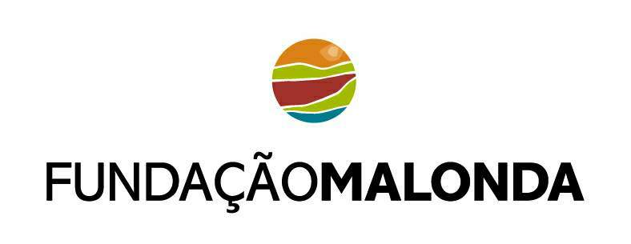
STEPS TAKEN, FORESTRY PLANTATION PROMOTION, FLORESTAS de NIASSA LDA and CHIKWETI Forests of NIASSA SARL
Month and Year | Issue
May 2000 | Sida representative Ulla Andrén received a first request to give support to the provincial Government of Niassa in managing and exploring an existing pine plantation around Lichinga. Ms. Andrén met with Provincial Director of Agriculture, Provicial Director of Forestry and Wildlife. Meetings continued at a Forest Certification course held in Sweden in May 2000
October 2001 | Programa Malonda received request from Provincial Director of Agriculture regarding management of existing pine plantation of 1400 ha, including a proposal for Malonda to provide credit for small scale entrepreneurs to explore these resources
December 2001 | A first study, “The Market for Pine, Produced by Small Scale Sawmills in Niassa Region, Mozambique” completed. The report concluded that investment by small scale operators would be inviable. A larger investment which focused on plantation was recommended
January 2002 | Letter from Governor of Niassa, David Simango, to propose that a Foundation is established asap and indicating that resources, such as the existing pine plantation, can be considered as part of the contribution for such a Foundation
April 2002 | Two potential investors, Dalnor and Holgersson gave their proposal for exploration of the existing pine plantation. They stated that it is necessary to combine the pine exploration with the exploration of hardwood
June 2002 | Direçcão de Agricultura responded at a meeting with Malonda and indicated their approval to add to the existing pine plantation, a concession of hardwood. Two main alternative concessions were proposed to Malonda for Consideration
August 2002 | Malonda responded that they would explore the possibility of 210 000 ha in Nungo (one of the alternatives proposed by Direção de Agricultura)
January 2003 | Inventory of Pine Forest and Hardwood Concession concluded by Malonda
March 2003 | Expert advice from Juma H. Juma, TechnoServe given. Malonda was recommended to identify larger investors to plant and to explore hardwood concession
May 2003 | Programa Malonda requested Provincial Government to promote the existing pine plantation and a hardwood concession
April 2003 – August 2003 | Preparation of minimum requirements and establishment of a “wishlist” of investors.
August 2003 | Invitation for Expression of Interest to 36 companies
September 2003 | Expression with a positive reply received from 10 companies
October 2003 | Governor of Niassa responded positively to Malonda request of May 2003 (pine plantation 1200 ha and hardwood concession 210 000 ha)
November 2003 | Visit to Niassa and the concessions by 3 companies
November 2003 | Negotiations with SPGC for plantation areas by 2 of visiting companies
November 2003-January 2004 | Malonda provided support to SPGC to carry out necessary studies for identification of suitable areas
February 2004 | Map – proposal for plantation areas presented to the 2 investors by SPGC
February 2004 | Malonda visit to Border Timbers in Zimbabwe – company proposed as manager in Niassa by one of the investors
March 2004-August 2004 | Soil Studies, evaluations carried out by investors
May 2004 | Concluded an Environmental Scanning report financed by Malonda and implemented by IMPACTO Lda. The report states that there is suitable land available (degraded areas) but that for the two investors, the area would need to be larger
May 2004 | Comments received from SPGC and relevant provincial authorities as well as the potential investors regarding the environmental scanning report. Comments were added to the report
May 2004 | Letter of Intent from Chikweti to Provincial Government, Niassa
June 2004 | Positive response to Chikweti Letter of Intent from Provincial Government, Niassa
June 2004 | Environmental Scanning report finalised and approved by all.
June 2004 | Recommendations from CTC Consulting regarding way forward: community delimitation, Community Consultation and Environmental Scanning
July-August 2004 | Comments from Sida Headquarters regarding environmental issues
August 2004 | Letter of Intent from SEL (Florestas de Niassa Lda)
August 2004 | First meeting with community representatives
August 2004 | Investors agreed on division of land for their respective plantations
August l2004 | Test Area started, Chikweti
September 2004 – February 2005 | Delimitation and Community Consultation, facilitation of meetings between investors and community. Ongoing contact with investors.
15 September 2004 | Information meeting at the Swedish Embassy on Malonda invitation regarding the forestry plantation prospects in Niassa. Participants: CPI, MADER, DNFFB MICOA, MIC, DINAGECA, CTA. National Directors participated. An e-mail list for distribution of information was established
November 2004 | Positive Response from Provincial Government regarding Letter of Intent, SEL (Florestas de Niassa) Observers FAO and independent observer Helder Soares commented on process for land application and prospects for forestry plantation  Ground Rules established for a Community Fund of 420 000 USD (two investors to join)
December 2004 | Application CPI for Chikweti, Forests of Niassa
January 2005 | Approval Council of Ministers for 220 000 ha of land, among which 110 000 ha plantation area Malonda Foundation
February 2005 | Letter from SPGC Niassa regarding availability of land (for CPI approval purposes). ToR approved by MICOA for Environmental Study. Application CPI for Florestas de Niassa Lda
April 2005 | Fundacao Malonda, Certidão Negativa registered
June 2005 | DUAT Application accepted and sent to DINAGECA
August 2005 | CPI approval for Chikweti Forests of Niassa SARL
September 2005 | Meeting with DINAGECA – DUAT documents had to be revised. Plano de uso e aproveitamento de Terra handed to SPGC and DINAGECA
October 2005 | DINAGECA recommended that the land areas be divided into less than 10 000 ha each, the reason being that they are not all continuous and cover three districts and four communities and that land areas already were approved by Council of Ministers earlier the same year.
November 2005 | DUAT application documents for Malonda Foundation re-sent from SPGC to DINAGECA  Malonda Foundation formal application to GoM for existing forestry plantation around Lichinga (1400 ha)
December 2005 | Meeting, Minister of Agriculture, investors Florestas de Niassa and Ambassador of Sweden and meeting Minister of Planning and Development and Ambassador of Sweden. Minister Mandlate said the approval for Florestas was only a formality and it would be given before end of the year 2005. Florestas began to mobilize their resources to start in January
January 2006 | No approval for Florestas by council of Ministers.  13 of 16 DUAT applications for Malonda Foundation with DINAGECA. One DUAT application for Foundation “lost” one had to have map redone and one was left at SPGC Niassa by mistake.  Minister of Agriculture Tomas Mandlate visited Niassa and re-confirmed Florestas de Niassa approval was a matter of formality.
February 2006 | Governors participated in Council of Ministers. Governor Bimbe met with various Ministers about the importance of the forestry plantation projects.  Board Member Carvalho Neves of Malonda Foundation received information that the Council of Ministers would take decision on Florestas de Niassa on 21February or latest 28 February.  13 of 16 DUAT applications signed by MINAG and returned to Ministry of Agriculture, Juridical Department for analysis  Minister of Agriculture Tomas re-visited Niassa and the Forestry investments were once again discussed  Councellor of Swedish Embassy was in contact with Minister of Planning of Development regarding delay of approval.  Malonda was informed that there had been a hesitation regarding the provincial support for the forestry plantation projects but that these issues had been resolved
March 2006 | Council of Minister Decision still not taken

