One more “Lichinga letter” from Mariette Asselbergs January 2007
Mariettejose@fastmail.fm
64 Cherry Orchard
Kidderminster
DY10 1SJ
UK

Dear friends,

Long overdue, yet this letter could not really be written much earlier, because all last year I was studying like an idiot and then awaiting the results of this never ending 3 year Master’s programme from Imperial College (University of London). It was an enormous pleasure doing it, and the best thing to carry me over the change from the Quinta to Kidderminster, but enough is enough, time to get up and going again!
Finally over now, with positive results coming through the post in the last days of December last year, I am now finally free to start something entirely new again!

But before (hopefully) jumping into new jobs and activities, here is one more of the Lichinga letters, telling about my two month’s visit last year to work on my thesis on Lichinga’s street trees.

I hope that for those of you who have followed the story of Lichinga/Niassa since 1990 when I first arrived there this will be a good last delivery of the never ending story!

Already in the first year of studying, when I did the Sustainable Forestry module, the idea had come up to try to study the value of Lichinga’s beautiful and impressive street trees.

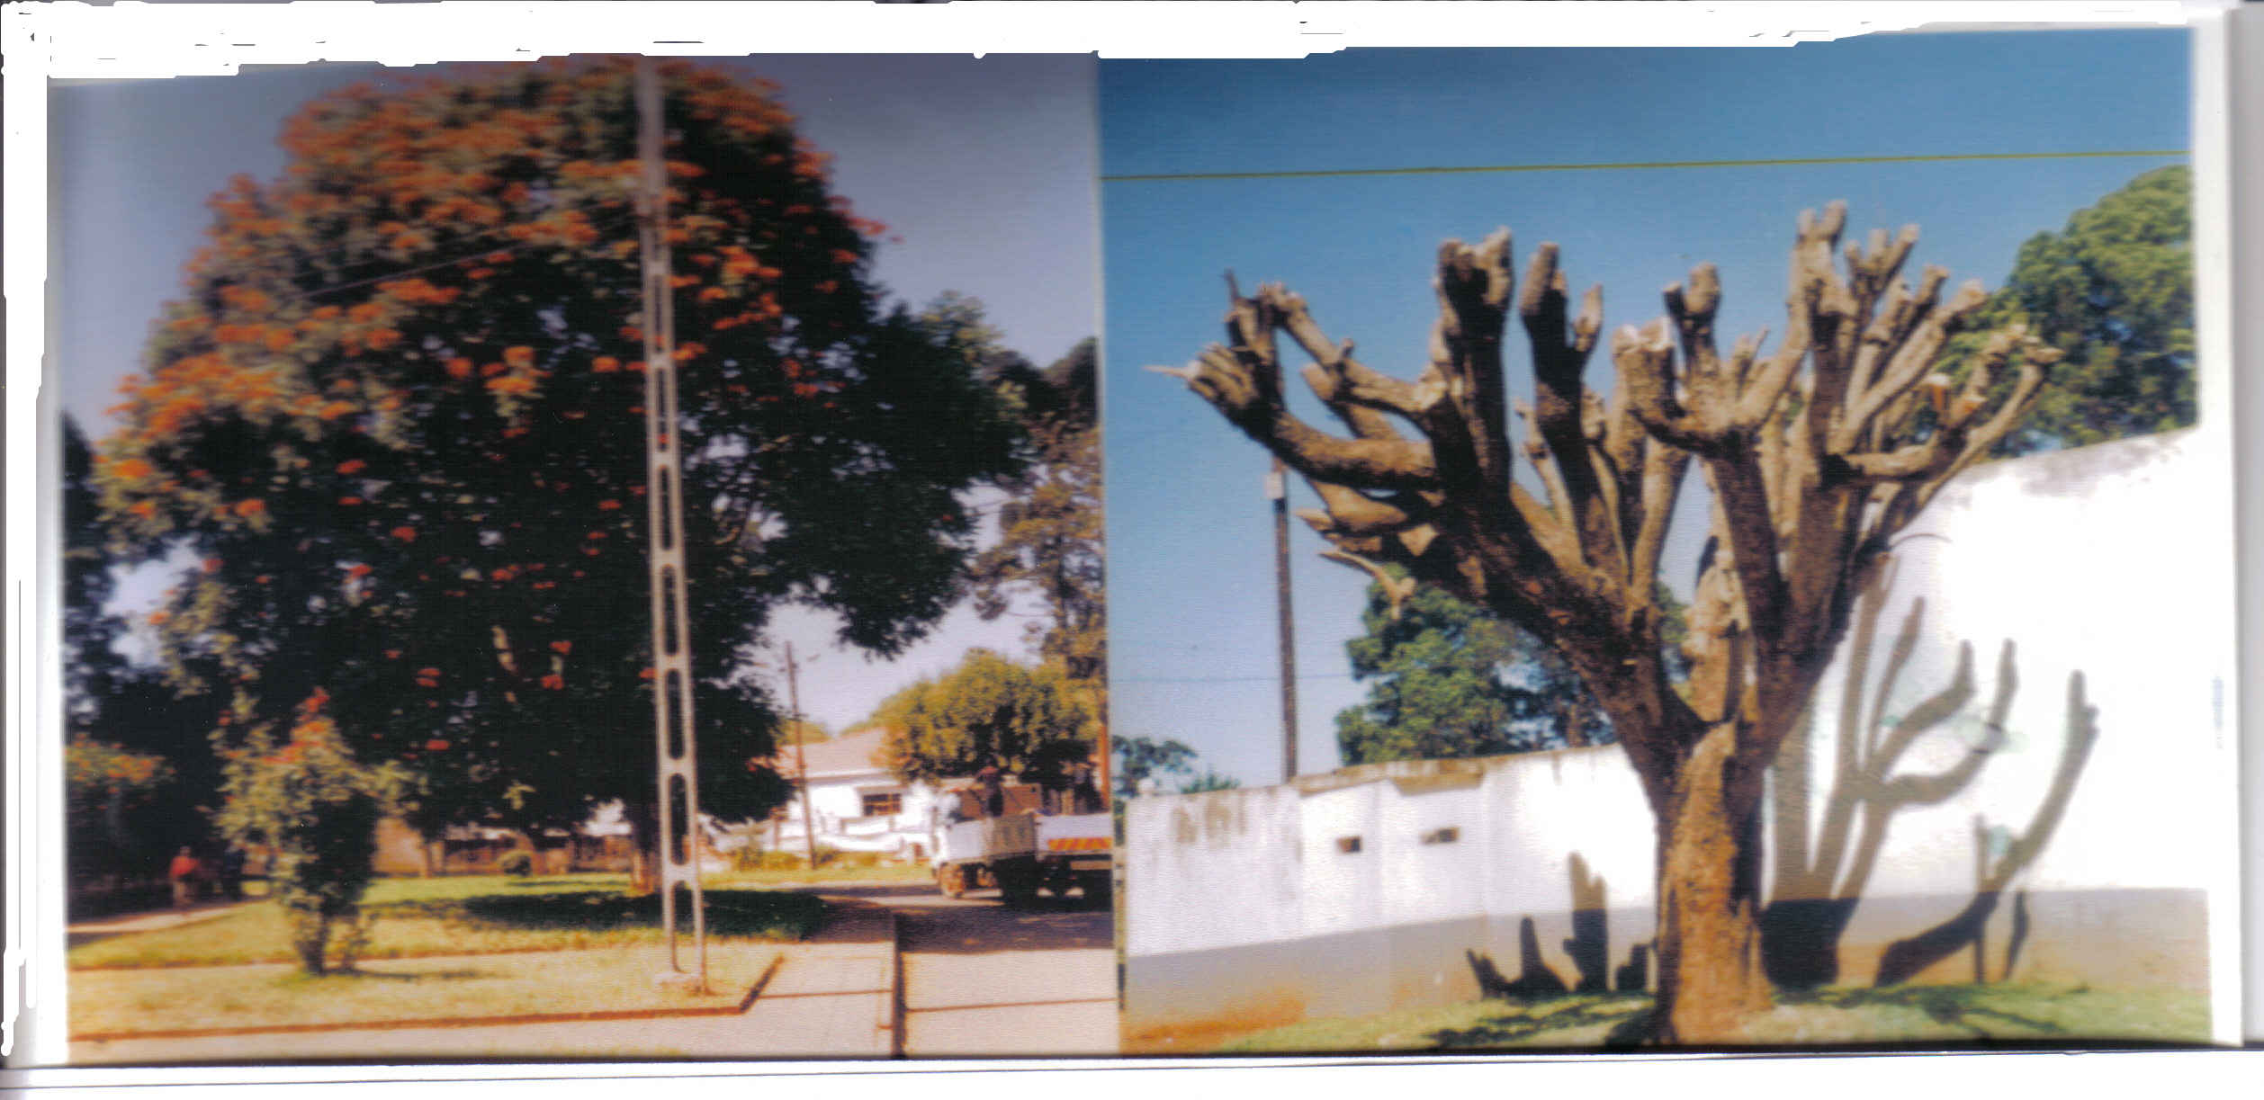

(As you can see I am still an illiterate in copying and posting pictures in documents, but this has to do to give an impression… If anybody wonders what “pollarding” means: the result is the right hand picture. I was interested in how much firewood that produces)

The next pages until p 8 are all about trees and a bit about town democracy, so if that doesn’t keep you wildly interested, skip from here to page 8.

Here is some of their history:

The traveller to Lichinga, capital of Niassa province, will be driving for many hours through rugged wild mountainous miombo woodland with few villages scattered along the road, sometimes visible far away on a hillside. In the last ten years the forest along the road has been cleared for villages, machambas or firewood, and where clumps of trees have been left, one can be sure this is a cemetery, where the dead need the shade to be able to rest.

Lichinga then, is a surprise, a small town of brick and “cement” houses surrounded by large trees with a splendid feast of flowers in any season: the blue of Jacarandas announcing the coming of rains in September/October, red flame trees here and there as gigantic umbrellas to celebrate the start of the rains in December, golden Cassias during rainy season up to May, and red again from African Tulip trees in the dry season from April to November.
The avenidas as the Portuguese built them everywhere, double lanes, with a wide middle strip planted with grass, bougainvilleas in purple, yellow and red, pointsettas fiercely red in June. Thick trunks of pollarded street trees line the avenidas, the crowns joining up and often arching over the roads. All big holidays and visits of VIPs are marked by liming the tree trunks with an almost fluorescent white.

Lichinga, was newly built as capital of Niassa province in 1932, with a street plan modelled on a beehive, streets going round in concentrical circles around the central “Praça” with the provincial Governo, the cathedral, (recently also the new mosque), the army’s barracks (now the higher institute of public administration), the library, the civil registration building, the cinema, the disco Paraisio, and the Bank. For 30 years it was no more than a tiny military and administrative outpost, hundreds, almost a thousand kilometres from any major town. Only in 1962, under pressure of the starting independence war in the North, was the growing town granted official status of “cidade”, and it was at this time that the streets were planted with ornamental trees.

Now more than 40 years later what stands out is the explosive growth of the town’s population as well as the economic and social boom of the last 10 years. The population has increased 30 fold since 1970, and has doubled since 1994. In 1964 in the whole of Niassa Province including Lichinga, there were 144 children in school, the highest level available was 4th class. When I first came in 1992, the highest level of education possible was 9th class, and there was one vocational school. Now there are 3 university faculties, 2 higher institutes and general education up to 12th class available.
In the ‘60s and ‘70s the hospital, 1km from the Praça, was referred to as “the hospital out there in the bush”, now townships extend in a radius of 5-10 km around town.

In the 70s Lichinga was surrounded by dense forest, lions regularly killed cattle within 3 km from the town centre, and although lions again attacked currals in 2004 causing a sensation, the plateau is now deforested for 50 – 80 km around town from firewood collection, charcoal burning and agriculture. While talking with me about the trees, firewood, “Man and Nature”, people talked about poverty as leading cause of environmental damage, the role of government in mitigating this relationship, their problems, successes, and hopes for the future, plans and ambitions, if not for themselves, then for their children. There was no doubt that the issue of trees hade a place in the wider context.

All over Moçambique the Portuguese colonialists planted ornamental trees along roads and avenues in cities, towns, small administrative “postos”, and generally near their farms and rural “cantinas” (trade posts). The main species planted were exotic ones: Jacarandas (Jacaranda mimosifolia), African Tulip Trees (Spathodea campanulata ) and Yellow Cassias (Senna multijuga). Most people refer to all these trees as “Acácias”. Around the town initially Eucalyptus spp., later pines (Pinus patula and Pinus eliottii) were planted.
Why were they planted? As a reminder of Portugal where towns tend to be planted with ornamental flowering trees which are regularly pollarded? Or “Marking the stage where settlers turned their minds on matters beyond basic survival” ? To make a statement of power and civilization in the wide green wilderness of Niassa, contradicting natural forms as a display of human abilities? “A highly visible expression of man’s imposition of order over nature … a symbol of control over the landscape and its inhabitants…an expression of ownership and power. …inextricably connected with the social and economic preoccupations of the time”? Is it of importance that planting coincided with the start of the liberation war in Niassa in the early ‘60s?
When asked, old Portuguese inhabitants of Lichinga (Sr Mideiros, Dona Etelvina Faria, Sr Neves) think that the main reason for the trees was their influence on the climate, especially during the cold, windy and dusty dry winter. Their beauty, with always one of the tree species in flower during the year, was another consideration. But it is interesting to note that several lonely flame trees in the bush near Majune indicate old army bases from the independence war.
It is typical in Portuguese culture to pollard ornamental street trees. The practice has continued here until today, more or less every three years. The reason for the pruning was the control over form and size of the trees. They were exclusively planted in the Portuguese part of town (“cement town”) and firewood production was not a consideration at the time.

The trees remained after Independence, and more were planted, e.g. jacarandas on the 9 km road to the airport. Governador Manave reigning with an iron fist had a department created especially for the town’s public trees, parks and flowers and made each state enterprise responsible for the upkeep of part of the newly planted trees. Even during the isolation and hardships of the destabilisation war in Southern Africa (1984 -1992) all trees were carefully protected and maintained.

However, with the fast socio-economic development of the last 10 years, including explosive population growth, building of houses and offices, increase in numbers of cars, and privatisation of houses, “stress” on the trees has become increasingly evident and they are now regularly cut down. This is a development seen everywhere in the world where towns grow fast.

Is there a future for these trees in a modern town? Do they serve some useful purpose or are they only a burden on a town’s budget? What happens in other towns in Southern Africa?

These were questions I wanted to study for my thesis. It fitted well in the programme which emphasised the multidisciplinary “holistic” way of analysing both development and environmental situations. So I combined a quantitative study of the amount of firewood these trees produce (as a mostly unintentional and invisible by-product), with a qualitative study of people’s opinions, ways of thinking about the trees and their environmental role. For this last part of the study I used a “Q sort method”. (A footnote in a Lichinga letter! Well, I thought I would include this for who is interested in the details…..). The result of a Q sort done by people is (after computer analysis) to show different ways of thinking, different, subjective, points of view on a subject, be it trees, music, food, politics, or even the use of the Q sort method itself!

Subjective thinking at a personal level can be seen in terms of levels of brain functioning subject to survival (“reptilian brain”), emotions (“mammalian brain”) and rational thinking (“human brain”). But it is social and political relationships that shape natural resource management. In an Indian context Robbins showed – using the Q method to find what forest products people thought most important - how foresters, farmers and indigenous people see forests differently as survival value for different groups of people (the poor, pastoralists, builders, investors) versus the technical ground cover function for administrators and government. On the other hand McPherson and Haip described how attitudes in Tucson, Arizona, changed radically from massive popular (Anglo-Saxon) involvement in tree planting (“creating an oasis”) in the ‘20s up to the ‘40s, to a water-conserving and desert-appreciating attitude nowadays, all in interaction with city council policies and ecological, technological (air conditioners) and economic developments.
Comaroff and Comaroff argue that in South Africa fierce debate and campaigning against “alien plants” (specifically the Jacaranda) is “a language to voice an existential problem about what nationhood and belonging mean for a new nation state in a globalising world and what moral and material entitlements it might entail”. They see it as falling back on apartheid ways of thinking in the need to define what (and who) belongs and doesn’t in South Africa. In the case of Lichinga would it be possible that the trees were a statement, comparable to the “Aqui é Portugal”- this here is Portugal – in mosaic on the front step of every Town Council building in colonial times? Asserting the confidence and ambition of the empire builders? Is it possible that today’s Mozambican town inhabitants and councillors still feel this statement of territory marking? Does that play a role in the increased tendency to cut street trees down?
Looking for similarities in Lichinga however, I could not find them. There is no doubt that the trees are considered to be exotic, even though few of the young people know that it was the Portuguese who planted them. They have no local names, there is no indication for local uses (e.g. for medicine or ceremonies), some people even mentioned that it might be dangerous to experiment with medicines since these trees were not from here. Yet, nobody I interviewed considered exotic trees improper for the town, and very few would like to experiment with native trees to replace them. It was surprising to find such positive attitudes to the street trees and disagreement with the idea of getting rid of them in the process of becoming a fast growing city. Problems are recognised: the interference with power lines, the danger of falling branches on roofs, the disruption of pavements, but people thought them manageable, solved by regular pruning.
But what seems to be similar to the situation in Lichinga is the “all but invisible underclass part of the local economy” (the importance of firewood for the poor), in South Africa played by the “alien” rooikrans, sold as firewood, and in Lichinga by its exotic ornamental street trees. “Discourses over nature cast a sharp light on everyday actions and events”.

It will not come as a surprise with the growth of Lichinga’s population, that firewood is fast turning into a critical issue. Ten years ago charcoal was brought in on bicycles from 30 km distance, but in 2006 this has increased to 50 – 80 km. In the environmentally protecting pine forest plantations around Lichinga, women used to collect dead branches, but in the last 5 years whole trees were increasingly being cut down (illegally) for firewood. Recently the forests have been sold to a private investor and all firewood collection there has been banned. Officially all charcoal making is supposed to be under licence and controlled, but this is generally seen as unenforceable for the many small scale producers, for whom it is one of the very few ways of earning some cash. There are attempts from the forestry department, to teach better, sustainable practices and the long term vision is to organize charcoal burners into associations with the obligation of replanting and protecting forest.

Few people were aware of the amount of firewood produced by the now fully developed 40-year-old ornamental street trees. We found, counting, pruning, measuring and weighing, that the firewood production from the 40 year old town trees is considerable, between 1000 and 2000 m³ of solid wood, (comparable to at least 200-400 truck loads) each 3 year cycle, and equal to the total annual amount of firewood for which the forestry department issues licences in the whole province!
Volume measurements of branches and measurement of pruned wood both showed production of pollard wood of ca. 0.35 m³ for Cassias after one year growth, and ca. 1.5 m³ for Cassias, Jacarandas and African Tulip trees after 3 years growth, with signs of some partial pollarding in in-between years to protect electricity wires. If for comparison reasons we convert these data in per ha data, then the town trees with an average crown area of ca. 37m² represent 270 trees per ha, or for 890 trees an area of 3.3 ha with a production of approximately 150 m³/ha/year. This seems very high when compared with conventional data based on incremental growth per ha for production wood. My tutor had difficulty believing these results, but the photographs of the stacked firewood from each tree had to convince him. As it did the Town Council’s President Cristiano Taimo, who we called as a witness and who got so enthusiastic that he brought all his personnel of the Council’s office to see it. Altogether it looks like Lichinga’s ornamental trees can compete easily with purpose firewood trees like eucalyptus spp..

Opinions differ on the practice of pruning. Although everybody sees it as the task of the Town Council, opinions differ on how the tree maintenance should be paid for. For some this is simply a cost the Town Council should bear, for others it should try to recover the costs with the firewood from the prunings. But a link between tax and service provision (tree maintenance) is generally distrusted, referring to the tax for rubbish collection which is paid automatically with the electricity bill, by anybody connected to the grid, whereas rubbish collection only takes place in “cement town”, even though people in the bairros also pay their electricity plus the extra tax. My friends from the Mutumes band (which used to be the BSN when they were just kids playing at the Quinta), suggested that the pruning might be outsourced to youth organisations, allowing them to sell the firewood in order to raise money for activities and events for young people: there could be a “festival of pruning”.

Although the Town Council is increasingly decentralised, and financially “on its own”, there was a strong feeling that selling the firewood would “give the Town Council a bad name”. The prunings were (until last year’s pruning) simply left for anybody who wanted to take them. When pruning was outsourced to the Association for the Combat against Unemployment (ACODENIA), the prunings were allegedly no longer a free for all, but taken by family members of the cutters and sold. People disapproved of this, but accepted it as “normal practice these days”. In the Q sort, only one of the viewpoints was in favour of selling, the others preferred free distribution to the needy, hospital etc. Some pointed out that both controlled and organised free distribution and sale of the prunings would be impossible “in real life” since the Town Services don’t have sufficient transport and personnel for this purpose.

Firewood should not only be judged by its quantity, but also by its quality, according to local preferences. These involve – apart from heat produced and length of burning – also spark, smoke, light and ash production, and its quality as raw material for charcoal. In Lichinga there are also a few large-scale uses of firewood: for burning bricks, baking bread, and cooking in institutions like the hospital and the prison. This time I did not have time to look into these qualities except for discussing them in the open interviews, where opinion on quality was generally very positive.

In this context is the contribution by the street trees important or just a drop in the ocean? In Lichinga a very small and wealthy part of the population cooks with electricity. Of the rest, whoever can afford it will cook with charcoal, firewood being the source of energy for the poorest, not only for cooking but also for warmth in cold winter months and light at night. The town’s street trees with 500 m³ solid wood production per year (plus “raminhos” ~ 150 000 kg green weight) could provide 100-200 families (700 – 1400 people). In a population of 141 000, this is just “a drop in the ocean” (< 1%), but on the other hand it represents 3.3 ha highly productive forest and shows potential for being increased. In town there are at least 200 spaces available for new trees (~ 0.75 ha). The townships are spreading out fast these last years, without any space reserved for parks or green zones, even though there is no lack of space. Jacaranda, African Tulip Tree and Yellow Cassia could be planted in strips or parks in between townships. Eventually every 270 trees will represent a hectare of forest, not only producing potentially ca 130 m³ of renewable firewood annually, but also absorbing the CO₂ of 104 625 car kms and protecting against dust, wind and erosion……

What came out of the Q sorts was in a way very interesting for me.
There were three different ways of thinking about the trees, but two of them told me also something about the perceptions on democracy, participation, “good governance” as the fashion of the day is now:

One type of thinking is active, with opinions about new planting of trees: Where, how, which types. This coincides logically with the wish that the Town Council should consult with inhabitants about tree cuttings and plantings.

The second type of thinking is much more general, but stresses a careful conservation- type acting of Man in Nature. In contrast with the first type of thinking, it trusts the Town Council with all decisions about trees, and even agrees with the selling of firewood, an issue that is generally considered politically sensitive.

It was clear that there were two very different ways of thinking about good governance, one focused on participation and the other on trust in authority. And the interesting thing was, that the Q sort unequivocally linked a wish to be consulted and to participate with strong opinions and active thinking about the trees, and on the other hand an attitude of trust in authority together with the feeling that problems or issues concerning trees were not for the “man in the street” to be worried about, since she or he had a town’s council to take care of that. (Interesting enough, if Mozambicans say something is somebody’s “right”, this just as often means it is somebody’s “duty”, so if it is the Council’s “right” to take care or decide about the trees, then that just as often means it is considered its “duty”). Common sense says this is no surprise, but I was pleased that a survey about street trees showed that two very different perceptions about the council’s rights and duties exist next to each other, and also that a wish for a participatory democracy comes from people not in a gratuitous way, but joined with the wish to be actively involved and contribute. In practice this might end up with a council trusted by the one group to do what it wants, doing in a democratic and consulting way what the other group vocally and actively asks it to do. Do the actively participating people and groups have a right in a democracy to dominate decisions?

-o-o-o-o-o-o-o-o-o-

So far, the above is more or less a popularised version of my thesis work.
Something chosen as a definite deviation from vet work!

It was great to be back in Lichinga. I brought my fold up bicycle and my laptop, and I stayed for 2 months in dona Hilaria’s Bar Triangulo. She has some 6 or 7 rooms in her quintal behind the bar and it was the best possible environment for living and talking to old friends and making new ones. Always music, always cold beer, always people dropping by, right in town. Within days I had three of my old workers employed for 2 months to help with measuring the trees and pollarding and weighing and measuring 6 whole trees. They did a fantastic job, no accidents at all, very careful measurements and cross checking and they got into the whole thing with great enthusiasm. Twice Antonio met a bee nest when up in one of the trees, we found numerous orchids growing hidden in the stumps, and one tree even had a huge hamerkop nest, right in town! And another friend of the very first beginning, Sigauque who is now a school teacher, did all the interviewing with me, and was the very best person to discuss ideas with. Even though he doesn’t drink, for years he had a little bar in his living room, where his quiet smiling respected-by-everybody presence prevented any rowdy environment even though people got drunk. Directors rubbed shoulders with workers and passers by, there were often the most amazing discussions going on.
The bar doesn’t exist anymore now that he is working three shift-teaching, days and evenings, but the same interest in discussions continues and he knows absolutely everybody in town.

I had been away for a year, and it was striking how Lichinga is changing, booming. There is building going on everywhere, the bairros stretch up to the airport 9 km out of town, to mini cabora dam, surrounding the agricultural research station and Mideiros’ old farm.
There are traffic jams in town (when I remember when there were only 7 cars in 1992!), absolutely everybody has mobile phones and texting and night time conversing is a generalised activity since Mcel and Vodacom in turns provide these activities for almost or entirely free in a murderous competition for clients.
What will stay with me is this image of elderly Mozambican women sitting with their mobile in their lap, absorbed in their own world, texting children and grandchildren, sending hem a 100 contos on their phone account for their birthdays….by phone! Who would have thought that possible in 1994 when we used to go to the airport to give somebody a message or money for somebody in Maputo! Even in 2000 when we got the first internet server in Lichinga, or 2002 when the first mobiles got a signal!
Lichinga’s outdoor market, where up to last year women were sitting on the ground with their vegetables for sale under an umbrella in the heat, under a piece of plastic in the rain, was now covered by a gigantic roof, built by the town’s council. And not only that, there were now public toilets and even a bicycle guarding place where for 5 contos (20 USD cent) you could safely leave your bike, 20 kg of sugar, or anything else you bought and didn’t want to carry around. A young man had seen the same in Beira, asked the town council if he could run a place like that and got his licence within 2 weeks! And I have never lost a bicycle yet, he said proudly.
What was more: almost everybody I asked commented on the fact that things were going well, ever better, that there was hope, trade and jobs to do, money to be earned, things to buy.
There were only two groups not happy about the present day:
The market women, although happy about the roof and the concrete tables provided for their trade, complained that they were with far too many of them, and not enough customers. Which is absolutely true, Lichinga’s fabulous production of fruits and veggies will only become a good trade once the road to Pemba is finished or if somebody builds that canning factory……
The other group were the charcoal vendors, who come cycling with 3 or 4 huge bags of charcoal, easily surpassing their own weight, from as far as 80 kms away, pushing their bikes up the many hills. It is their only hope to earn some cash, since the maize and beans are just enough for the family and their trade is not particularly lucrative so far from Lichinga. It is incredibly hard work, to cut the trees, heap them, cover them in grass and mud, burn them in a very controlled way, then load the bags and get them to Lichinga to sell them for 2, if lucky 3 USD a bag of 25 kg, 6-10 USD for a trip.
They can maybe make 2 trips a week. If their was another way to earn this money locally, they wouldn’t do this, wouldn’t struggle their way up to Lichinga they said. They knew that the forest was fast being destroyed, moving further and further away, but what to do?
“Poverty sucks your bones dry”.

Otherwise, everybody had plans, was busy doing things, building things.
And still in this small scale Lichinga, things were directly visible: my payment to Hilaria was instantly used to buy cement and build a nice outdoor place with benches and tables and a cover against rain in her Quintal, where she hoped to be able to attract people wanting to have private parties. The firewood we pruned from my study trees went to Serviços Urbanos who used it to heat tar and filled all the town’s potholes before the 25th of June, Independence day.

It was great to be there, a part of it and yet no responsibility, no struggle to find money to pay the workers each end of the month, no worries about sick animals or where to sell the Quinta’s products, or about the roofs in the rainy season, the road’s passability, if the car would stay OK, or most nagging the threats from corrupt direcções and extortion of increasing amounts of moneys.

I went to see the Quinta of course, and news was good and sad both.
The restaurant and surroundings looked brilliant, very much more civilised with neat grass planted, lots of flowers, lots of peach trees, in the process of installing an electric pump and making connecting water pipes to the kitchen. Unfortunately they had had a lot of bureaucratic problems, even though Tamele is director and high up in Frelimo. They were not allowed to keep the name, Quinta Capricornio, even with my permission, and they still have no licence to use the guesthouses (no conditions according to the officials), and no connection to cabora bassa electricity in town yet. So difficult for the restaurant to function properly, especially since they had not bought the solar installation and now still depend on a generator.
But Ivone was doing a good job, putting in an enormous amount of effort. It is no longer a special restaurant though, with high quality local food and a pride in Lichinga’s products. Chicken and chips, mainly.

The farm and the animals was another story, most of them dead, from negligence paired with ignorance and well, whatever. A number of workers sacked or sent to work elsewhere, a lot of complaints about late payment of wages and ill treatment. I don’t think it has a future as a farm, as it is going now, it was painful to see, but there was nothing I could do about it any longer.

To end this on a more cheerful note, the two donkeys (Jasmine and Frollo) I gave to Quinta Belo Horizonte on the other side of town, as payment for transport of my crate of books to Maputo, and who are the only surviving donkeys of my 7, had a female foal in July, so…….a vida continua.

And now, back here, the luta starts again, or let’s say I join in again.
I have applied with a proposal to do a mid term evaluation of a rural development project in Sierra Leone (with CARE), and I will continue to try that at every possible opportunity.
Have prepared a CV in English, Dutch and Portuguese which I’ll send to a range of potential job suppliers, looking for anything in the fields of development, environment or vet or a combination of these. A bit like fishing really, see what’ll come up.
I can’t do much with my hands, so practical vet work is out, but I have my computer so I can write, which pushes me in the consultancy corner isn’t it? Otherwise I am fit and Ok so I hope I can find things to do involving travelling to rural areas in far away places, I am really not an office person….
I am pretty much tied up here in Kidderminster, but that doesn’t mean I cannot travel at least 6 months a year, or take up a job elsewhere in UK for half the week and travel up and down.
I would really like to do more research and have some ideas of places/people to approach, who knows?

So I expect this to be the last of the Lichinga letters. Things have gone very different from what I expected in 1990 when it all started (for me there), but certainly for Lichinga I could never have imagined that developments would/could go so fast in the way they have gone, from the dire poverty and underdevelopment of the war besieged town I knew first, to the busy and booming Lichinga of 2006. How can people see Africa as “a sinking continent” with “failed governments”?

A short word about the family:
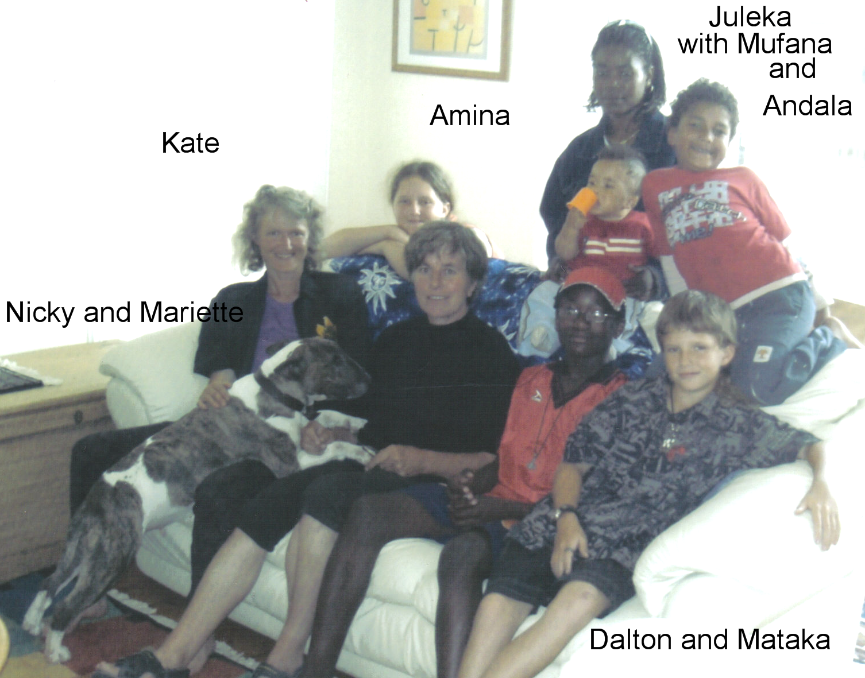

Here we are, last summer when they all stayed with us:
Amina and Mataka – Kate and Fergal’s kids
Dalton – Juleka’s eldest
Andala, and Mufana – Juleka and Fergal’s kids
Kate and me and dog Nicky.

Kate passed her last membership exam for psychiatry at first try, so no more exams, but at the moment jobs for completing her specialisation are extremely rare, especially around here, so she may have to go for some in between jobs until she gets what she wants (child and adolescent psychiatry).
The children are growing up and it is fascinating and lovely to see them twitching their way into adulthood, one moment the serious and responsible and critical young adult in control of her/himself, the next the giggly, irresponsible affectionate and spontaneous child again. Amina now 15 and starting to do GCSEs hoping to be a lawyer in the future, Dalton who will be 14 in June practicing and enjoying his new voice and attending his 94 emails a day, mostly from his girlfriends……and very much a “B talent”, anything maths, physics or technical. Mataka with 12 still really a nice and funny child, but ominously he and Dalton cleaned up their room this Christmas and transferred boxes and boxes of toys to the cellar. Last summer they still played with them, now they said they’d store them until their 6 year old brother Andala comes for holiday….
The room is now dedicated to computer games, air hockey, football and slopping out with a “do not disturb” sign on the door.
It is a pretty long stretch until summer when they’ll be here again, maybe with their two younger brothers Andala and baby Mufana. But at least 5 quid phone cards allow for hours of conversations on Sundays when Kate always calls them.

With late best wishes for 2007.

Cheers
Mariette

4 579 in 1970, 39 004 in 1980, 73 550 in 1994 and 141 000 in 2006 (Town Council archives)
In short the method is based on a representative sample of opinions from the existing “concourse” on a subject. A variety of people are then asked to sort the opinions (cards with statements) from maximum agreement to maximum disagreement, on a chart with locations following a quasi-normal distribution pattern. The statements form the sample, the people the variables. Computer analysis with a PQMethod package downloaded from http://www.rz.unibw-muenchen.de/~p41bsmk/qmethod/ computes a correlation matrix among the Q sorts and performs a Principle Components Analysis on this correlation matrix followed by a Varimax rotation. A Varimax rotation produces a solution that maximizes the variance explained. This helps to focus on distinct patterns of opinions, “points of view” (Van Exel and de Graaf 2005), on the subject, which function as “operant or functional subjectivity” (Brown 1993) in human thinking and communication. The method was used here mainly as an experiment and a helpful tool to stimulate discussion and gain insight in existing opinions on the subject of street trees.
Based on a production of 1500 m³/ha/y

