PGR Manager: Progress Monitoring Report – Guidance for students
This is a brief guidance on how to fill the progress monitoring form online for full-time and part-time PhD students.

- Go to https://doctoral-research-system.open.ac.uk/

- Login (see Logging into PGR Manager guide)

- The My Project button on the right-hand side will take you to your project page where you can access your Progress Report
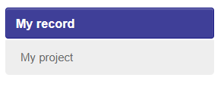

- Click on the Progress Review button


- Create a new application. You can also view old Progress Reports here
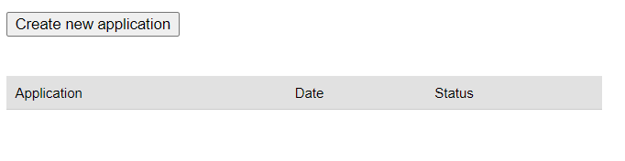
- Follow instructions to check your details are correct. If you request changes, the Research Degrees Team will be notified

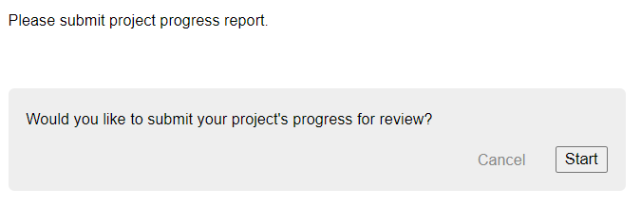
And
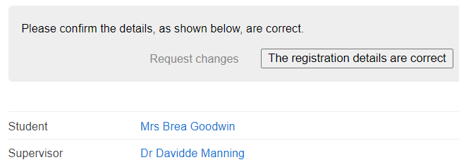

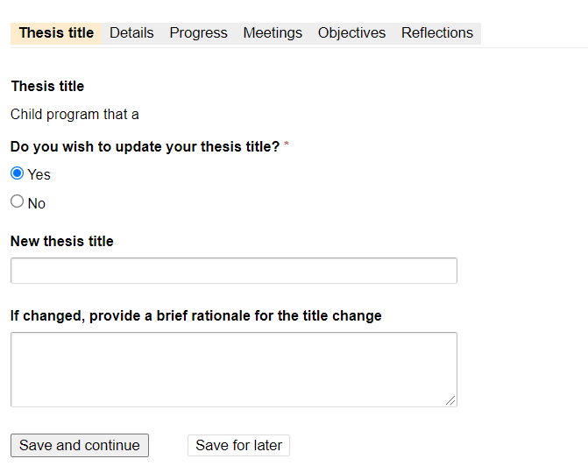

Details Tab: If you did not have a meeting with your Third-Party Monitor, please explain why for example – you didn’t have any issue to raise with them. If you are not sure of the name of your Third Party Monitor is, please contact your Postgraduate Convenors.
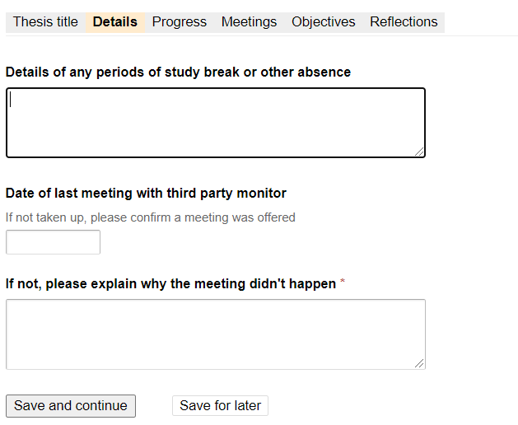

Progress Tab: Answers for Progress during the last 12 months (looking back) should be detailed and descriptive. The process is designed to help you reflect on what work and training you have completed. The Progress Report is read by your supervisors and your Director of Research/Associate Dean of Research/ARC Research Degrees Coordinator who want to ensure that you are getting the support you need and progressing as you should.
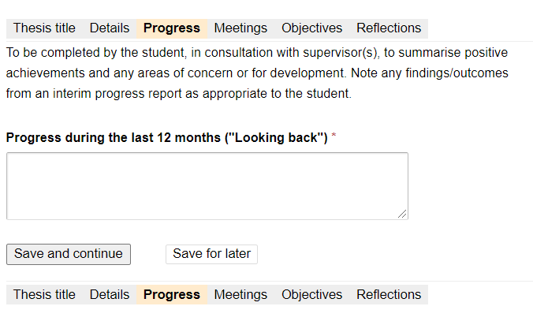
Meetings Tab: You should say how often you meet your supervisors and how you stay in touch in-between meetings. You and your supervisors are required to have 10 meetings per year (full-time) or 5 meetings per year (part-time). You can add suggestions or feedback for interactions here. If you have any issues with the levels of meetings or interactions with your supervisors, please inform the faculty.
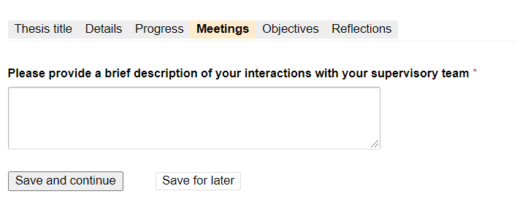

Objectives Tab: This should be detailed and descriptive. This is a chance to capture and help resolve any issues you think you may encounter in the next year, as well as help plan your next steps to ensure you remain on track with your submission. You should discuss this section with your supervisors where possible.
Your thesis plan is usually a timeline or Gantt chart, showing how you will ensure you will submit your thesis by your submission deadline or, if funded, your funding end date.
Your estimated thesis submission date must be before your submission end date. If you are close to submitting, please ensure you have completed the Notice to Submit workflow under ‘Examination’ on your project page.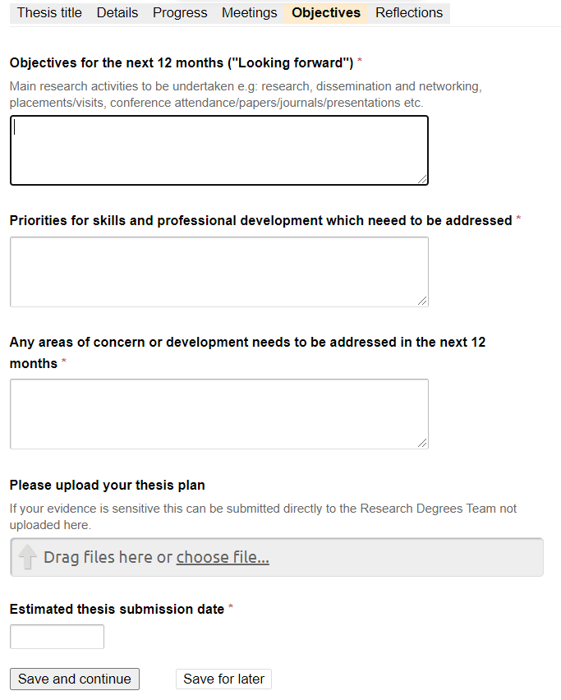

Reflections Tab: This should be detailed and descriptive and is a chance for you to reflect on what you have learnt. It is more general than just the progress of your degree.

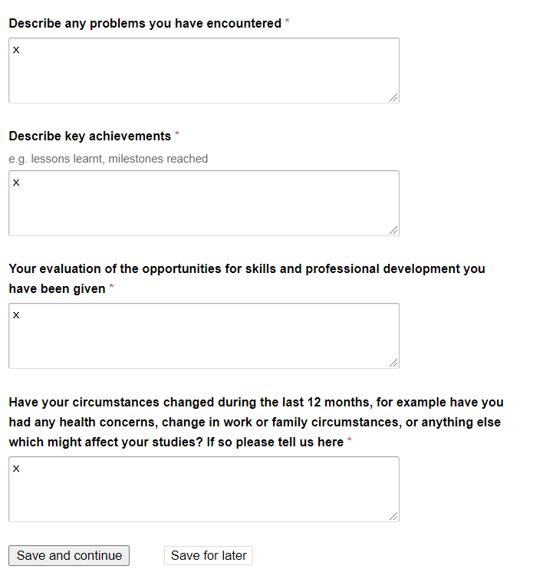
Complete each of the sections above. If you cannot complete it all at that time, click ‘save for later’ and start editing when you are ready.

Submission of the report
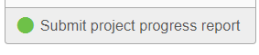

Reviewing your report: You can chose to review Progress Report by clicking ‘Review’ and then ‘Continue’ button
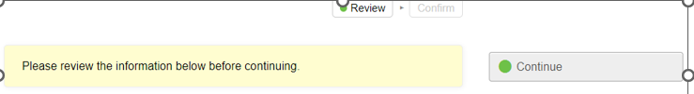

Confirm your submission: If you are satisfied with the report, choose ‘confirm’. You will be given a chance to add any additional information in the notes section, if you don’t have any please click ‘Confirm: Submit’ button.
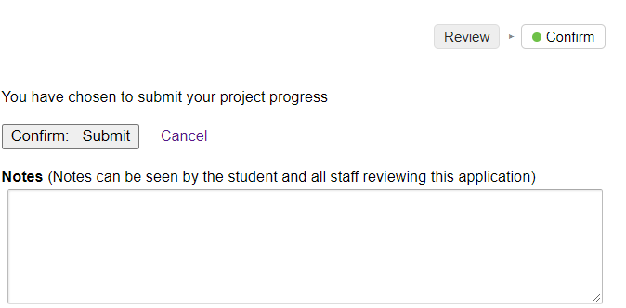

You can keep track of who needs to do what next with your Progress Report by looking at the box on the right side of the screen. Any of your supervisors can take over the task so if your Lead Supervisor is on Leave, email another supervisor asking them to take over the task.
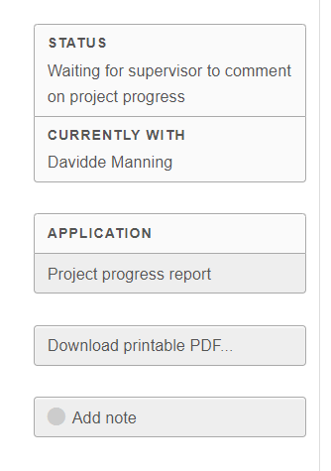
Once your Progress Report has been confirmed, you will receive an email notification from no-reply-pgr-manager@open.ac.uk. You can view everyone’s comments by going back to the Progress Review tab and selecting this years’ Progress Report. Then click on each section, or select the ‘Download printable PDF’.

For reference only, the full template looks as follows:
Student Report
Thesis title
Thesis title
xxxxxxxxxx
Do you wish to update your thesis title?
Yes
New thesis title
yyyyyyyyyyy
If changed, provide a brief rationale for the title change
Project details
Details of any periods of study break or other absence
Date of last meeting with third party monitor
If not, please explain why the meeting didn't happen
Project progress
Progress during the last 12 months ("Looking back")
Supervision meetings
Project objectives
Objectives for the next 12 months ("Looking forward")
Project reflections
Describe any problems you have encountered

