PGR Student Induction Programme

What do I need to bring?

All students (including OU staff members)
- A laptop/tablet – unless your funder is providing one and you haven’t received it yet
  - Original Degree certificate(s), including certified translation if not in English or Welsh
- Proof of identity, which must be one of:
  - Current passport or national identity card, or
  - Current UK or EEA driver's license, or
  - HM Armed Forces identity card
- Proof of nationality, which must be one of:
  - Current passport or national identity card, or
  - UK birth/adoption certificate, or
  - UK Home Office naturalisation/registration certificate

Non-UK students
- Proof of English language proficiency as supplied with your application. This will be one of:
  - Secure English Language Test (e.g. IELTS certificate)
  - Proof of nationality of a majority English-speaking country
  - Degree certificate from a majority English-speaking country
  - Degree certificate used to support English Language Proficiency Statement
- Student route visa holders:
  - Proof of the date you entered the UK (e.g. boarding pass, flight confirmation)
  - Share code (if not provided already)
  - Visa letter from UKVI (if not provided already)

All documents MUST be originals. You will NOT be registered for your degree until you have provided all required documentation.

Please note: Student route visa holders should arrive at 9.00; part time students should arrive at 10.00; all other students to arrive by 10.30.
Day 1: Tuesday 29 September 2026
Time | Activity | Who? | Where?
9.00–10.00 | Registration for student route visa holders  Present your original documents to register for your degree and verify your immigration status. Pick up a lunch voucher.  Tea, coffee and pastries provided | Student route visa holders | Library (Atrium)
10.00-10.30 | Registration for part-time students  Present your original documents to register for your degree. Pick up a lunch voucher.  Tea, coffee and pastries provided | Part-time students | Library (Atrium)
10.30–11.30 | Registration for all other students  Present your original documents to register for your degree. Pick up a lunch voucher.  Tea, coffee and pastries provided | Full-time students except student route visa holders | Library (Atrium)
Clubs and societies stalls 9.00-11.30
Meet representatives of OU clubs and societies at stalls in the Library Atrium.

Campus tours 10.00-11.00
After you've registered, take a tour of the campus with our friendly guides to find out about useful locations, and a bit of history, and hear a few rumours! Tours depart every 30 minutes from the Library Atrium (meet under the Tree of Learning)
11:45–11.50 | Group photograph  A group photograph of all our new starters under the Tree of Learning in the Library entrance | All students | Library (Atrium)
11.50-12.00 | Make your way to the Berrill Theatre  Meet at the entrance to the Hub at 13.45 or make your own way over | All students
12.00–13.00 | Graduate School Director’s welcome and essentials  The induction talk that gets students scribbling the most notes: Clare Warren will cover vital regulations, take you through the PhD timeline, and talk about where to seek help | All students | Berrill Theatre
13.00–14.00 | Lunch and networking  Use your voucher to buy lunch in The Hub. We’ll walk you over from the Tree of Learning in the Atrium after the group photo, or make your own way over. We have reserved some tables if you want to sit together, or take some time for yourself. | All students | Hub
14.15–14.45 | Getting started on your PGR journey – 5 things to bear in mind  Helen Bowes-Catton (Training Lead, Graduate School) gets you started on your epic quest | All students | Berrill Theatre
14.45 – 15.45 | Information for Student Route visa holders  Roles, responsibilities, and regulations for individuals on an OU-sponsored student route visa. This is also a chance for you to ask Student-Route-visa-related questions. | Student Route visa holders | Berrill Theatre
15.00-16.00 | Information for part-time UK students  Information about being a part-time PGR, including the OpenLearn platform and mini modules  PGR part-time volunteers will attend | Part-time UK students | TBC
15.00-15.45 | Tour of XR studios  An optional tour atound the XR studios in Jennie Lee Building - TBC | TBC | Jennie Lee Building
16.00-17.00 | Introduction to UK Research and  Innovation (UKRI)  Sara Spencer talks you through the regulations and  responsibilities which apply to students funded by UKRI | Research Council funded  students (including  DTPs) * | TBC
16:00 onwards | Informal networking in the PGR Common Room, Library Building  If you still have energy, come over to the Common Room for an informal meet-up with existing students and staff, with light refreshments | All students | PGR Common Room, Library

That’s it for Day 1! During the evening, if you have been given an OU laptop on Day 1, please turn it on and log in to allow updates to happen.Please remember to bring your fully-charged laptop (OU and non-OU laptop) to Day 2!

Day 2: Wednesday 30 September 2026
Time | Activity | Who? | Where?
09.00–09.30 | Tea and coffee | All students | Berrill Café and Mezzanine
09.30-09:45 | Welcome from the Pro-Vice Chancellor  Our Pro-Vice Chancellor (Research) welcomes you to the OU – this will be a recorded message.  Then we introduce Day 2. | All students | Berrill Theatre
9:45–10.35 | Introduction to Core Training and Professional Academic Communication in English (PACE)  Judith Taylor (Training Lead, Graduate School), Helen Bowes-Catton and Julia Molinari (PACE) discuss the wide range of training opportunities available to research students | All students | Berrill Theatre
10.35–10.50 | Research inspiration/ Haikus  Dr Helen Bowes-Catton and Dr Judith Taylor get you talking about what led you to your research topic and the OU | All students | Berrill Theatre
10.50–11.10 | Comfort break and responding to ‘what is your research inspiration?’  Tea and coffee will be provided | All students | Berrill Café and Mezzanine
11.15–11.45 | Introduction to PGR Manager  Get to know the system you will use to manage your student journey. Led by Mate Szenyan | All students | Berrill Theatre
11.45–12.00 | Library  An introduction to online Library platforms for PGRs | All students | Berrill Theatre
12.00–13.15 | Lunch  Use your lunch voucher in the Hub restaurant. As before, some seating has been reserved. | All students | The Hub
13.15–13.30 | Make your way to the Berrill Theatre  Meet at the entrance to the Hub at 13.15 | All students | Berrill Theatre
13.30-14.45 | Question and answer with current research students  An opportunity to find out more and ask existing students questions about life at the OU | All students | Berrill Theatre
15.00–17.00 | Afternoon social  Mingle with existing PGRs – pizza and drinks provided | All welcome (optional) | The Hub

Day 3: Thursday 1 October

Faculty Induction Day – information regarding your faculty induction day will be sent to you separately.
Please note: Quiet space is available throughout all three days in the PGR Common Room (on the ground floor of the Library building) and throughout the Library building.

Where to find the Graduate School
The Graduate School is located on the Ground Floor, Betty Boothroyd Library
Walton Hall, Milton Keynes, MK7 6AA. We operate an appointment system.
Phone +44 (0)1908 653806 or x53806 Mon-Fri 9:00-16:30
See more about booking appointments here: Contact us | Graduate School Network

Directions to the OU
- Maps and venues at Walton Hall and Directions to the campus, parking and accommodation
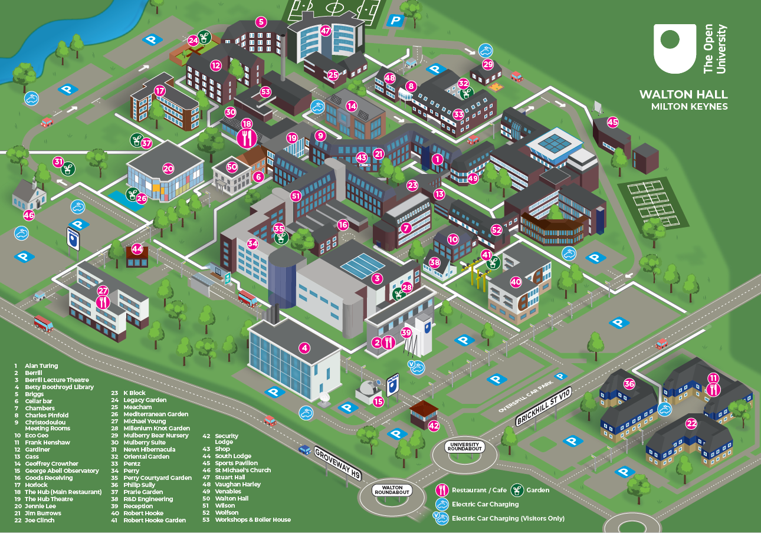
- Parking – use Overspill car park opposite Berrill Building (39) or Library car park (4). NB. the car park opposite Robert Hooke (40) is not available.

