

Your emotional resilience skills:
A guide for students studying emotionally challenging content

This guidance is for Open University students who may come across emotionally challenging content as part of their studies. It aims to provide you with practical help and suggestions to help you study topics that are emotive or difficult for you.
What are emotionally challenging topics, and why do we study them?
Academic study involves being curious – about the world, about people, and about the way things are and why, as well as how things could be different. Academics ask questions and seek answers, and as a student in higher education you will be introduced to a wide range of sources, examples, and case studies to help you grasp the central issues and debates of your chosen academic subject.
Many academic disciplines may require engaging with materials that are emotionally challenging. This might be what made you interested in your chosen discipline. There are no fixed rules about what people find upsetting, but common topics that students may find distressing can include:
- human suffering and distress,
- animal suffering or environmental destruction
- injustice or inequality such as racism, homophobia, ableism, or gendered violence
What’s the impact of studying emotionally challenging topics?
Studying emotive topics can be motivating and engaging and help relate your developing academic understanding to real world examples. This material can also be empowering. It can help you to make sense of your own past experiences in new ways and find out how you can contribute to making change in your community, career, or wider society.
However, sometimes emotional responses can impact on your learning and wellbeing. Case studies featuring emotionally challenging content can feel different for different people. It is normal to have a wide variety of emotional responses to case studies featuring violence, injustice, or human suffering. Most people find materials like this upsetting, and you may even be surprised by your own emotional responses to this content. When faced with emotionally challenging content, you may feel a range of emotions such as sadness, anger, frustration, or fear. Over time this might lead to sleep difficulties, nightmares, low energy and feeling tired or worn out.
Some people may find that stimuli (such as images, words or phrases, sounds, smells, people, places, and situations) can bring back or ‘trigger’ vivid memories and emotions of a previous traumatic event. This can be experienced as emotional or physical symptoms such as feeling frightened, stressed, or panicky, or becoming breathless, nauseous, or dizzy. Some people may experience a worsening of symptoms of conditions such as anxiety, depression, or post-traumatic stress disorder.
Your emotional responses may contribute to feeling a sense of imposter syndrome (not feeling cut out to study a subject with a lot of emotionally challenging topics). This could even lead you to think about withdrawing from your studies. You are not alone in feeling this way and there are suggestions for who you can talk to below. Remember your emotional responses are important, you already have some skills to process them – and you can develop new ones. Noticing and working with the wide range of emotional responses you might experience in your study (see figure 1), and then identifying and applying your emotional resilience skills, can enrich your learning and wellbeing.

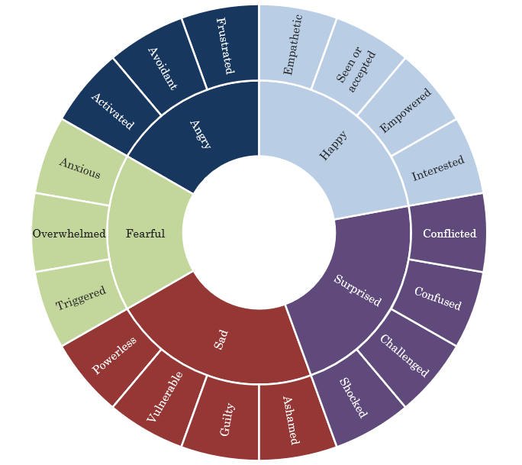
Figure 1: The range of emotional responses that students reported when studying emotionally challenging content (Downes et al 2022)

How to take care of yourself when studying emotionally challenging topics
There are various strategies that you can try if you find course content emotionally challenging. Here are some strategies and skills that draws on research with Open University criminology students (Downes et al 2022) about how they managed their emotional responses to topics they found challenging in their studies:
Apply your existing skills
- You may already have a whole range of skills that you can now apply to your studies. You may be, or have been, in other environments where you learnt to detach yourself from difficult emotional experiences, used ‘professional distance’ to cope with upsetting situations, or did things to help you to ‘switch off’ or look after yourself after a stressful event. Think about how you might now apply these skills in your studies. Your skills can help you to decide how and when to best engage with content that you might find challenging.
Plan ahead
- If you know that there are certain topics (such as sexual assault) that will be difficult for you, you can take steps to prepare how and when you study these topics. You might find that you are able to engage with this content if you know about it in advance; or you may need to avoid it altogether.
- Some courses have content notes, and others give a preview of topics at the start, which will help you make an informed decision about how and when you can engage with the material. Alternatively, your tutor can let you know what topics will come up in your course and help you make a study plan to ensure you look after yourself whilst still meeting the learning outcomes of the course.
Embrace flexibility
- Many people find that simply taking a short break helps them manage their feelings and gain a sense of calm. Plan regular study breaks and allow yourself more time for breaks if you are studying material that you find challenging.
- Explore your options of how you can best participate in learning events on topics you find challenging. Adjustments could include opting-out of one or more collaborative activities, attending some tutorials online instead of face-to-face (thereby allowing you to step away discreetly), or accessing recordings of sessions that you can then study at your own pace.
- Think about where and when you study material that you find challenging. What boundaries can help you to switch off and avoid carrying difficult emotions into your personal life? This might include studying materials in a particular place, for instance in a library or workspace rather than at home. Or it might help to study materials at certain times of the day rather than studying it late at night just before you go to bed.
- If there is content that is very emotionally challenging for you, explore how you can engage with it differently. For example, if it is written material you could decide to skim read it, or if it is audio or audio-visual material you could decide to read a transcript rather than watching or listening to it. You might also be able to avoid using a particularly distressing case study or example in your assignment.
- You could engage with the material in short bursts and intersperse your study time with something you enjoy, helping you to relax. Alternatively, you might decide to leave the topic for now, and return to it later when you feel stronger – sometimes gradual and repeated exposure to an emotionally challenging topic can strengthen your ability to study it again.
Use your support system
- Sometimes being a distance student is isolating and thinking about emotionally challenging content alone can make it harder to deal with. Talking to others about the content can help you name and manage what you are feeling. You could talk to friends or family, or to other students on your course, face to face or online. You could also consider the OU Students Association's Peer Support scheme to receive non-judgemental study support from a fellow student who has been trained to help you achieve a better study experience.

- You can talk to your tutor about a topic or assignment that is coming up on your course that you expect to find challenging. You can also talk to your student support team about how the course content is affecting you. The Open University has a system in place to support students who are finding their studies challenging. This includes access to free, confidential online mental health support via TalkCampus and free, confidential and anonymous text message support service for students via Shout. The Open University also provides a ‘Your Wellbeing’ page that you can find on your study site by clicking on the ‘Succeed’ tab. Your emotional wellbeing is important and using these services when you need to is all part of caring for yourself and succeeding in your studies.
Be reflective
- Thinking about why you are studying can help you make sense of your feelings. Your motivations to study might relate to academic or career goals, or to your personal life or past. Having your motivation clear can help you to carry on when the material is challenging. For example, students have reported that reflecting on how they could use their own experiences to help others in the future helps them to work with challenging content. This can help you to stay engaged with what you are studying.
Physical self-care
- Many people find movement – such as exercise, gardening, or walking – a useful way to channel difficult or strong emotional responses.
- Physical self-care such as taking a nap, a relaxing bath, or having a favourite meal or a hot drink, can all help you to find calm and balance if you are experiencing a challenging emotional response to what you are studying.
Emotional self-care
- Recognising that emotional responses are a normal part of learning can be very helpful because it validates and acknowledges that feelings are an important part of learning new things. Be gentle with yourself and acknowledge that having a strong emotional response to a topic is a normal and empathetic reaction. Even experienced academics can become emotional about the topics they study.
- People can find various things helpful for managing difficult feelings, including journaling /writing. Some people also find mindfulness, breathing exercises, positive self-talk or affirmations are helpful in managing challenging emotional responses.
- You may find it useful to set up some ‘glimmers’ in your home or study space. You can think of glimmers as the opposite of triggers. Glimmers are cues of safety that can help to bring yourself back to a calm and peaceful place. This could include a picture of a loved one, a playlist of music, or using a favourite scent, essential oil, or candle. Feel free to try out different things to find out what works best for you.
Engage with the things that bring you joy
- Studying can feel all-encompassing at times. Engaging with the things that make you happy – anything from TV shows or video games to music, craft, art or pets – can help you cope with any difficult feelings.
- Make time for play and fun with your loved ones. Give yourself space and time to enjoy yourself. Experiencing joy can help you to manage your studies when they get tough.

Where to get further help
If your course content has made you very distressed, or exacerbated a mental health condition, you might need to seek further help, below are some suggestions for where you can find help inside and outside of The Open University.
- If your feelings have made it difficult to keep up with your studies or complete your assignments, speak to your tutor. They may be able to offer you an extension, or help you catch up. Remember that your tutor can also advise where potentially challenging material is in the course and guide you on the extent to which you need to engage with it to complete your assignments.
- If you need to talk through your emotional responses to study content free, 24/7, confidential and anonymous support is available for all OU students. You can choose the most comfortable way for you to talk when you are ready. If you’d like to chat via text message, you can access support via Shout by texting OU to 85258. If you’d like to access support in a safe and completely anonymous online space you can access support via TalkCampus. Full details are available on the OU Help Centre’s Mental Health Support page.
- If your studies have exacerbated an existing mental health condition you may want to talk to your GP, counsellor or professional if you are already in touch with mental health services. The Open University also has a Mental Health Casework and Advice Team who provide specialist, one-to-one support service for students needing guidance on managing complex mental health difficulties or severe emotional distress alongside their studies. To be referred to this team, you will need to first contact your student support team.
- If during your studies, you recognise that you are, or have been, affected by domestic abuse or gender-based violence (GBV) you may wish to disclose this to The Open University. Full information about how The Open University will respond to these types of disclosure is available in the Domestic Abuse/Gender Based Violence Policy. A list of relevant helplines and services that you can access support from is available here.
- If your mental health and wellbeing has been impacted by an incident of discrimination that has happened to you or someone else at The Open University, you are encouraged to report it using the Report & Support tool. You can choose to do this anonymously or provide your name. If you do give your name, the incident will be investigated, and you will be signposted to additional support.
- If you are interested in support and resources around studying with a mental health issue and the everyday challenges of student life Student Minds is a charity that provide specialist support for students struggling with their mental health. They also run Student Space that provides expert advice and information, student stories and support to help all students to navigate the challenges of student life, as well as support via text chat, phone, webchat, and email. There is a list of other external mental health services available on the Help Centre.
- If you are in crisis, you should seek help immediately. If you or someone else is in danger, call 999 or go to your local Accident & Emergency department now. Alternatively, you can speak anonymously to a helpline like the Samaritans, who are open 24 hours a day on 116 123 (UK). If you need help urgently for your mental health, but it is not an emergency, get help from NHS 111 online or call 111.

