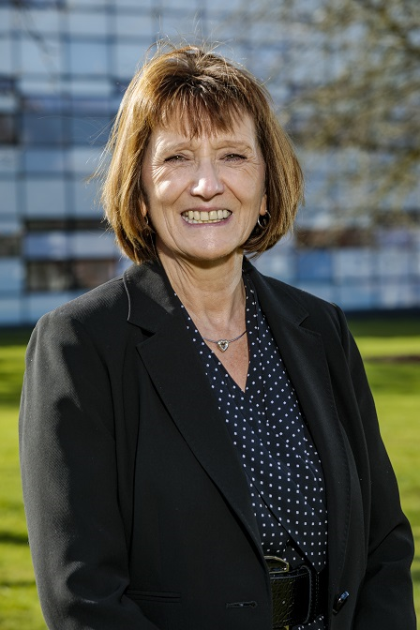

Jeanette Hartley, PhD Candidate.

Faculty of Business and Law
Role: FBL Representative on Post Graduate Research Student (PGRS) – Graduate School (GS) Liaison Group

I have represented FBL on the PGRS-GS Liaison Group since the group was first formed during the 2017/18 academic year. I shall be completing my PhD this year and now need to handover to a new representative.
I have found performing the role a great way to:
- Help resolve GS related issues raised by fellow PGRS and the FBL student committee
- Directly influence and provide feedback on OU initiatives led by the Graduate School
- Expand my personal network across the university
What is involved in representing FBL on the PGRS-GS Liaison group?
The Group meets monthly and is chaired by Lindsay O’Dell, Director of the Graduate School. The primary aim of the Group is to provide a platform for PGRS representatives from each faculty to put forward ideas, provide feedback and raise issues directly with the Director and staff of the Graduate school and with representatives from other key services, including the Library, Training and the Student Association.
The scope of the Graduate School includes:
- Management and operation of the student journey
- Liaising with faculties and research students,
- General enquiries and advice,
- Implementing regulations,
- Updating process
- Co-ordinating training
- Promoting student opportunities
- Building a PGR student community (on-line and Face to face)
- General responsibility for student wellbeing
Recent examples of where the PGRS-GS liaison group has provided input and made a difference:
- Provision of a permanent common room in the Library building
- Creating suitable spaces for students who want/need to study on campus in the evenings
- Green issues
- Highlighting the impact of the “six-hour rule” (limit on number of hours that may be worked) on students in year 4 where funding has ended. And the inconsistency with Tier 4 rules that allow 20 hours (Requests to work more than 6 hours are now more likely to be agreed)
- Driving analysis to demonstrate that very few PhDs are completed within the three-year funding period (ongoing)
- Fast-tracking issues raised by individuals
If you are interested and thinking of volunteering but would like to discuss the role in more detail, you are very welcome to contact me: Jeanette.hartley@open.ac.uk

