Supervisor name | Susanne P. Schwenzer
Supervisor email address | susanne.schwenzer@open.ac.uk
Project Title | After the dust has settled: Post-impact hydrothermal alteration minerals, fluids and habitability

Project Title | After the dust has settled: Post-impact hydrothermal alteration minerals, fluids and habitability
University [where doctoral researcher (DR) will register] | The Open University
Which institution will the DR be based at? | As above
If ‘other’, please add institution here
Theme  (Max. 2 selections) | Climate & Environmental Sustainability ☐  Organisms & Ecosystems ☐  Dynamic Earth ☒
Key words (required, must be separated by a comma) | Impact crater, petrology, hydrothermal, modelling, habitability
Please explain how the project fits within the NERC remit (office use only) | The project aims to study rocks and minerals in an impact structure on Earth which therefore matches the Dynamic Earth theme.
Supervisory team (including institution & email address | PI: Susanne P. Schwenzer, The Open University, susanne.schwenzer@open.ac.uk  Co-I: Julia Semprich, The Open University, julia.semprich@open.ac.uk  Collaborator: John Spray, University of New Brunswick, jgs@unb.ca
Is the PhD suitable for part time study? | Yes ☒  This is a requirement of NERC

Project Highlights:
- Becoming an independent user of cutting edge as well as industry-standard analytical, laboratory, and modelling methods (optical microscopy, electron microprobe, thermochemical modelling software, e.g., Geochemist Workbench).
- Investigating how water-rock interactions and resulting element mobility shape environments and habitability on Earth.
- Understanding impact crater processes with relevance to Early Earth at a time life first emerged – with potential applications to other planetary bodies.

Overview (including 1 high quality image or figure):
Large hypervelocity impact events that generate craters >75 km diameter on Earth are environmentally modifying and may influence mass extinction events. However, the heat distributed by these impacts via subsequent melting and fluid release can potentially provide new habitats for microbial life on Earth, especially during its very early history (>4 Ga). The main barrier to testing this is that plate tectonics, erosion, burial and volcanicity have erased these early environments such that our knowledge is primarily derived from models that have limited ground truth.
This project will investigate the hydrothermal system of the ~85 km-diameter Manicouagan impact structure of Quebec, Canada. The following key processes will be investigated: (1) generation of the hydrothermal system, with heat from the impact-generated superheated melt sheet mobilizing ground- and surface-waters in the immediate environment; (2) the spatial distribution of hydrothermal alteration within the structure; and (3) the mobility of elements and potential habitability within the modified rocks. Manicouagan is well exposed and ~10 km of drill core is held by the collaborator Dr Spray at the Planetary and Space Science Centre in eastern Canada. This provides an unprecedented third dimension to the impact structure, with three of the drill holes held penetrating ~1.5 km depth. Access to these materials will facilitate characterisation of the temperature evolution and fluid availability in a terrestrial crater, which will then be used in models to simulate impact-induced hydrothermal systems in the oldest preserved rocks (Archean 2.5 – 4.0 Ga and Hadean >4.0 Ga). Further, the temperature profiles and fluid geochemistry can be implemented into simulation experiments to test implications for the survival of microbial life. By investigating the temperature, volatile- and fluid-flow and associated bio-geochemical history of the Manicouagan structure, and extrapolating the obtained data to Early Earth impact scenarios, this project will improve our understanding of the role of impact craters as warm, wet oases for supporting life.
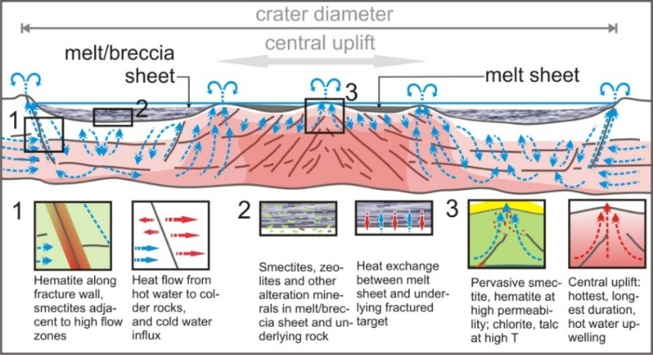
Figure 1: Qualitative assessment of the impact heat distribution, water flux and alteration minerals for a crater in basaltic target lithology. The goal of this project is to quantify the contribution of hydrothermal systems to habitability for Early Earth.
Figure description: A picture of a cross-section of an idealized impact crater depicting its rim and central uplift. In the crater subsurface temperature dependent water flow along fractures and associated mineralization due to hot-rock water interactions are depicted alongside temperature zones.
Methodology:
- Optical microscopy and chemical mineral analysis will be used to study the alteration mineralogy and geochemistry in the different crater regions.
- Thermochemical and phase equilibria modelling using industry standard and research software (Geochemist workbench, CHIM-XPT, Perple_X) will be employed to understand the alteration parameters that cannot be measured such as fluid temperature and chemistry.
- The new data and models will be combined to test and refine existing hydrothermal models, particularly those for Early Earth impact craters using relevant parameters such as rock compositions and temperature estimates

Training and skills:
DRs will be awarded CENTA Training Credits (CTCs) for participation in CENTA-provided and ‘free choice’ external training. One CTC can be earned per 3 hours training, and DRs must accrue 100 CTCs across the three and a half years of their PhD.
The student will be trained in optical microscopy, electron beam mineral analytical techniques and petrologic, laboratory, and modelling methods, to the level of independent user. In addition, field work will provide planning and sampling skills. With the international and interdisciplinary nature of the project, teamwork and collaboration are an essential aspect of the work. Special emphasis will be on the oral and written communications skills, ranging from e-mail and phone to Teams/Zoom discussions, e.g., in the planning of the field work, to conference presentations, report writing and publication in peer-reviewed journals.

Partners and collaboration (including CASE):
This project will be in collaboration with Professor John Spray, Director of the Planetary and Space Science Centre at the University of New Brunswick in Fredericton, Canada. John’s team focuses on investigating hypervelocity impacts, planetary materials, frictional melting, impact cratering mechanics, terminal ballistics and the geology of the Moon and Mars. As part of this collaboration, the supervisory team will encourage the successful doctoral researcher to apply for a Mitacs Globalink Research Award (https://www.mitacs.ca/our-programs/globalink-research-award/), which would enable the student to visit the core repository and to carry out field work and research in Canada.

Possible timeline:
Year 1: Oct to July: Literature work, familiarising with mineralogy, petrology, geochemistry of rocks in the impact structure, familiarising with cooling and thermochemical modelling, and initial models based on estimated temperature values and rock compositions from the literature, preparation of the field trip; prepare application for internship. July to October: Project report writing, summarizing petrological data in writing, preparation for more detailed geochemical work.
Year 2: Detailed petrological and geochemical work (ideally in the field as part of the exchange), understanding the cooling history from data obtained from the rock samples studied. Attend a national or international conference.
Year 3: Phase equilibria and thermochemical modelling to understand fluid conditions and extrapolation of models to Early Earth conditions. Prepare publication. Write up and submit thesis.

Further reading: (in Harvard Reference Style)
Osinski, G.R., Spray, J.G. and Lee, P. (2001) ‘Impact-induced hydrothermal activity within the Haughton impact structure, arctic Canada: Generation of a warm, wet oasis’, Meteoritics and Planetary Science, 36, pp. 731-745. https://doi.org/10.1111/j.1945-5100.2001.tb01910.x
Osinski, G.R., et al. (2013) ‘Impact-generated hydrothermal systems on Earth and Mars’, Icarus, 224, pp. 347–363.
Schwenzer, S.P. and Kring, D.A. (2009) ‘Impact-generated hydrothermal systems capable of forming phyllosilicates on Noachian Mars, Geology, 37, pp. 1091-1094.
Spray, J.G., Thompson, L.M., Biren, M.B. and O’Connell-Cooper, C.D. (2010) ‘The Manicouagan impact structure as a terrestrial analogue site for lunar and martian planetary science.’ Planetary and Space Science, 58, pp. 538-551.

Further details:
Students should have a strong background in Earth sciences and enthusiasm for laboratory work and data analysis. Experience of thermochemical modelling is desirable. The student will join a well-established team researching into fluid rock-interaction and geo-microbiology on Earth, Mars, Venus, and icy moons (https://www.open.ac.uk/research-groups/astrobiology/). Please contact Dr. Susanne P. Schwenzer (susanne.schwenzer@open.ac.uk) for further information.

