


OU Scotland Cares Newsletter
April 2026

Hello
With spring now underway, we’re happy to share our April newsletter. This month also marks Care Experienced History Month — a time dedicated to recognising and honouring the diverse stories of those with care experience throughout history.
This newsletter is designed especially for care experienced students in Scotland, bringing together useful updates, opportunities, and support.
In this issue, we bring you information on:
- Care Experienced History Month
- Opportunities to connect online with OU students including a session for care experienced students in Scotland and The Big Blether which is open to all students
- Study support for the months ahead
- Careers and employability opportunities
Enjoy the read! If there’s anything you’d like to see in the next issue, please let us know through the anonymous suggestion form.

Care Experienced History Month
Care Experienced History Month takes place throughout April and is a time to recognise, reflect on and share the stories of care experienced people, past and present.
The month concludes on 30 April with the International Care Experienced Day of Remembrance. This day was created by care experienced people across the world who called for the recognition that care experienced people have been part of societies in all corners of the world for as long as can be remembered.
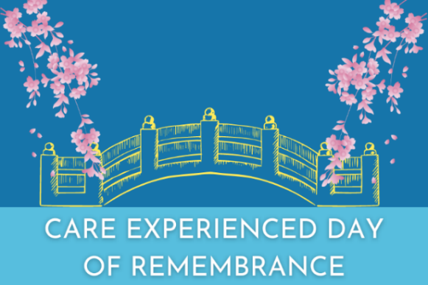
This image represents a bridge from the past to the present, a bridge to the people, a bridge to the future and bridging the divide in understanding of the history of care experienced people.
Last month, the Children (Care, Care Experience and Services Planning) (Scotland) Bill was passed, marking an important step forward in strengthening support, rights and protections for care experienced people. This represents meaningful progress in Scotland’s continued commitment to Keeping the Promise.

Connect with OU Students
- Connect, Chat and Skill Sharing
Friday 24 April, 15:30 – 16:30
During Care Experienced History Month, The OU Scotland Cares team is running a relaxed 60-minute online session for care experienced students at The Open University in Scotland.
We’re hosting a friendly space where you can take a break, meet other students, and share study tips and tools to help you stay organised and motivated.
This is a supportive, no-pressure space to connect with other care experienced students. You won’t be asked to talk about your care experience or anything personal. You’re welcome to join in whatever way feels comfortable for you. Whether you stay for the whole hour or just pop in for a few minutes, we’d love to see you!
To register for the online session, please complete the registration form.

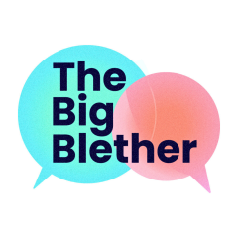
- The Big Blether
Tuesday 28 April, 18:30 – 19:30
The OU in Scotland invites all OU in Scotland students to join us for a Big Blether via video call. A good blether can help us through a tough time, give us the confidence to overcome a hurdle or just put a smile on our face at the end of a long day.
Our Big Blether events are fantastic opportunities to meet fellow students and have a chat. Join us for fun activities and uplifting conversations! You can find out more about the event and reserve your space via the Big Blether Eventbrite page.

Study Support for the Months Ahead

As we move further into spring, many of you will be reaching important points in your module. This might mean preparing for an End of Module Assessment (EMA) or an exam in May or June or focusing on your ongoing coursework and assignments.
The OU has a range of resources to support you at every stage of your studies. For those working towards exams or EMAs, there is helpful guidance on exam techniques, adjustments and what to do if the unexpected happens. You can explore everything in one place on the Exams and EMAs page in the Help Centre.
For students working on assignments, the Assignments page in the Help Centre brings together everything you need to know about preparing and submitting work, and what support is available if you run into any problems.
The Student Hub Live Archive also has a collection of recorded interactive sessions hosted by OU tutors. The recordings include study skills workshops, community events, and plenty of ideas, best practices, tips, tools and resources that can be very helpful. Recordings include ‘Preparing for, and producing your best EMA’ and ‘End of Module Assessments and Remote Exams’.
And remember, if you’re unsure about anything or need a bit of guidance, your tutor is there to support you – and you can always contact your Student Support Team too.

We Care Fest

We Care Fest continues to run this academic year and is open to all care experienced students studying at Hub for Success partner colleges or universities. It offers a relaxed and welcoming space to meet other students and staff from across the partner organisations. Forthcoming sessions include:
Friday 1 May, 14:00 – 17:00
Thursday 21 May, 10:00 – 12:00
To find out more about We Care Fest, for the full list of sessions and to register, check out The Hub for Success website.

Careers and Employability Opportunities
- Power up your career skills
Monday 20 April – Friday 24 April
Power up your career skills 20 - 24 April is a five-day series of six careers skills workshops to help you:
- Search smarter for opportunities using labour market information (LMI).
- Present your authentic self in applications and interviews.
- Build and use your networks for opening new opportunities.
- Discover the advantages and options for postgraduate study.

- People skills in a digital world
Wednesday 22 April, 12:00 – 13:00
This employer panel event will help you build the confidence to show you have the skills employers value most. Many employers create workplaces with people of diverse experiences and perspectives, and you’ll hear from them why your “people skills” can help them harness the power of this diversity. Whether you’re preparing for your first job or looking to boost your employability, this session will give you the insights and motivation you need to succeed.
- Career together: focus time to think about your future
Thursday 7 May, 12:30 – 13:45
Career Together are 75-minute Adobe Connect sessions to give you protected, booked time to focus on yourself and work on your own future – in the company of other OU students. If you’re struggling to find the time, motivation or confidence to finally get that CV updated or LinkedIn profile created, write a job application or just want to kick start your future, it’s for you.

- Unlock your career potential with LinkedIn workshops
Tuesday 9 June, 11:30 – 12:45
Discover how LinkedIn can support your career journey in this one-hour interactive workshop, covering how to optimise your profile, build your network, find work, and use helpful tools on the platform.

Thank you for reading to the end of this newsletter. If you have any questions, please contact us at OUScotland-cares@open.ac.uk and a team member will be more than happy to help.

Keep well,
OU Scotland Cares Team

Unsubscribe from these messages:
You are receiving this email because you have told us you have experience of being in care and opted in for marketing communication. If you think you are getting these mailings by mistake as you have never been in care, or if you would like to know how to opt out, please contact us at OUScotland-cares@open.ac.uk for advice.

