# The Weight of the Pen: Legal Legacies and the Destruction of Murujuga

As Law Students, we are taught to see contracts as tools, as vehicles for facilitating transactions, managing risk, and enabling progress. But what happens when the contracts we help draft become instruments of irreversible harm?

This is the question we must confront in the case of Woodside Energy’s Burrup Hub expansion, particularly the Pluto Train 2 project, which processes gas from the Scarborough field. While this may appear to be just another energy infrastructure project, it poses at direct threat to Murujuga, home to the world’s oldest and most significant collection of Aboriginal rock art.

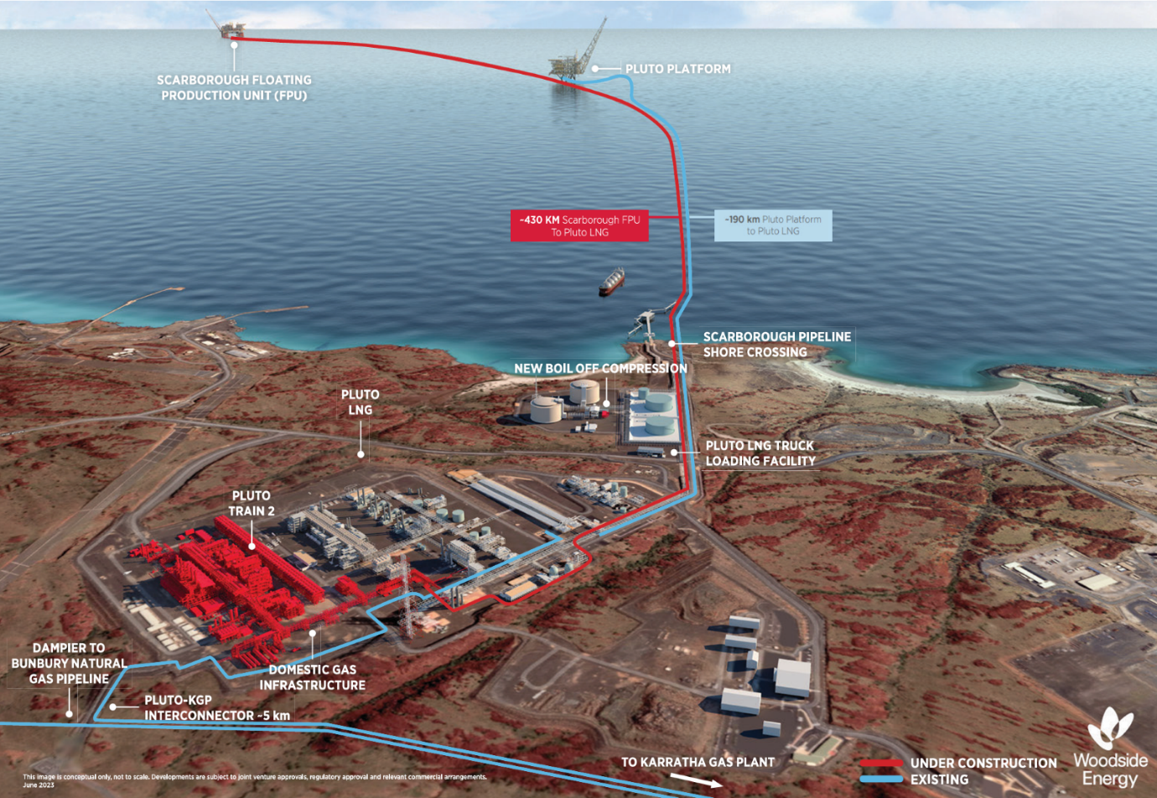*Image: Scarborough Energy Project conceptual diagram (Woodside Energy, 2024)*

## Murujuga: A Living Archive of Humanity

Murujuga, also known as the Burrup Peninsula, is a sacred cultural landscape containing over two million petroglyphs, some dating back 40,000 years. These engravings form an unbroken narrative of human presence, including the oldest known depiction of a human face. According to Professor Benjamin Smith of Friends of Australian Rock Art, Murujuga is “the most important rock art site in the world.”

This rock art forms part of a dynamic, living ecosystem. The engravings are etched into a delicate patina formed over millennia by natural processes involving minerals, bacteria, and fungi. This patina is highly sensitive to environmental changes, particularly acidic pollution.

## The Acid Test: How Industry is Erasing History

Woodside’s LNG operations, including the Pluto Train 2 facility, emit acidic gases such as nitric oxide. These emissions mix with dew and rainfall, forming acids that dissolve the patina and destroy the rock art. Professor Smith’s research shows that pH levels on the rock surfaces have dropped from pre-industrial levels of 7 to as low as 3.8, a level that accelerates degradation.

Woodside’s own data reveals that 30% of the dust produced by gas processing falls directly on the rock surfaces. When combined with moisture, this dust becomes acidic and eats away at the rock. The damage is not hypothetical, it is measurable, ongoing, and, if left unchecked, will result in the loss of significant portions of rock art within 40 years.

Image: *Petroglyph #16. Extensive flaking is visible around and over this fish petroglyph that was not evident in the 1970s. Left a scanned slide by the Aboriginal Sites Department 1974. Right is a born digital image by B.W. Smith 2021. The red arrows show flaking of the rock varnish not evident in the 1974 image. Note that the top right corner of the rock is concealed by shadow in the 1974 image. (creative commons license) Smith, Benjamin & Black, J. & Mulvaney, Kenneth & Hœrlé, Stéphane. (2022). Monitoring Rock Art Decay: Archival Image Analysis of Petroglyphs on Murujuga, Western Australia. Conservation and Management of Archaeological Sites. 23. 1-23. 10.1080/13505033.2022.2131077.*

## Legal Instruments of Destruction

The legal foundation for this destruction lies in the 2003 Burrup and Maitland Industrial Estates Agreement (BMIEA). According to Professor Smith, this agreement was signed under pressure and misinformation, coercing the Aboriginal community into relinquishing control over 50% of their land. A “gag clause” in the agreement prevents Traditional Custodians from objecting to industrial development on that land.

This clause has enabled the approval of projects like Pluto Train 2 without meaningful consultation or consent. The Western Australian Government has even removed requirements for independent environmental monitoring, further weakening protections.

## The Role of Law Firms: Complicity or Accountability?

Law firms that facilitate contracts for projects like Pluto Train 2 are not neutral actors. Their work is a critical step in enabling developments that violate Indigenous rights, accelerate climate change, and destroy irreplaceable cultural heritage. As Professor Smith put it, “The liquefying of gas isn’t the issue, it’s the energy used to do it.” If powered by green energy, the local environmental damage could be avoided. But the broader issue remains: these contracts enable the continued extraction and burning of fossil fuels.

The Environmental Protection Authority (EPA) has already stated that current regulatory conditions are inadequate to protect Murujuga. Yet, law firms continue to draft and execute contracts that ignore these warnings.

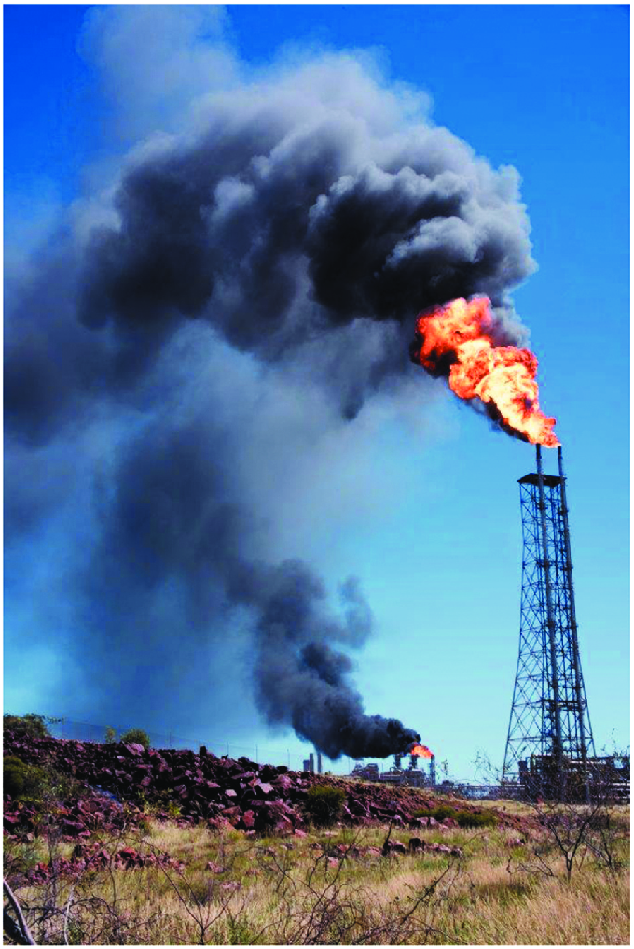

*Black smoke from the natural gas flaring towers. Image by R. Chapple 2017.*

## A Legacy Written in Stone…and Acid

This is not just about environmental degradation. It is about cultural genocide, as described by Traditional Custodians and the UN Human Rights Committee. The destruction of Murujuga is a continuation of colonial violence, this time executed not with guns, but with legal documents.

As law students, we are taught to consider the duty of care in our work. That duty must extend beyond clients and contracts to the communities and cultures affected by our actions. The “weight of the pen” is real. It can either protect or destroy.

**We must ask ourselves: What kind of legacy do we want to leave?**

Now, more than ever, it is time for law firms to consider their actions. As Woodside have managed to secure a 50-year extension, despite a record number of appeals lodged against the decision. Is money worth more than history, culture, and climate? No amount of money towards carbon offsets will bring back the heritage lost through pollution.

As law students, we're taught that not only is it important to uphold the rule of law, but also to consider the moral responsibility to do the right thing. When the infrastructure in place to protect the concerns of people and communities fails to do so, what legacy are they leaving behind? Is this the future that awaits us in our legal careers?

The weight of the pen is heavy, and it is our responsibility to ensure that it is used to protect, not destroy. The legacy we leave behind will be judged by our actions today. Let us choose to stand on the right side of history.

If you’re interested in the Australian Rock Art and the work of Professor Smith to preserve it for future generations, watch this video from the Australian Institute which was released after the writing of this Post. <https://australiainstitute.org.au/post/video-report-the-fight-to-save-murujuga/>

**Notes:**

Special Thanks to Professor Benjamin Smith, a leading authority on archaeology in the Burrup area, who gave up his valuable time to provide valuable insight into the issue.

**References**

Smith, Benjamin & Black, J. & Hoerlé, Stéphane & Ferland, Marie & Diffey, Simon & Neumann, Jolam & Geisler-Wierwille, Thorsten. (2022). The Impact of Industrial Pollution on the Rock Art of Murujuga, Western Australia. Rock Art Research. 39. 3-14. Available at: <https://www.researchgate.net/publication/355393113_The_Impact_of_Industrial_Pollution_on_the_Rock_Art_of_Murujuga_Western_Australia>

Australian Conservation Foundation (2022), *What is Woodside’s Controversial Scarborough gas project?* Available at <https://www.acf.org.au/what-is-scarborough-project> (accessed: 27 April 2025).

NOPSEMA (2025), *Project – Scarborough Project.* Available at <https://info.nopsema.gov.au/offshore_projects/41/show_public> (accessed: 27 April 2025).

Offshore Energy (2018), *Woodside takes over Scarborough from Exxon. FID in 2020.* Available at <https://www.offshore-energy.biz/woodside-takes-over-scarborough-from-exxon-fid-in-2020/> (accessed: 27 April 2025).

S&P Global (2023) *Scarborough: A refresher for Australia’s major gas development still on track for 2026.* Available at <https://www.spglobal.com/commodity-insights/en/research-analytics/scarborough-refresher-for-australias-major-gas-development> (accessed: 27 April 2025).

Woodside Energy (2025) *Scarborough Energy Project*. Available at <https://www.woodside.com/what-we-do/growth-projects/Scarborough-Energy-Project> (accessed: 27 April 2025).

Woodside Energy (2024) *The Scarborough Energy Project.* Available at <https://www.woodside.com/docs/default-source/our-business---documents-and-files/scarborough/scarborough-energy-project-fact-sheet---november-203.pdf?sfvrsn=24fc8d2c_7#:~:text=The%20development%20of%20the%20Scarborough,enough%20to%20power%20more%20than> (accessed: 27 April 2025).

Woodside Petroleum Ltd (2021), *Scarborough and Pluto Train 2 Developments Approved.* Available at <https://www.woodside.com/docs/default-source/asx-announcements/2021-asx/060.-scarborough-and-pluto-train-2-developments-approved.pdf> (accessed: 27 April 2025).

Measuring the impact of emissions on the Murujuga rock art Available at: <https://cosmosmagazine.com/history/makah-rock-art/>

Murujuga: industrial and cultural connections Available at: <https://researchimpact.uwa.edu.au/research-impact-stories/murujuga-industrial-and-cultural-connections/>

Cultural Heritage and the Murujuga Petroglyphs Available at: <https://www.prindleinstitute.org/2019/07/cultural-heritage-and-the-murujuga-petroglyphs/>

Yara Shades of Green Assessment Update 2022 Available at: <https://www.yara.com/siteassets/investors/057-reports-and-presentations/other/2021/yara-cicero-shades-of-green-report-20212.pdf>

Murujuga Aboriginal Corporation (no date) About Murujuga, Murujuga Aboriginal Corporation (MAC). Available at: <https://murujuga.org.au/about/about-murujuga/> (Accessed 20 April 2025)

Murujuga Aboriginal Corporation (2023) Statement by Murujuga Aboriginal Corporation regarding Woodside Energy - Murujuga Aboriginal Corporation (MAC), Murujuga Aboriginal Corporation (MAC). Available at: <https://murujuga.org.au/statement-by-murujuga-aboriginal-corporation-regarding-woodside-energy/> (Accessed 21 April 2025)

Royce Kurmelovs | Indigenous elders in WA say ‘gag clause’ denies them a say in industrial developments on their land | Western Australia | The Guardian Available a: <https://www.theguardian.com/australia-news/2022/mar/24/indigenous-elders-in-wa-say-gag-clause-denies-them-a-say-in-industrial-developments-on-their-land>

<https://www.legislation.wa.gov.au/legislation/prod/filestore.nsf/FileURL/mrdoc_47480.pdf/$FILE/Legal%20Profession%20Uniform%20Law%20Application%20Act%202022%20-%20%5B00-d0-00%5D.pdf?OpenElement>

<https://www.parliament.wa.gov.au/publications/tabledpapers.nsf/displaypaper/4013653cf2452bb31bf84d5f482585280004a618/$file/tp-3653.pdf>

<https://www.wa.gov.au/system/files/2019-06/Burrup%20and%20Maitland%20Industrial%20Estates%20Agreement.pdf>

ESDNEWS (2024) Conservation group drops Scarborough legal challenge. Available at: <https://esdnews.com.au/conservation-group-drops-scarborough-legal-challenge/>

LNG journal (2028) Australian energy industry unsettled by delay in Pluto LNG expansion as environmentalists play a different card. Available at: <https://lngjournal.com/index.php/latest-news-mainmenu-47/item/109441-australian-energy-industry-unsettled-by-delay-in-pluto-lng-expansion-as-environmentalists-play-a-different-card>

Adam Morton Nov 2024, The Guardian, Fifty-year extension for one of Australia’s biggest CO2 emitters likely after WA ditches emissions-reduction rules. Available at: <https://www.theguardian.com/australia-news/2024/nov/11/fifty-year-extension-for-one-of-australias-biggest-co2-emitters-likely-after-wa-ditches-emissions-reduction-rules>