Equity, Diversity and Inclusion Strategic Plan

Our vision and commitment
2026 - 2031

§
Contents
1. Introduction 5
1.1 Our context 6
1.2 Our legal duties 7
1.3 Why EDI matters at the OU 8
1.4 PVC-EDI Office: who we are and how we work 9
1.5 EDI governance 10
2. Our EDI vision and principles 11
3. Our priority areas 12
3.1 Disability, Neurodiversity and Accessibility 13
Our objectives for 2026 - 31 13
3.2 LGBTQIA+ 15
Our objectives for 2026 - 31 15
3.3 Race 17
Our objectives for 2026 - 31 17
3.4 Gender 19
Our objectives for 2026 - 31 19
4. Good EDI practice 21
4.1 Our commitment to sharing good practice and collaboration 21
4.2 Good EDI practice in the Nations 21
The Open University in Ireland 22
The Open University in Wales 23
The Open University in Scotland 24
4.3 Overarching activities and practice 25
5. Our success measures 28
5.1 Staff KPIs 29
5.2 Student KPIs 30

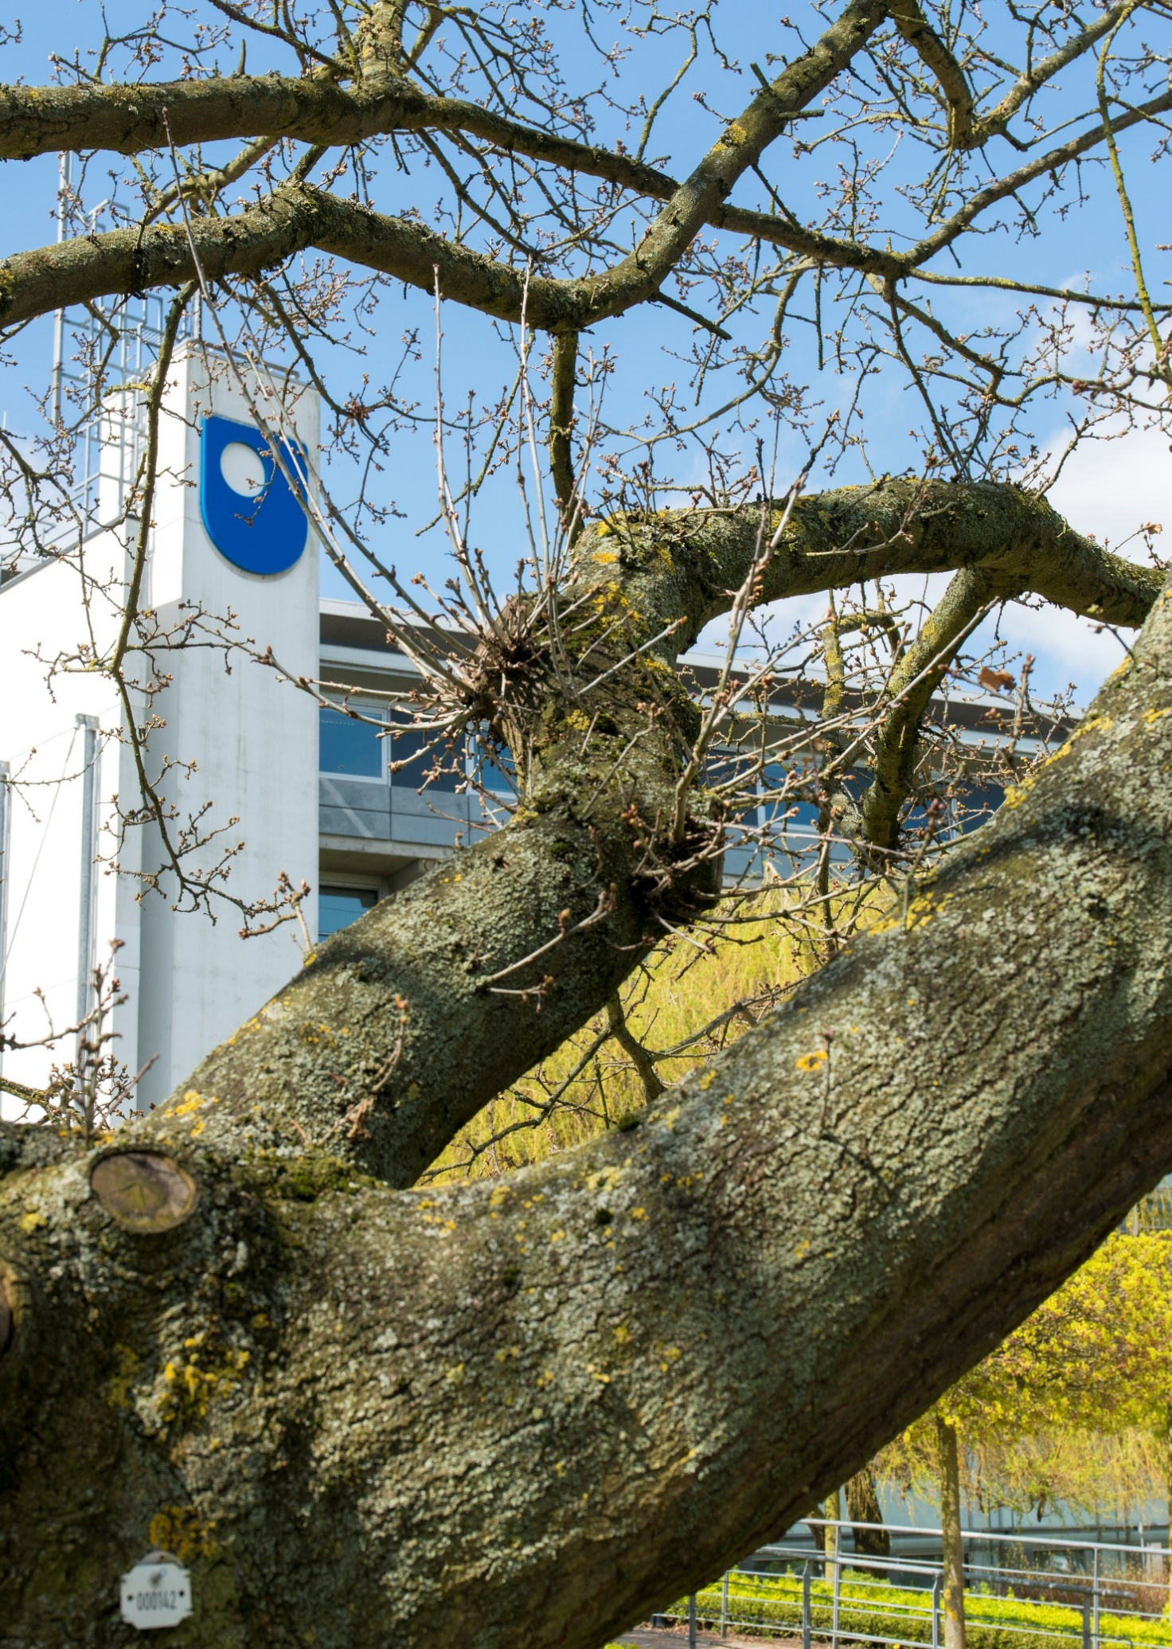

1. Introduction

The Equity, Diversity and Inclusion (EDI) Strategic Plan replaces the Open University’s 2022 Institutional Equality, Diversity and Inclusion Plan and Equality Scheme for England, Wales, Scotland and Northern Ireland, bringing our EDI “why” and “how” into a single document. The Plan sets out how The Open University (OU) will embed equity, diversity and inclusion across our culture, systems, policies, practices and behaviours. It signals a strategic shift from a focus on equality, understood as providing the same support to everyone, to a focus on equity, understood as recognising different needs and responding through targeted, contextualised action to advance inclusion.
Professor Allán Laville, Pro-Vice-Chancellor Equity, Diversity & Inclusion (PVC-EDI)
EDI is everyone’s responsibility. Lived experience must inform decision-making, but responsibility for change does not sit with minoritised colleagues and students. We all have a role to play in creating an inclusive university where people feel they belong, are treated with dignity and respect, and can thrive.
The Equality Scheme for Northern Ireland complements this Strategic Plan by outlining the statutory processes and commitments that apply specifically within the Northern Ireland context.

For the purposes of this strategic plan and our wider work, we incorporate accessibility under the heading of Inclusion and use the widely recognised term EDI, with E standing for equity rather than equality. This reflects our intentional strategic focus on equity.

Professor Allán Laville
PVC-EDI

1.1 Our context

The OU was created to widen access to higher education and promote social justice. We are a UK-wide university with a global reach, the biggest university in the UK, a leader in open education, and the largest UK provider of higher education for disabled people.
Our mission is to be open to people, places, methods and ideas. Our EDI work helps us remove barriers to learning, employment and participation and supports our wider commitment to social justice.
Our vision is to offer life-changing learning that meets people’s needs and enriches society. Our core values are to be inclusive, innovative and responsive.
Our student and staff communities include people from a wide range of backgrounds, lived experiences and circumstances meaning EDI work is central to what we do.
We want everyone who works or studies with us to:
- feel that they belong at the OU
- be treated with dignity, fairness and respect
- be able to flourish and reach their potential, free from unlawful discrimination, harassment and victimisation

1.2 Our legal duties
As a public body operating across the four nations of the UK, the OU has important statutory duties relating to equality and human rights.
These include the Public Sector Equality Duty under the Equality Act 2010 across England, Scotland and Wales, and Section 75 duties under the Northern Ireland Act 1998.
The Access and Participation Plan (APP) is also a legal requirement and condition of registration with the Office for Students (OfS). It supports students from minoritised backgrounds in accessing higher education and achieving equitable outcomes.
This EDI Strategic Plan shows how we will meet these legal duties by embedding EDI best practice and committing to the priorities of the Access and Participation Plan (APP) to inform the way we teach, support students, employ people, partner with others and manage our organisation.

1.3 Why EDI matters at the OU
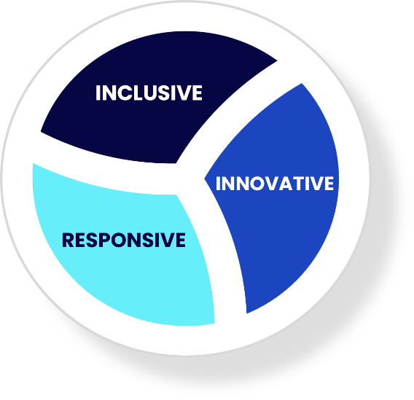
EDI is central to the OU’s mission to make higher education open and accessible to people who might otherwise be unable to access it. Openness must be matched by equity, so that everyone, regardless of background or circumstances, can thrive.
EDI is reflected in our values of being inclusive, innovative and responsive. We want everyone who works or studies with us to feel they belong, be treated with dignity and respect, and be able to reach their potential free from discrimination, harassment and victimisation.
EDI is everyone’s responsibility. Real cultural change will only happen if EDI is embedded as core work across the whole institution, not delegated to a single team or particular groups.
The EDI Strategic Plan supports the 2027–2032 University Strategy, particularly themes 1 and 2: Creating societal impact and Supporting student success, and the People and Culture enabler. Our actions will continue to evolve and remain aligned with these priorities.

1.4 PVC-EDI Office: who we are and how we work
The PVC-EDI Office is the University’s hub for equity, diversity and inclusion expertise. We turn OU-wide commitments into practical approaches that work across different parts of the institution. The Office is made up of two distinct but connected teams: the EDI Team and the APS (Access, Participation and Success) Team.
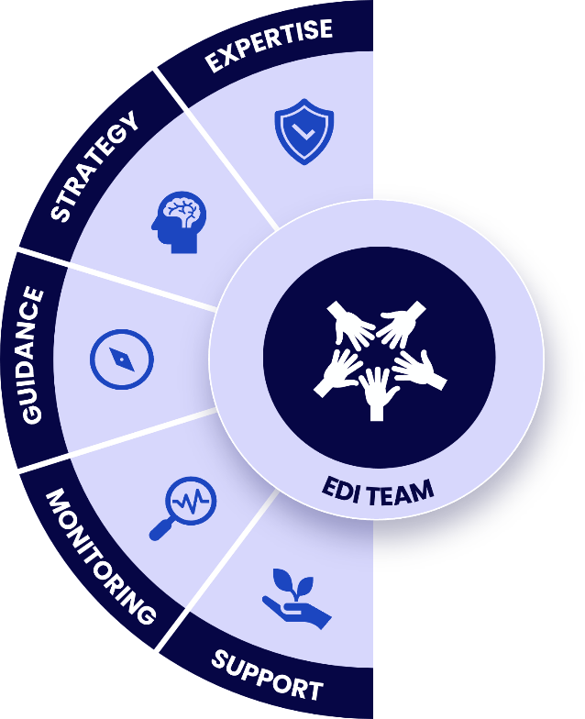
We do not “own” EDI. Instead, we enable the wider University to deliver EDI through their roles, decisions and local plans.

The EDI team does this by providing specialist expertise, strategic direction, practical guidance, monitoring and support.
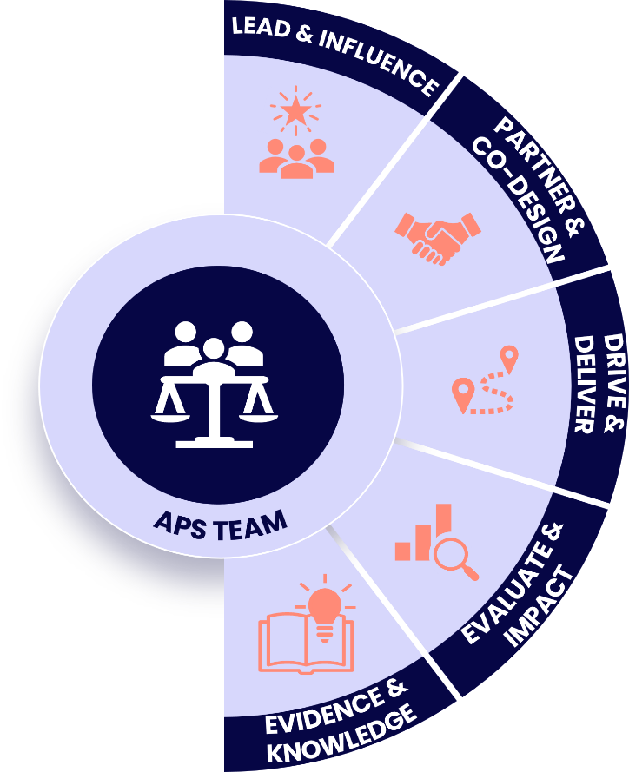

The APS Team leads the delivery of the Access and Participation Plan (APP) through an evidence-informed work focused on reducing inequity for APP-prioritised students.

The Office works in partnership with faculties, units, staff networks, Trade Unions, the Students Association and other representative groups supporting local EDI actions, helping faculties and units to integrate EDI and APP priorities into policies, processes and projects and learning from and recognizing the value of lived experience and expertise across the OU.
The Office does not lead on specific areas, such as individual staff or student cases, and operational student support and related administrative processes. These sit with the relevant people management or student support teams.

1.5 EDI governance
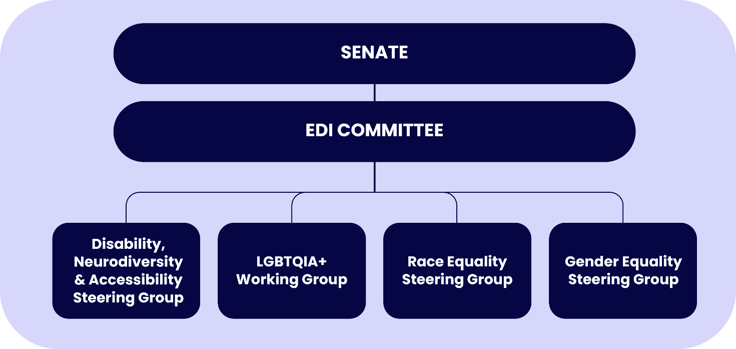
The image below illustrates the University’s current EDI governance structure. This structure is under review, in light of the wider institutional governance review and the expansion of the PVC-EDI Office.

2. Our EDI vision and principles
Our vision for EDI at the OU is to have a fair and inclusive organisational culture and to be sector-leading in equitable and inclusive policy and practice. We want students’ journeys to be equitable, a diverse staff community at all levels, a strong sense of belonging, alignment between what we say and do, and clear accountability.
To achieve this, we will ensure that EDI is embedded in our strategies, policies, processes and everyday behaviours. We will be guided by four principles:
1. Evidence-led
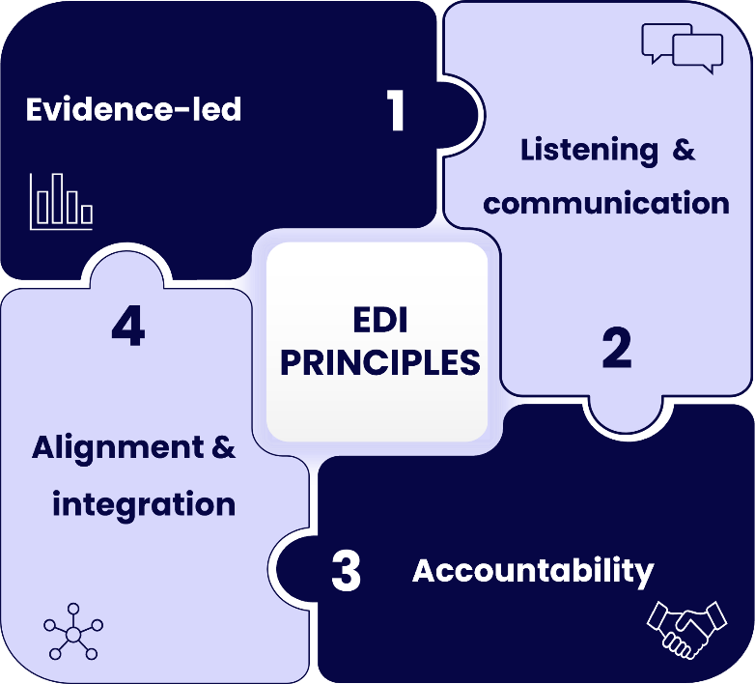
Base decisions on reliable data, research and lived experience; monitor and evaluate progress through clear measures and KPIs.
2. Listening and communication
Keep communication open in all directions and value the lived experience of diverse groups.

3. Accountability
Set clear, realistic objectives with identified owners, governance and regular reporting.

4. Alignment and integration
Integrate and embed EDI objectives into the University Strategy, the People Strategy, business planning, risk management, and performance measures across the University.

3. Our priority areas
The Plan identifies four priority areas for focused action between 2026 and 2031. They are:
- Disability, Neurodiversity and Accessibility
- LGBTQIA+
- Race
- Gender
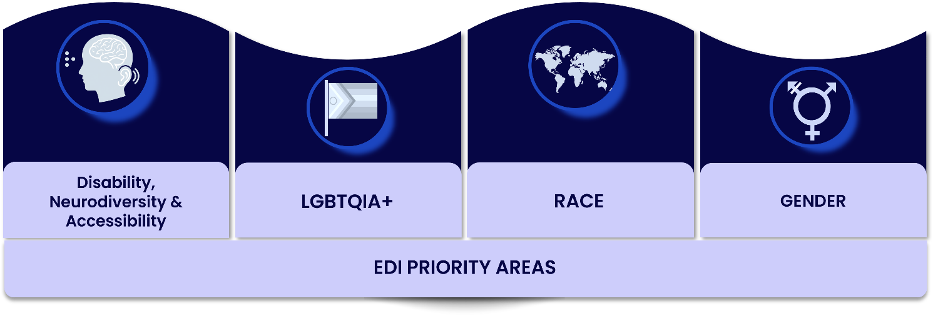
These priority areas reflect persistent inequities in staff and student experience and outcomes, and existing frameworks such as Athena Swan, the Race Equality Charter, the APP and staff networks. These priorities do not limit our broader commitment to tackling all forms of inequity.


3.1 Disability, Neurodiversity and Accessibility
The OU is the largest UK provider of higher education for disabled people, with over 39,000 students who have shared a disability studying with us.
We also employ disabled and neurodivergent colleagues across all parts of the institution.
Accessibility lies at the heart of our OU mission and values and is the key to enabling success for our disabled and neurodivergent staff and students.
In this Strategic Plan, we use the terms ‘disability, neurodiversity and accessibility’ to encompass disabled and neurodivergent staff and students, as well as individuals with diverse access needs. The actions set out in the Plan will be underpinned by an intersectional approach.

Our objectives for 2026 - 31
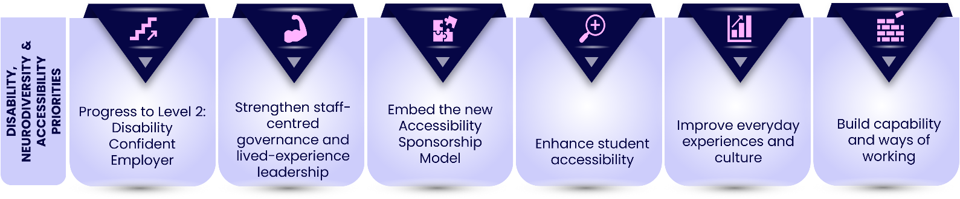
Over the lifetime of this Strategic Plan, we will:
1. Progress to Disability Confident Level 2, using the findings of our 2023/24 self-assessment which evaluated our readiness for progression, to address gaps and progress from Level 1 to Level 2 (Disability Confident Employer).
2. Strengthen staff-centred governance and lived-experience leadership. Embed the Disability, Neurodiversity and Accessibility (DNA) Steering Group and its working groups as the focal points for strategic oversight, clear direction and listening exercises with disabled and neurodivergent staff and students to ensure that our priorities reflect lived experience.
3. Embed our new Accessibility Sponsorship Model. Enable more focused accessibility work with three senior sponsors covering student, staff and digital accessibility. The model will reduce overlap, prioritise resources and align accessibility work with wider strategic priorities.
4. Enhance student accessibility. Review and enhance how student accessibility is supported and resourced, ensuring approaches are sustainable and informed by student need and institutional priorities.
5. Improve everyday experiences and culture. Clarify and streamline reasonable adjustment processes for staff and students. Enhance data on disability and neurodiversity and review the impact of our accessibility initiatives.
6. Build capability and ways of working. Provide guidance and development on accessibility and disability and neurodiversity inclusion. Support and resource staff networks.

This work responds to persistent barriers in digital accessibility, learning materials, systems, recruitment, progression, reasonable adjustments, mental health and wellbeing, and inconsistent practice across the institution.


3.2 LGBTQIA+
LGBTQIA+ inclusion is essential to creating a safe, equitable and welcoming environment for everyone in our community. While we celebrate significant progress through networks, events and visible commitments, we know that data on LGBTQIA+ staff and student experience is limited, especially in distance-learning contexts.
At the OU, we use the term LGBTQIA+ to reflect the full diversity of sexual orientation, gender identity and sex characteristics within its community. LGBTQIA+ is an inclusive and widely recognised term that acknowledges and supports the visibility and belonging of all individuals who face discrimination due to their gender identity or sexuality.

Our objectives for 2026 - 31
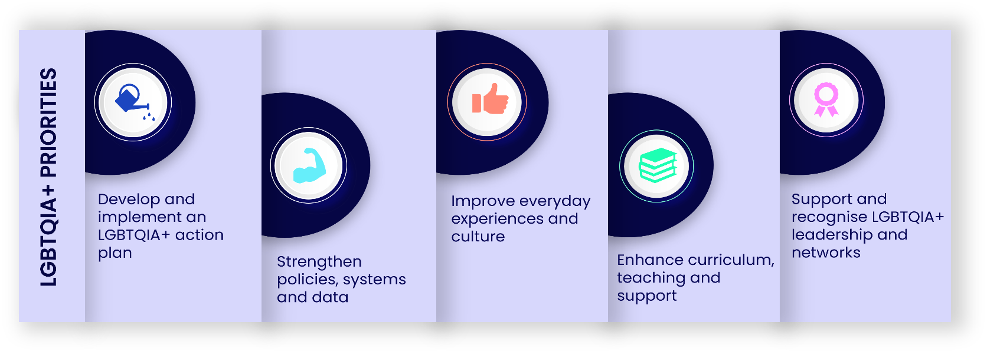
Over the lifetime of this Strategic Plan, we will:
1. Develop and implement an LGBTQIA+ Action Plan informed by the findings of the upcoming LGBTQIA+ Lived Experiences Report and the student research project to create a SMART Action Plan. Work in partnership with Athena Swan team so gender inclusion work reflects LGTBTQIA+ experiences, including trans, non-binary or gender diverse inclusion.
2. Strengthen policies, systems and data. Review policies, systems and data t to ensure they are inclusive of diverse sexual orientations and gender identities, including trans, non-binary or gender diverse people. Improve how we collect and use data on LGBTQIA+ identities, so we can better understand outcomes and target interventions.
3. Improve everyday experiences and culture. Equip managers, tutors and leaders with guidance and development on LGBTQIA+ inclusion, including trans, non-binary or gender diverse inclusive practice. Ensure reporting routes are visible, trusted and responsive to LGBTQIA+ issues.
4. Enhance curriculum, teaching and support. Work in partnership to ensure that curriculum, teaching materials and student support reflect and affirm LGBTQIA+ identities. Improve supervision, pastoral support and community-building for LGBTQIA+ students.
5. Support and recognise LGBTQIA+ leadership and networks including the Proud and Trans staff networks.

This work responds to concerns about safety, disclosure, belonging, bullying and harassment, policy and systems limitations, and reliance on small numbers of committed individuals rather than shared institutional responsibility.


3.3 Race
Our race inclusion work is guided by our Race Equality Charter (REC) Bronze Award received in February 2026. We use the term “race equality” where it aligns with the REC, wider institutional and sector language. However, our work is equity-focused, ensuring that actions are designed, implemented and evaluated in response to identified barriers, needs and inequities.

Our objectives for 2026 - 31
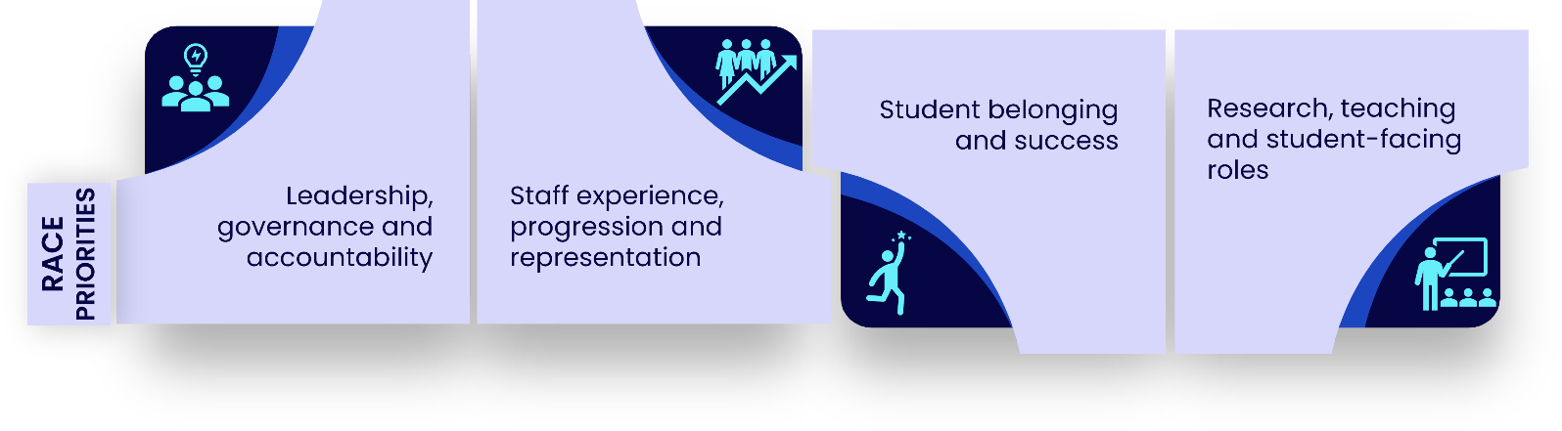
The REC Action Plan identified seven priority areas and for the purposes of this Strategic Plan we group our objectives under four themes:
1. Leadership, governance and accountability. Increase racial diversity in governance and senior decision-making structures and equip leaders with the skills and confidence to make inclusive decisions and hold themselves accountable for race equality outcomes.
2. Staff experience, progression and representation. Improve recruitment, retention, progression and cultural climate for racially minoritised (RM) staff, particularly Black staff, and address underrepresentation at senior grades. Strengthen reporting routes, support and protections so that RM staff can safely speak up about racism and see action taken.
3. Student belonging and success. Work towards eliminating ethnicity awarding gaps, especially the Black-white awarding gap and improve belonging and cultural climate.
4. Research, teaching and student-facing roles. Enhance support for racially minoritised research-only staff and postgraduate research students and increase the racial diversity and cultural competence of Associate Lecturers/Regional Academics and other student-facing staff.

In addition to the REC priority areas, we’ll work on Decolonisation, forming a dedicated working group to examine and address prioritised knowledge and perspectives within teaching, research and leadership; how institutional policies and processes may disadvantage particular student groups; whose voices are represented in governance and strategic decision-making; and how historical and contemporary inequities can shape experiences of belonging, success and progression.

The REC evidence base shows persistent inequities in senior representation, recruitment, confidence in responses to racism, student module outcomes and belonging. The Plan aims to move beyond documentation towards tangible change in lived experience.
Detailed actions for race inclusion are set out in the REC Action Plan (2026-31).


3.4 Gender
Gender inclusion has long been a focus at the OU through the Athena Swan Charter. The OU holds an institutional Bronze award and several School and unit awards which shows a commitment to promoting fairness, inclusion and opportunity for women, men and gender-diverse colleagues and students.
We use the term “gender equality” to align with the Athena Swan Charter and wider institutional and sector language. However, our work is equity-focused, ensuring that actions are designed, implemented and evaluated in response to identified barriers, needs and inequities.
The Plan uses Athena Swan as a framework for sustained change while recognising that gender inclusion must go beyond awards and compliance.

Our objectives for 2026 - 31
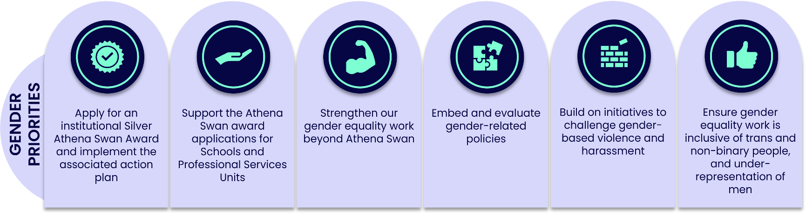
Over the lifetime of this Strategic Plan, we will:
- Apply for an institutional Silver Athena Swan award, and, subject to approval, implement the associated action plan.
- Support the Athena Swan award applications for Digital Services and Learner Discovery Services (LDS), and for the Schools of Languages and Linguistics (LAL), Socials Sciences and Global Studies (SSGS), and Law School.
- Strengthen our gender equality work beyond Athena Swan, including action on gender pay gaps, progression and representation at senior levels.
- Embed and evaluate our Menopause Policy and other gender-related policies, ensuring line managers and leaders actively support staff through key life stages.
- Build on initiatives to challenge gender-based violence and harassment and promote safe, inclusive cultures.
- Ensure gender equality work is explicitly inclusive of trans, non-binary or gender diverse people, and responsive to under-representation of men in particular disciplines or roles.

This work responds to issues related to workplace culture, intersections between gender, race, disability, trans, non-binary or gender diverse identities, caring responsibilities, reproductive health, gender-based violence and harassment.
Detailed actions for gender inclusion are set out in the draft institutional Silver Athena Swan Action Plan. This is a live document that is reviewed and refined throughout the five-year cycle, informed by staff experiences and emerging evidence.

4. Good EDI practice

4.1 Our commitment to sharing good practice and collaboration
The University is committed to sharing and scaling good EDI practice so that equity, diversity and inclusion are embedded across the OU, rather than delivered as isolated initiatives.
The Plan will be delivered through a coherent University-wide approach that promotes collaboration, continuous improvement and evidence-informed practice. This will help reduce duplication, support innovation and accountability, and enable colleagues to learn from effective approaches that improve outcomes for staff and students

4.2 Good EDI practice in the Nations

The Nations play a key role in delivering the EDI Strategic Plan by translating University-wide priorities into locally relevant action. Working within central governance, they respond to nation-specific legal, policy and community contexts, engage local stakeholders, and embed EDI principles into decision-making and delivery.
This flexible approach ensures the Plan remains aligned to the University’s overall strategic framework while being responsive to local demographics, challenges and opportunities.


The Open University in Ireland
The OU in Ireland works within the legal duties set out in the Northern Ireland Act 1998, including the requirement to promote equality of opportunity across protected characteristics and good relations between the two community traditions. These duties are reflected in the OU Equality Scheme, annual reporting to the Equality Commission for Northern Ireland (ECNI), and Fair Employment data on the composition of our workforce in Northern Ireland.
Through our Outcome Agreement with the Department for the Economy, we are committed to widening access, addressing regional imbalance and reducing barriers to education. This includes partnerships with organisations such as AWARE NI, The King’s Trust and Libraries NI, as well as tailored support for scholarship students, including Black Open Futures, Carers, Inclusive Futures and Sanctuary scholars.
Over the coming years, the OU in Ireland will continue to engage with key developments, including the Northern Ireland Disability Strategy 2025–2035, race equality legislation reform, a new Widening Participation Strategy, and work with LGBTQIA+ grassroots organisations.



The Open University in Wales
The OU in Wales works within the UK-wide Equality Act 2010 and the specific Statutory Duties (the 2011 Regulations) that apply in Wales, including requirements to publish equality objectives, undertake impact assessments and engage with citizens. As an institution funded by Medr, we support its obligations as a listed public educational body in Wales.
Our approach to inclusion brings together EDI, sustainability and wellbeing under the banner of Social Responsibility. This reflects the Well-being of Future Generations Act 2015, which encourages a collective endeavour to improve economic, social, environmental and cultural wellbeing of Wales, and aligns with the wider OU mission to be inclusive, ethical and socially responsible.
We also support the Welsh Government’s ambition to make Wales an anti-racist nation through our Race Equality Charter work and dedicated social responsibility activity. Socio-economic inequity remains a key focus, particularly for students in IMDQ1 areas, who are prioritised within the Access and Participation Plan (APP).




The Open University in Scotland
The OU in Scotland works within the Scottish Funding Council (SFC) and its entire Outcome Framework and Assurance Model (OFAM), where EDI is embedded across governance, planning, delivery and monitoring outcomes.
We also meet EDI legislation through Public Sector Equality Duty (PSED) reporting and delivery of National Equality Outcomes (NEOs). These include improving success, retention and satisfaction across protected characteristics; reducing gender imbalances; improving disabled students’ experience; supporting mental health; tackling harassment; and ensuring representative staff, Boards and Courts.
Our approach to EDI is strategic, evidence-based, integrated and focused on improvement, using data, Equality Impact Assessments and clear actions to improve outcomes for staff and students.
We also deliver statutory responsibilities relating to corporate parenting and British Sign Language (BSL). Through our Corporate Parenting Plan, we have increased the number of students declaring care experience and continue to strengthen student voice, staff awareness and partnerships with other corporate parents (e.g., Hub for Success, CEECEF). We also publish a BSL action plan.

The OU in Scotland works in partnership with a range of organisations to support work on racism, gender balance, gender-based violence (GBV), estranged students and forced migration. This includes participation in Scotland’s first higher education survey on GBV led by the charity EmilyTest.

4.3 Overarching activities and practice
Delivery of the Plan will be supported by cross-University activities such as:
- Equality Impact Assessments (EIAs) help ensure that OU policies, projects and services are fair, inclusive and do not disadvantage particular groups. They support early identification of risks, mitigation planning, and compliance with the Public Sector Equality Duty and Section 75 of the Northern Ireland Act 1998.
In June 2026, an updated EIA template (2026) and EIA screening tool (EIA-ST) were launched to streamline and simplify the process for authors. Accessing EIAs has also been made easier for staff, as they can now be accessed directly via the Intranet A–Z.
- Staff networks provide safe, supportive spaces for colleagues to share experiences, strengthen belonging, and contribute lived experience to University decision-making. They help shape inclusive policies and practices, increase visibility of diverse groups, and support cultural change across the OU.
The OU supports its nine staff networks with dedicated budget, FTE release time for chairs/co-chairs, and ongoing guidance from the EDI Team, helping networks contribute effectively to institutional EDI priorities.
The OU’s staff networks are: Black and Minority Ethnic Network, Carer Staff Network, Enabling Staff Network, International Communities Network, Proud Network, Neurodiversity Network, Trans Network, Women@OU Staff Network, and Menopause Moments.
- Student support, connection and community. OpenSU (Students Union) provides several ways in which students can access support, advocacy and advice as well as opportunities for students to form connections with each other and build student-led communities. This includes activities such as Welcome Week, Individual Representation Service, Community drop-ins, OU Students Connect, OU Pride, EDI newsletter, Black Asian and Minority Ethnic Students Group, Disabled Students Group, Allyship Hub, Menopause Support Hub, Neurodiversity Support Hub.
- Carers at the OU. The OU recognises that caring responsibilities are an important and often under-acknowledged part of colleagues’ and students’ lives, with impacts on wellbeing, career progression, engagement and equity.
We have strengthened support through the Dependants and Carers Leave Policy and Procedure, the institution-wide Carer Passport, related guidance on flexible support, manager guidance in the People Manager Toolkit, membership of Employers for Carers, and support for the Carer Staff Network, amongst other initiatives.
This work helps normalise conversations about caring, supports more consistent management practice, and provides a clearer framework for colleagues and students with caring responsibilities.
- The Access and Participation Plan (APP) focuses on removing barriers for Black students, students with mental health difficulties, and students from areas of socio-economic disadvantage. Together, these groups represent around 30% of OU students. Supported by an annual £2.5m commitment, the APP aims to address inequities within University culture, systems and practices and create lasting structural change.
- The Inclusive Curriculum Tool (ICT) supports authors and editors to review curriculum content, including assessment, to improve inclusion and accessibility. Mandated for all new curricula since March 2022, the ICT is now being developed into a digital platform with OU-developed AI tools to improve consistency, coverage and impact evaluation.
- Learning and Development. The OU is strengthening EDI learning through a range of programmes and resources that build confidence, awareness and inclusive practice across the University. Including:
- The Allyship Programme, launched in 2024, which helps colleagues understand how to use their privilege and power to support equity and inclusion. More than 300 colleagues have engaged with the learning so far and over 95 have completed the full programme.
- The EDI Learning Hub provides a central platform for colleagues to access resources on a wide range of EDI topics, including materials linked to REC and Athena Swan priorities.
- Replacing Equality Essentials with the new mandatory Equity and Inclusion Essentials course, providing a refreshed foundation in EDI concepts, legal duties and what good equity practice looks like in everyday work at the OU.
- Publishing the one-hour version of Union Black course on OpenLearn and MyLearningCentre (MLC), supporting staff and students to understand racism and take practical steps towards anti-racism.


5. Our success measures
The Key Performance Indicators (KPIs) below reflect the priority areas of the EDI Strategic Plan: Disability, Neurodiversity and Accessibility, LGBTQIA+, Race and Gender inclusion. They are evidence-informed and based on areas where data shows persistent inequities in staff and student experience, representation, recruitment, progression and outcomes.
Gender and race KPIs align with areas requiring improvement and are supported by the Race Equality Charter and Athena Swan action plans.

For disability, neurodiversity, accessibility and LGBTQIA+ inclusion, KPIs focus on colleague experience and will inform SMART action plans through the relevant governance groups. Sexual orientation and gender identity are measured separately to avoid masking differences in experience, particularly for trans colleagues.

Student KPIs are drawn from the approved Access and Participation Plan 2025–2029. Together, the staff and student KPIs provide an evidence-informed framework for annual monitoring across the life of the Strategic Plan.

5.1 Staff KPIs
By the end of the Strategic Plan period:
- The gap between female senior staff representation (defined as staff on PB or SS pay grades) and overall female staff representation will be reduced from 9 percentage points (2024/25) to within 4 percentage points (2030/31).
- The proportion of racially minoritised candidates at appointment stage will be consistent with proportion at application and shortlisting stages. In 2024/25 the gap from applicant to appointment for racially minoritised colleagues was 22 percentage points.
- The gap in positive responses to values-based engagement survey questions between colleagues who shared disability(ies) and those who do not will reduce from 9 percentage points (2024/25) to 3 percentage points or less (2030/31).
- The gap in positive responses to values-based engagement survey questions between transgender colleagues and the overall colleague population will be reduced from 8 percentage points (2024/25) to 3 percentage points or less.
- The gap in positive responses to values-based engagement survey questions between LGBQA colleagues and the overall colleague population will be reduced from 3 percentage points to 2 percentage points or less. It was 3ppt in 2024/25.

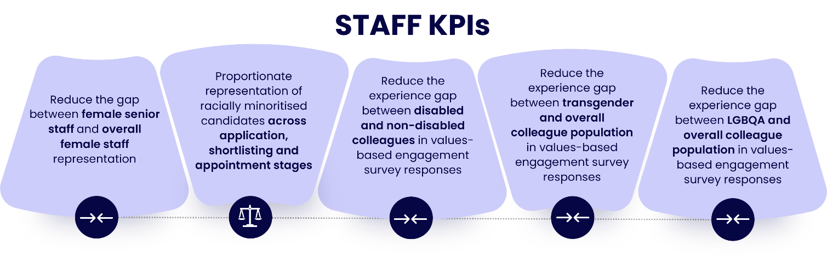

5.2 Student KPIs
By the end of 2029, we will:
- Increase in the number of Black students recruited, above that expected from population changes, from 1,131 (2023/24) to 1,256 (2028/29).
- Reduce the gap in module pass rates between students in IMDQ1 and IMDQ5, by increasing the pass rates for students in IMDQ1 from 58.0% (2022/23) to 62.8% (2028/29).
- Reduce the gap in module pass rates between students with and without mental health difficulties, by increasing the pass rates for students with mental health difficulties from 54.9% (2022/23) to 63.7% (2028/29).
- Reduce the gap in module pass rates between Black students and white students, by increasing the pass rates for Black students from 56.8% (2022/23) to 63.7% (2028/29).
- Reduce the gap in FHEQ level 4 and 5 module pass rates at grades 1 and 211 between Black students and white students, by increasing the pass rates for Black students from 36.9% (2022/23) to 50.3% (2028/29).
- Reduce the gap in Positive Progression rates between graduates with and without mental health difficulties by increasing the Positive Progression rates for graduates with mental health difficulties from 67.9% (2022/23) to 71.7% (2028/29).
