Equity, Diversity and Inclusion Strategic Plan

Our vision and commitment
2026 - 2031

§
Contents
1. Introduction 5
1.1 Our context 7
1.2 Why EDI matters at the OU 10
1.3 Our legal duties 12
1.4 PVC-EDI Office: who we are and how we work 14
1.5 EDI governance 17
2. Our EDI vision and principles 18
3. Our priority areas 20
3.1) Disability, Neurodiversity and Accessibility 23
Context and case for action 23
What we’ve achieved so far 24
What we’ve learned 25
Our objectives for 2026 - 31 27
3.2) LGBTQIA+ 29
Context and case for action 29
What we’ve achieved so far 30
What we’ve learned 31
Our objectives for 2026 - 31 32
3.3) Race 34
Context and case for action 34
What we’ve achieved so far 34
What we’ve learned 35
Our objectives for 2026 - 31 37
3.4) Gender 40
Context and case for action 40
What we’ve achieved so far 40
What we’ve learned 43
Our objectives for 2026 - 31 43
4. Good EDI practice 46
4.1 Our commitment to sharing good practice and collaboration 46
4.2 Good EDI practice in the Nations 47
The Open University in Ireland 47
The Open University in Wales 50
The Open University in Scotland 52
4.3 Overarching activities and practice 54
Equality Impact Assessments (EIAs) 54
Staff Networks 54
Student support, connection and community 55
Carers at the OU 56
The Access and Participation Plan (APP) 57
Learning and Development 58
5. Our success measures 59
5.1 Staff KPIs 61
5.2 Student KPIs 62

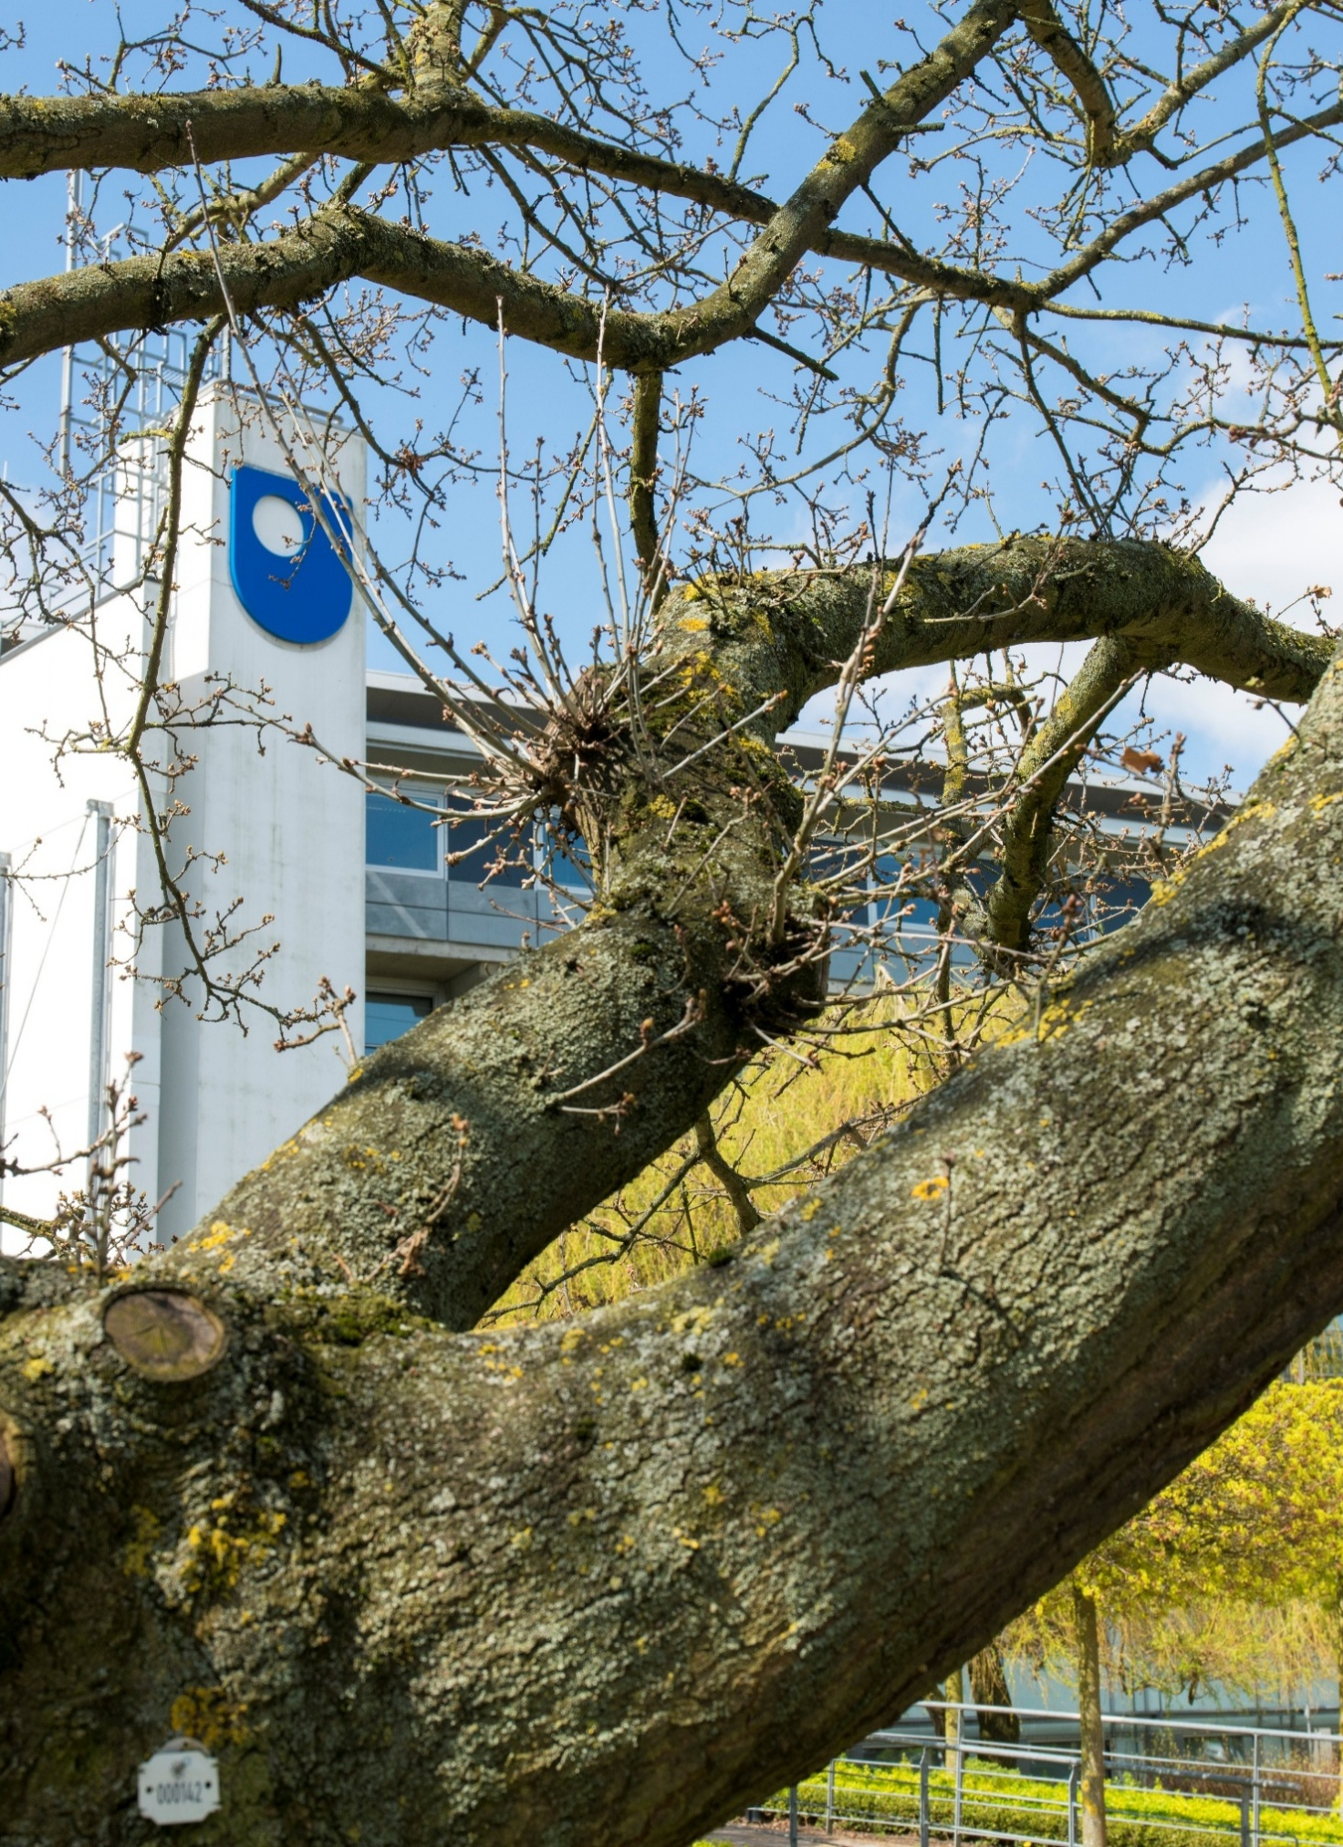

1. Introduction

This Equity, Diversity and Inclusion (EDI) Strategic Plan replaces the Open University’s 2022 Institutional Equality, Diversity and Inclusion Plan and Equality Scheme for England, Wales, Scotland, and Northern Ireland bringing our EDI “why” and “how” into a single document. It signals a strategic shift from a focus on equality, understood as providing the same support to everyone, to a focus on equity, understood as recognising different needs and responding through targeted, contextualised action to advance inclusion.
Professor Allán Laville, Pro-Vice-Chancellor Equity, Diversity & Inclusion (PVC-EDI)
The EDI Strategic Plan sets a clear direction for the whole University and provides a shared framework for every part of the OU to drive change and embed equity, diversity and inclusion in everything we do. Central to this approach is ensuring that lived experience informs decision-making in practice. This means creating meaningful opportunities for minoritised groups to contribute, influence and be heard with confidence that input is acted on meaningfully and in a timely way.
While lived experience is essential to understanding barriers and shaping meaningful change, responsibility for EDI does not sit with colleagues from minoritised communities. Creating an inclusive university is a shared responsibility. We all have a role to play as allies, through ongoing and active practice such as listening, learning, challenging exclusionary behaviours and practices, and taking action to foster a more inclusive culture.
The EDI Strategic Plan positions EDI principles as a lens through which we view our culture, environment, behaviours, policies and practices, making clear their importance for all OU staff, students and communities and contributing to the OU’s wider commitment to social justice.
The Equality Scheme for Northern Ireland complements this Strategic Plan by outlining the statutory processes and commitments that apply specifically within the Northern Ireland context.
We recognise that many faculties are now using the term Equality, Diversity, Inclusion and Accessibility (EDIA). However, for the purposes of this strategic plan and our wider work, we incorporate accessibility under the heading of Inclusion and use the widely recognised term EDI, with E standing for equity rather than equality. This reflects our intentional strategic focus on equity. Where we refer to equality in this document, it is because the term relates to specific legislation, duties or established frameworks, such as the Equality Act 2010, the Race Equality Charter, and the Equality Scheme in Northern Ireland amongst others.”


Professor Allán Laville
PVC-EDI


1.1 Our context

The Open University (OU) is a pioneer in distance learning and was created to widen access to higher education and promote social justice. Since its establishment in 1969, more than 2.5 million people worldwide have achieved their learning goals by studying with us. Today, we are the biggest university in the UK and one of the largest universities in Europe, with over 136,000 students.
Our mission is to be open to people, places, methods and ideas. This means we actively work to remove potential barriers to learning, employment, and participation by promoting educational opportunity and social justice through high-quality education to all who wish to realise their ambitions and fulfil their potential.
Our vision is to offer life-changing learning that meets people’s needs and enriches society. Our core values are to be inclusive, innovative and responsive.
We are:
- The UK’s only university dedicated to support distance learning, with a significant presence in all four nations of the UK.
- A UK-based university with a global reach, we have over 8,600 international students directly registered with the OU.
- A leader in open education, with over 3.5 million OpenLearn course completions by learners worldwide.

Our student communities include people from a wide range of backgrounds, lived experiences and circumstances. In 2024/25, our student profile included:
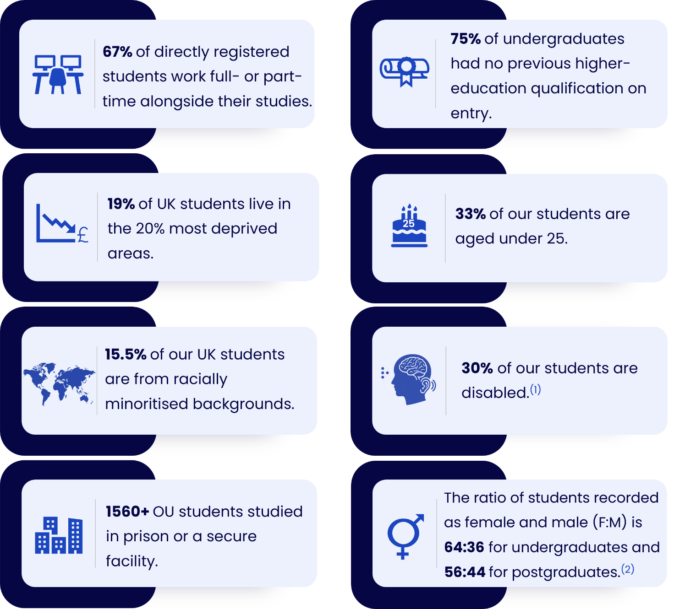
______
⁽¹⁾ We are the largest UK provider of higher education for disabled people, with over 39,000 students who have shared a disability studying with us (as of February 2026).
⁽²⁾ The data presented is ‘Sex’ data and is in line with the responsibility to share this data under the Equality Act (2010).
Our workforce profile also includes colleagues from a wide range of backgrounds and lived experiences. As of December 2025:

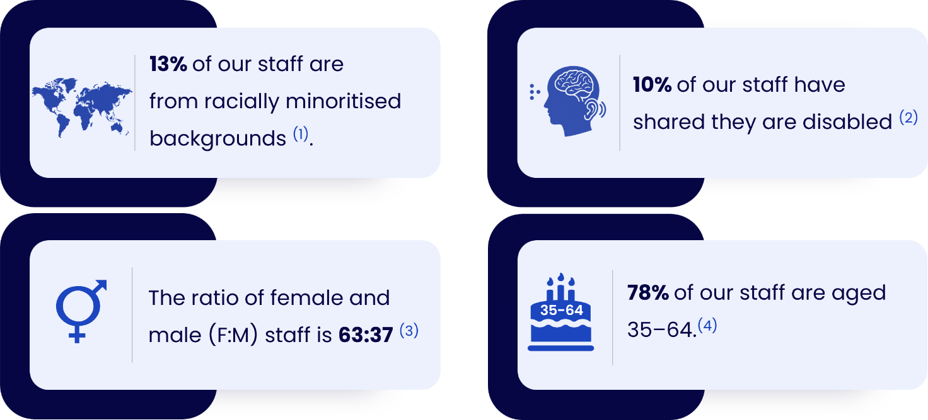
______
⁽¹⁾ Detailed ethnicity breakdown: 79% White / 4% preferred not to say / 5% unknown or no data (percentages may not add up to 100 due to rounding).
⁽²⁾ 86% of our staff are non-disabled and for 4%, the disability status is unknown or we have no data.
⁽³⁾ Our system allows staff to record non-binary genders, but disclosure rates are low.
⁽⁴⁾ Detailed age breakdown: 10% between 25–34 / 22% between 35-44 / 29% between 45-54 / 27% between 55-64 / 11% 65 and over (percentages may not add up to 100 due to rounding).

These figures help us understand the diversity that exists within our student and staff body and where further action is needed to improve representation, participation, experience and outcomes.

1.2 Why EDI matters at the OU
Our mission commits us to making higher education available to people who might otherwise be unable to access it. We know that discrimination and structural barriers waste talent and deny opportunity for individuals, for the University and for society. We also recognise that openness must be matched by equity, so that everyone, regardless of background or circumstances, can thrive.
EDI is reflected in our core values:
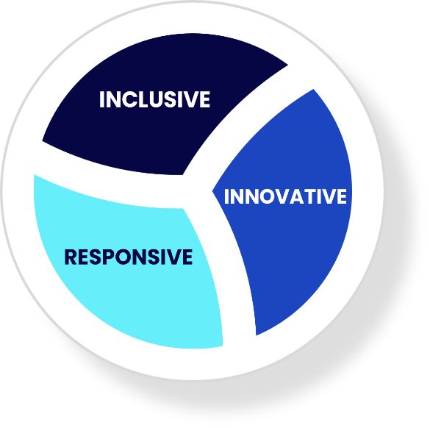
- Inclusive – We value diversity and foster a culture where everyone can belong, contribute, and succeed.
- Innovative – We recognise that new ideas flourish when different perspectives are welcomed and celebrated.
- Responsive – We listen actively, adapt thoughtfully and stay attuned, proactively shaping our response to changes in the EDI landscape and acting on the needs of all members of our diverse community.

We want everyone who works or studies with us to:
- feel that they belong at the OU
- be treated with dignity, fairness and respect
- be able to flourish and reach their potential, free from unlawful discrimination, harassment and victimisation
We work with a wide range of communities locally, nationally and internationally – students, schools and colleges, other universities, governments, employers and partner organisations. To honour these relationships and stay true to our mission, we must reflect, value and actively support the diversity of the communities we serve and hope to serve in future.
Historically, EDI work has often fallen on the shoulders of the most marginalised staff and students, with little recognition or reward. We are clear that:


EDI is everyone’s responsibility, and we are all accountable for it.
Working towards a more equitable, diverse and inclusive OU benefits everyone. Real cultural change can only happen if EDI is seen as core work for the whole institution, not as something delegated to a single team or to particular groups.
The EDI Strategic Plan supports Theme 1: Creating societal impact, Theme 2: Supporting student success, and the People and Culture enabler within the 2027-2032 University Strategy. We will ensure that the actions within the Plan evolve, adapt and remain aligned with these strategic priorities, supporting their delivery over time.

1.3 Our legal duties
As a public body operating across the four nations of the UK, the OU has important statutory duties relating to equality and human rights.
Under the Public Sector Equality Duty (PSED) in Section 149 of the Equality Act 2010, across England, Scotland and Wales, we must have due regard to:

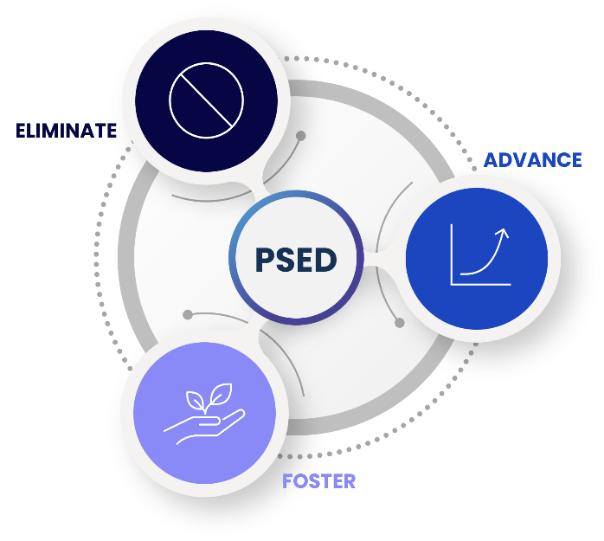
- Eliminate discrimination, harassment, victimisation and any other conduct prohibited by the Act.
- Advance equality of opportunity between people who share a protected characteristic and those who do not.
- Foster good relations between people who share a protected characteristic and those who do not.

The nine protected characteristics identified in the Equality Act 2010 are age, disability, gender reassignment, marriage and civil partnership, pregnancy and maternity, race, religion or belief, sex, sexual orientation.
People with caring responsibilities can also experience discrimination because of their association with someone who has a protected characteristic, and this is also unlawful.
In Northern Ireland, we must also meet the requirements of Section 75 of the Northern Ireland Act 1998, which asks us to promote equality of opportunity between:
- persons of different religious belief, political opinion, racial group, age, marital status or sexual orientation
- men and women generally
- persons with a disability and persons without
- persons with dependants and persons without
Additionally, we must promote good relations between persons of different religious belief, political opinion or racial group.

The Access and Participation Plan (APP) is a legal requirement and a condition of registration with the England regulator, the Office for Students (OfS). As the OU benefits from a Higher Fee Income, the OfS requires the University to make a proportional financial commitment to support students from minoritised backgrounds in accessing higher education and achieving equitable outcomes.

Although the OfS is the regulatory body for higher education providers in England, as a four-nation institution, broader priorities for Access, Participation and Success (APS) are managed by teams in each of the nations.
This institutional commitment is set out in the University’s Access and Participation Plan (APP).

This EDI Strategic Plan shows how we will meet these legal duties by embedding EDI best practice and committing to the priorities of the Access and Participation Plan (APP) to inform the way we teach, support students, employ people, partner with others and manage our organisation.

1.4 PVC-EDI Office: who we are and how we work
The PVC-EDI Office is the University’s hub for equity, diversity and inclusion expertise. We turn OU-wide commitments into practical approaches that work across different parts of the institution. The Office is made up of two distinct but connected teams: the EDI Team and the APS (Access, Participation and Success) Team.
We do not “own” EDI. Instead, we enable the wider University to deliver EDI through their roles, decisions and local plans.
The EDI team does this by providing specialist expertise, strategic direction, practical guidance, monitoring and support. We:
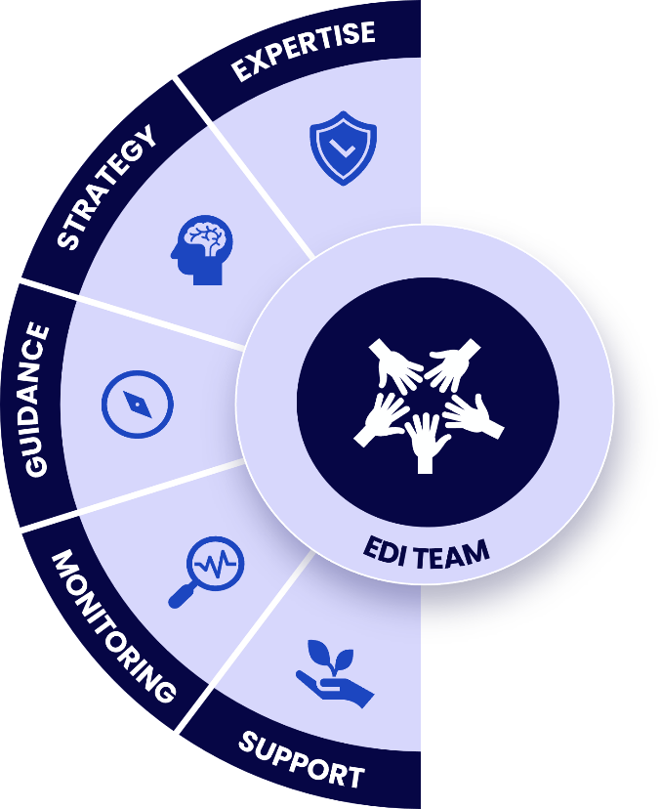
- Help the institution and colleagues meet and embed their EDI responsibilities by providing specialist advice on legal duties and EDI best practice.
- Enable faculties, units and teams to turn EDI commitments into practical local action through strategic projects and action plans aligned with institutional strategy.
- Create tools, frameworks, guidance and learning that enable colleagues to embed EDI in their work and build an inclusive culture.
- Monitor and report on progress to strengthen accountability and inform improvement.
- Support and challenge the University to keep equity, diversity and inclusion central to decision-making.

The APS Team leads the delivery of the Access and Participation Plan (APP) through an evidence-informed approach focused on reducing inequity for APP-prioritised students.
Working collaboratively across the OU, we support strategic, co-designed activity that drives forward change. We recognise that reducing inequity requires a whole-provider approach, and so we work beyond directly funded APP activity to influence wider institutional change. As the APS Team, we:
- Lead the implementation of the Access and Participation Plan (APP) by influencing institutional activity and funding strategic work designed to reduce structural inequity.
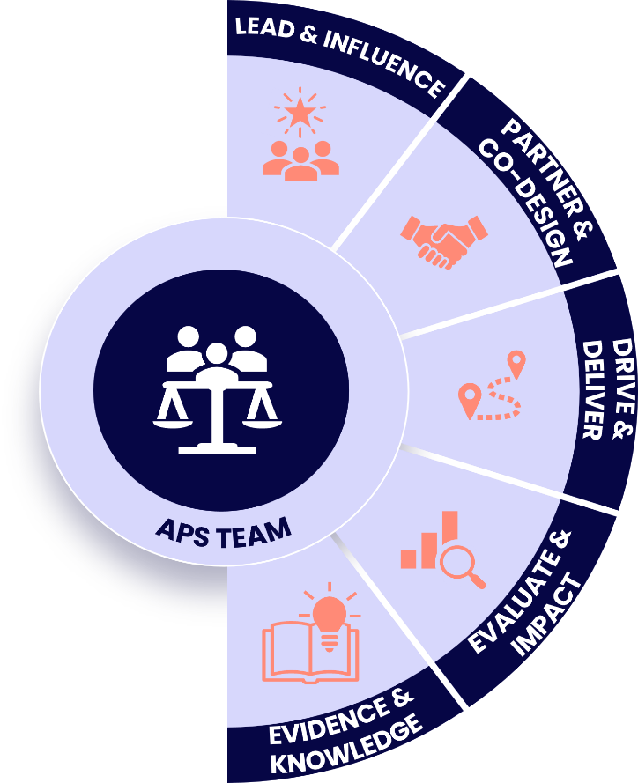
- Work in partnership with key collaborators, including our students, who are at the forefront of co-designed activity.

- Work together with faculties and units to drive forward the Plan, with a focus on reducing inequity for our APP-prioritised students: Black students, students who have shared they have mental health difficulties, and students residing in IMDQ1 areas.

- Ensure that a framework of evaluation with measurable outcomes underpins all activity and use evidence to learn, adapt and demonstrate impact.

- Build on sector and OU research and scholarship as
well as the expertise and lived experience of staff and students to contribute to knowledge creation and lasting change.

The PVC-EDI Office works in partnership across the University. For example, we:
- collaborate with Faculties and Units, advising and supporting on local EDI actions that align with this Strategic Plan (e.g., APP, Athena Swan and Race Equality Charter action plans).
- work with Faculties and Units to integrate EDI and APP priorities into policies, processes and projects (e.g., by advising on projects and Equality Impact Assessments - EIAs).
- support and learn from Staff Networks, Trade Unions, Student Union and other representative groups, recognising the value of lived experience and expertise across the OU.
We carefully focus our time and expertise and aim to:
- prioritise work with significant legal, regulatory, risk or equity implications.
- focus on institution-wide policies, systems and projects that affect many staff and students.
- invest in tools and frameworks that others can reuse, rather than one-off requests.
- be clear when something is better owned locally, with light-touch advice or signposting from us.
Responsibility for EDI outcomes is shared across the University. This Strategic Plan assumes:
- People managers, tutors and all staff play a day-to-day role in creating inclusive environments and making fair decisions.
- Faculties and units are responsible for developing, resourcing and delivering local EDI action plans, with clear ownership and governance.
- The VCE, Senate, Council and senior leaders are accountable for modelling inclusive leadership.

There are also areas we do not lead on:
- We do not manage individual staff or student cases (such as grievances, complaints or conduct issues). These sit with the relevant people management or student support processes.
- We are not responsible for operational student support and related administrative processes. Student facing EDI developments requiring new processes, systems, evaluation and resourcing will require Academic Services capacity and expertise.
- We cannot attend or advise in depth on every local initiative, but we can often provide tools, light-touch input or signposting.
Being clear and transparent about these boundaries helps us manage expectations, stay focused on high-impact strategic work, avoid duplicating what other teams are better placed to do, and support colleagues to take ownership of EDI in their own areas.

For more information, please visit the EDI intranet page (internal only).

1.5 EDI governance
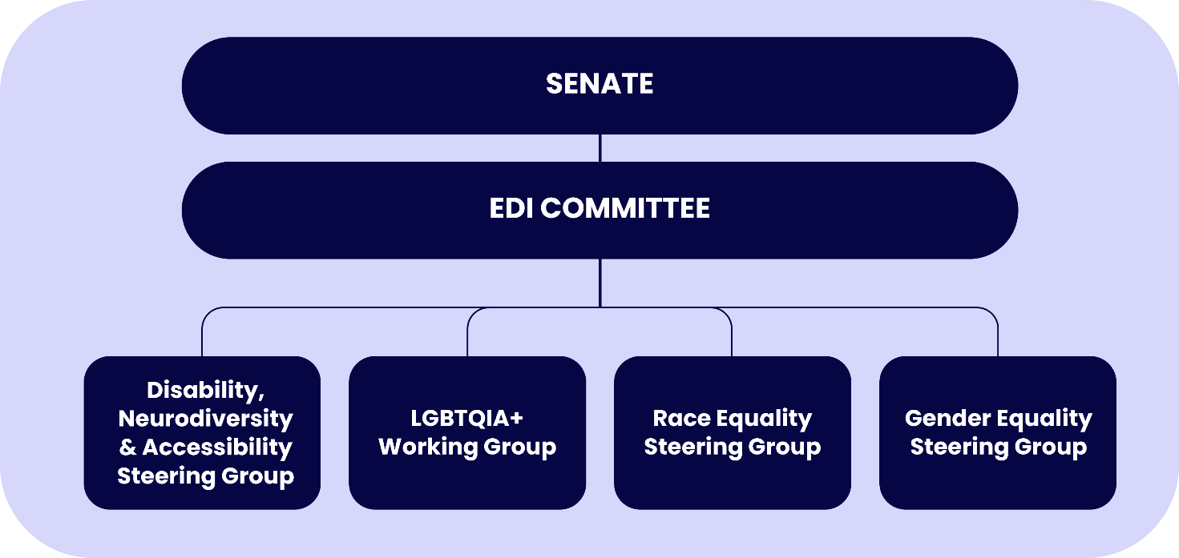
The image below illustrates the University’s current EDI governance structure. This structure is under review, in light of the wider institutional governance review and the expansion of the PVC-EDI Office.

2. Our EDI vision and principles
Our vision for EDI at the OU is to have a fair and inclusive organisational culture and to be sector-leading in equitable and inclusive policy and practice. We will have:
- students whose journeys are equitable, so that the OU experience is genuinely transformative for all, not just some
- a diverse staff community at all levels, in terms of lived experience, thought and knowledge
- a strong sense of belonging, where staff and students feel safe to be themselves and where bullying, harassment, discrimination and microaggressions are not accepted
- clear alignment between what we say and what we do on EDI
- commitment and accountability for this vision at all levels of the OU
To achieve this, we will ensure that EDI is embedded in our strategies, policies, processes and everyday behaviours. We will be guided by four principles:
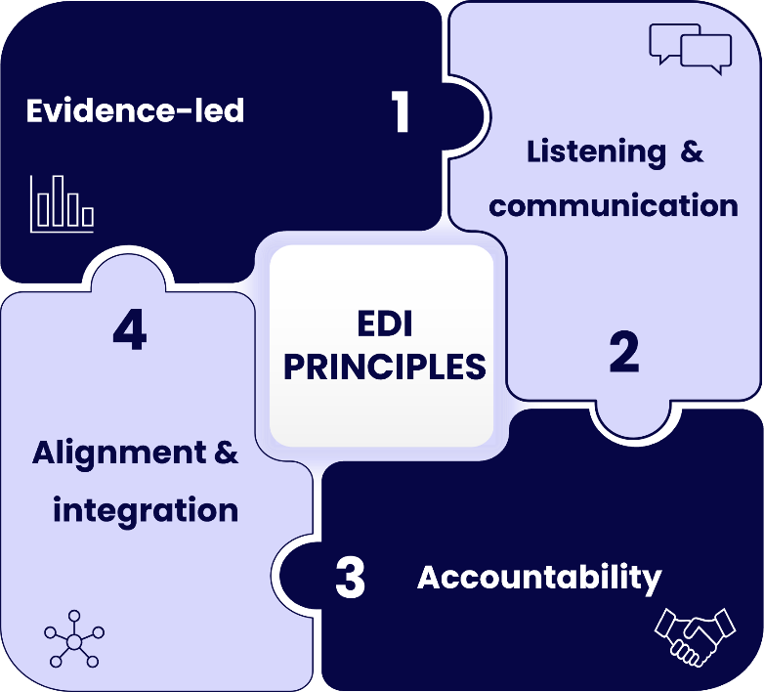
1. Evidence-led
- We will base our decisions on reliable data, research and lived experience.
- We will monitor and evaluate our progress using clear measures and key performance indicators.
2. Listening and communication
- We will keep communication open in all directions.
- We will listen actively to staff, students and partners, and value the lived experience of diverse groups.
3. Accountability
- We will set clear, realistic EDI objectives.
- Responsibility for specific actions will sit with identified leaders, teams, and governance bodies with regular reports on progress.
4. Alignment and integration
- We will align EDI objectives with the University strategy and with key frameworks such as the Access, Participation and Success Plan, and the People Strategy.
- We will integrate EDI into business strategy, risk management, and performance measures across the University.

3. Our priority areas
While we continue to work to advance equity and inclusion for all staff and students, particularly for communities covered by the protected characteristics set out in the Equality Act 2010, we have identified four priority areas for focused action between 2026 and 2031. These priorities do not limit our broader commitment to tackling all forms of inequity. They are:
- Disability, Neurodiversity and Accessibility
- LGBTQIA+
- Race
- Gender
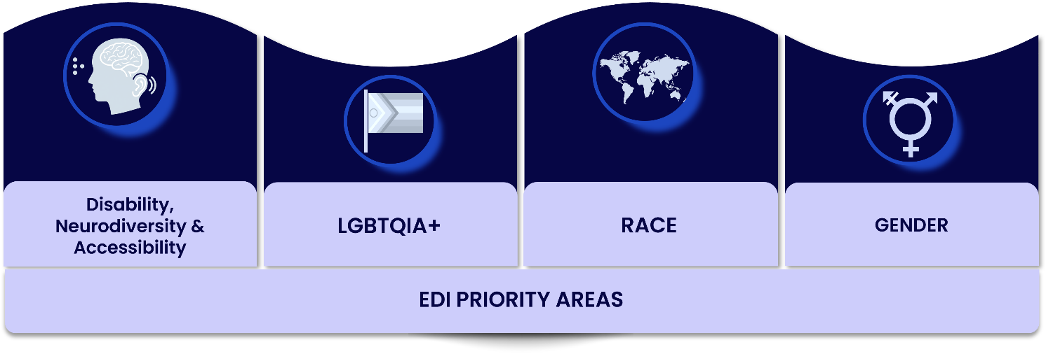

These priority areas reflect where evidence shows some of the most persistent inequities in staff and student experience and outcomes, and where we already have significant frameworks and activity in place such as Athena Swan, the Race Equality Charter, the Access and Participation Plan and staff networks.
From an APP and student outcomes-specific lens, the APP-prioritised student groups are reflected within the priority areas above. This includes a focus on our Black students, students who have shared that they have mental health difficulties, and students who reside in IMDQ1 areas.
Historically, our gender and race inclusion work has benefited from significant resource and focus, largely driven by our engagement with Advance HE Equality Charter frameworks. While this remains essential, this EDI Strategic Plan commits to broadening that focus. We will ensure that Disability and Neurodiversity, and LGBTQIA+ inclusion, are elevated as equal priority areas, supported by dedicated initiatives, governance, and measurable outcomes.
Across all four areas we will build on what has already been achieved, respond honestly to what staff and students have told us is not yet working, and focus on practical, evidence-led actions that improve lived experience and outcomes. This includes strengthening our understanding of, and response to, the experiences of people seeking sanctuary, including migrant, refugee and asylum-seeking students. We recognise the additional and intersecting barriers these groups may face and will draw on existing work within the REC, including a dedicated migrant-focused working group.
We also recognise limitations in our current data collection processes, particularly in how we capture information about students’ religious beliefs. We will therefore work to improve data quality to better inform support for staff and students from different religious backgrounds.
Delivery of these priorities will be fully integrated with, and directly support, the University’s wider strategic framework, including the University Strategy, People Plan, Mental Health and Wellbeing Strategic Plan (MHWBS), and education, research, and access and participation plans. The EDI Strategic Plan is a cross-cutting enabler and a fundamental driver of institutional performance, quality, and impact.
Through this integrated approach, EDI strengthens and connects our strategic commitments by embedding inclusive values into decision-making, culture, and outcomes.




3.1) Disability, Neurodiversity and Accessibility

Context and case for action
The OU is the largest UK provider of higher education for disabled people, with over 39,000 students who have shared a disability studying with us. This includes a significant number of neurodivergent learners, whose experiences, adjustment needs and modes of engagement must be explicitly recognised to ensure equitable learning, progression and outcomes can be consistently delivered.
The OU aims to be proactive rather than reactive by embedding an accessible by design approach. This will support the commitment to reducing awarding gaps between disabled students and those with no known disabilities as well as helping to make the disabled student experience more positive and consistent.
We also employ disabled and neurodivergent colleagues across all parts of the institution. Our ability to attract, retain and develop neurodivergent talent has a direct bearing on organisational effectiveness, staff wellbeing, productivity and innovation. Embedding neurodiversity across our policies, processes and culture – including inclusive design, reasonable adjustments and workforce development – provides a clear framework for consistent practice and assurance of delivery.
Accessibility lies at the heart of our OU mission and values and is the key to enabling success for our disabled and neurodivergent staff and students. The OU has a well-earned reputation as a sector leader in this field and many initiatives which contribute to this successful work.
While we have held Disability Confident Level 1 since 2020, we have now exceeded the usual three-year timeline for progressing to Level 2. This highlights a need for stronger coordination and oversight. Without a clear, visible and accountable approach to disability and neurodiversity, our capacity to address persistent inequities, meet legal and regulatory expectations, and evidence sector leadership cannot be consistently assured.
In this Strategic Plan, we use the terms ‘disability, neurodiversity and accessibility’ to encompass disabled and neurodivergent staff and students, as well as individuals with diverse access needs. The actions set out in the Plan will be underpinned by an intersectional approach.

What we’ve achieved so far
We have:
- Achieved Disability Confident Level 1 (Committed) and previously held a Disability Standard award through our membership of the Business Disability Forum. Level 1 focuses on employers making initial pledges, such as inclusive recruitment, offering interviews to disabled applicants, and providing reasonable adjustments, alongside choosing at least one practical activity to improve opportunities for disabled people.
- Completed a structured self-assessment in 2023/24 to understand our readiness for Disability Confident Level 2 and to identify where we need to improve how we recruit, support and develop disabled colleagues.
- Committed to publishing our Disability Pay Gap annually.
- In 2025, established a Disability, Neurodiversity and Accessibility Steering Group to coordinate and strengthen staff-focused activity across these three key areas. This work aligns with and complements existing student-focused structures, with dedicated working groups delivering targeted initiatives, including reasonable adjustments for staff, within a single, cohesive framework.
- Strengthened our approach to student neurodiversity by advancing targeted activity through the Disability, Neurodiversity and Accessibility Steering Group. This includes formal engagement with Students’ Union representatives to ensure student voice informs strategic direction and SeGA.
- Become a founding member of the Disabled Student Commitment (DSC), an enabler to addressing specific barriers that disproportionately affect our disabled students. It outlines 43 principles that cover the student lifecycle, including information sharing, course selection, support during studies, and transition to employment.
- Elevated our institutional commitment to digital accessibility governance and compliance by including it in the OU risk register.
- Embedded accessibility best practice across the OU by coordinating and driving change through guidance and training, compliance, digital design, research, and community development. This has included a particular focus on engaging stakeholders from across the OU whose perspectives had not previously been fully included.
- Embedded accessibility into digital design and development, ensuring that the OU is developing in alignment with contemporary UX (user experience) methodology and that the voice of disabled staff and students is represented in our digital spaces.
- Used the APP to strengthen our focus on students experiencing mental health difficulties, including identifying and tackling barriers in OU policies, practices, culture and structures that negatively affect this student group.
- Worked in partnership with Academic Services in implementing the OU’s Mental Health and Wellbeing Strategic Plan (MHWBS), ensuring alignment with our APP-prioritised students and a strategic focus on equity, including looking at using data to inform our approach to identifying and supporting specific cohorts of staff and students.

What we’ve learned
Feedback from staff and students highlight that:
- Accessibility – disabled students and staff still encounter barriers, particularly around digital accessibility, learning materials, assessment and some of the systems and tools they are expected to use.
Many systems and processes are not designed with neurodivergent users in mind, which can create additional cognitive and usability barriers and limit equitable access and participation.
- Recruitment and progression – practice, processes and policies are not consistently inclusive, and disabled and neurodivergent colleagues can face barriers in recruitment, workload, progression and access to development opportunities.
- Reasonable adjustments and policy – processes and guidance for requesting, agreeing and reviewing reasonable adjustments, and the policies that sit behind them, can be unclear or applied inconsistently across the OU.
- Awareness, training and communication – disability awareness, the availability and uptake of disability-related training, and communication about expectations and good practice all need to be strengthened so that inclusion does not depend on individual knowledge or goodwill.
- Gaps in resourcing and inconsistency in practice – work on disability, neurodiversity and accessibility has often relied on a small number of committed individuals, teams and staff networks, and good practice is not yet embedded or consistent across all areas of the institution.

- Mental health and wellbeing - students experiencing mental health difficulties are less likely to pass their modules, progress into further study, or move into graduate employment. Barriers faced by this student group include inflexible assessment and workload expectations; limited flexibility in teaching approaches or deadlines; inconsistent academic and wellbeing support; complex processes for accessing help; and cultural norms that discourage students from sharing difficulties or seeking support.

Our objectives for 2026 - 31
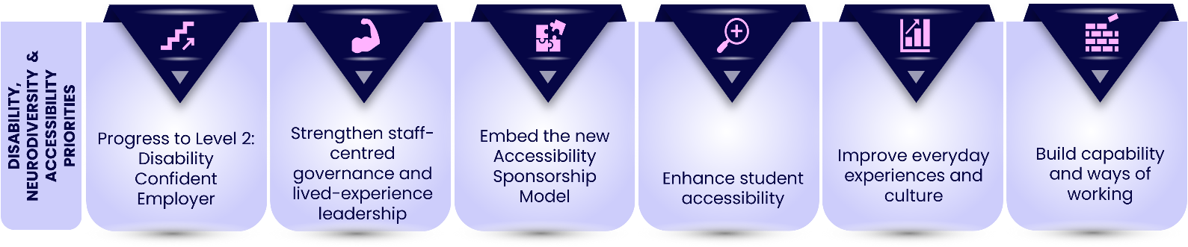
Over the lifetime of this Strategic Plan, we will:
1. Progress to Disability Confident Level 2
- Use the findings of our 2023/24 self-assessment which evaluated our readiness for progression, to address gaps and progress from Level 1 to Level 2 (Disability Confident Employer). Level 2 will require us to demonstrate deeper and sustained action through a structured self-assessment, including how we recruit, support, and develop disabled employees across areas like accessible recruitment, workplace adjustments, and ongoing staff development.
2. Strengthen staff-centred governance and lived-experience leadership
- Embed the Disability, Neurodiversity and Accessibility (DNA) Steering Group and its working groups as the focal point for this agenda. The Steering Group will ensure that disabled and neurodivergent staff and students shape priorities and decision-making, while maintaining alignment with complementary student-focused structures such as SeGA. It will provide strategic oversight, clear direction and lead listening exercises with disabled and neurodivergent staff and students to ensure priorities reflect lived experience. Dedicated working groups will take forward key priorities, working collaboratively to support an intersectional approach to driving institutional change through policy development and advocacy, while aligning with existing student-led activity.

3. Embed our new Accessibility Sponsorship Model
- Enable more focused accessibility work with three senior sponsors covering student, staff and digital accessibility. The model will reduce overlap, prioritise resources and align accessibility work with wider strategic priorities. Senior sponsors will strengthen governance by providing strategic oversight, clear direction and a collective voice for accessibility at the highest levels, supporting visibility, advocacy and institutional change.
4. Enhance student accessibility
- Continue to review and enhance how student accessibility is supported and resourced.
- Ensure approaches are sustainable and informed by student need and institutional priorities.
5. Improve everyday experiences and culture
- Clarify and streamline processes for requesting, implementing, and reviewing reasonable adjustments for staff and students.
- Enhance data on disability and neurodiversity to inform action and track progress.
- Plan and review how we measure the impact of our accessibility initiatives so that we can make sure we are being transparent, learning from lessons, and incorporating feedback and evidence into our decisions and work.
6. Build capability and ways of working
- Provide targeted guidance and development on accessibility, disability and neurodiversity inclusion.
- Support and resource staff networks so they can continue to act as critical friends, partners and advocates.
The KPIs detailed in Section 5 Our success measures will support our ongoing work through the Disability, Neurodiversity and Accessibility (DNA) Steering Group to develop a robust SMART action plan for DNA inclusion at the OU.


3.2) LGBTQIA+

Context and case for action
LGBTQIA+ inclusion is essential to creating a safe, equitable and welcoming environment for everyone in our community. At the OU, we use the term LGBTQIA+ to reflect the full diversity of sexual orientation, gender identity and sex characteristics within its community. LGBTQIA+ is an inclusive and widely recognised term that acknowledges and supports the visibility and belonging of all individuals who face discrimination due to their gender identity or sexuality.
While we celebrate significant progress through networks, events and visible commitments, we know that data on LGBTQIA+ staff and student experience is limited. For example, our systems allow staff to record non-binary genders, but disclosure rates are low. Our student systems do not currently allow this information to be recorded, and we know far less about LGBTQIA+ students in distance-learning contexts than campus-based universities do.
In addition, responses to our institutional EDI staff survey show that LGBTQIA+ colleagues are more likely to report bullying and/or harassment, with trans colleagues among those most affected at 24%.
We also recognise that the evolving legal context presents challenges for LGBTQIA+ inclusion, and we commit to navigating this responsibly while recognising the heightened anxiety and uncertainty experienced by our people.
We want to move beyond basic support to a more systematic, evidence-led approach that addresses the specific barriers faced by LGBTQIA+ staff and students, including trans, non-binary or gender diverse people.

What we’ve achieved so far
We have:
- Two active staff networks – the Proud Staff Network (for LGBTQIA+ identities) and the Trans Staff Network – which provide peer support, advocacy and insight into lived experience.
- A regular programme of LGBTQIA+ focused events and campaigns, including Pride and LGBTQ+ History Month, delivered in partnership with staff networks and Marketing and Communications team.
- Established an LGBTQIA+ Working Group in December 2025 to coordinate this agenda and develop a comprehensive LGBTQIA+ Lived Experiences Report and Action Plan, informed by listening exercises with staff and students.
- Secured funding through a pan-university scholarship scheme (funded by APP) for a research project on LGBTQIA+ student experience at the OU. A team of LGBTQIA+ scholars (staff and student interns) will explore the realities of distance learning, identity disclosure and belonging for undergraduate and taught postgraduate students.
- Trans and Non-Binary inclusion is also a priority in Athena Swan, which allows us to take a joint institutional approach to trans, non-binary or gender diverse colleagues inclusion.

What we’ve learned
Feedback from staff networks, issues known by us and the rationale for our scholarship project highlight that:
- Many LGBTQIA+ staff and students still navigate concerns about safety, disclosure and belonging, particularly in online and distance-learning spaces.
- Our policy and systems landscape are not always fully inclusive of diverse gender identities and sexual orientations (for example, limitations in how identities can be recorded or recognised).
- We lack consistent, institution-wide data on LGBTQIA+ experience, making it harder to identify and address inequities.
- Work has often relied on a small number of committed individuals in networks, rather than shared institutional responsibility.

Our objectives for 2026 - 31
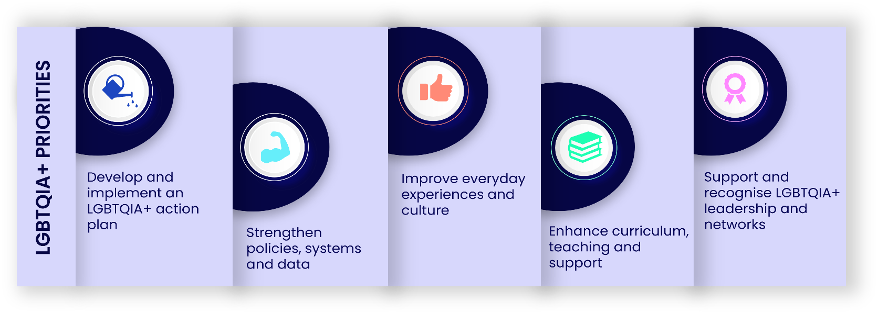
Over the lifetime of this Strategic Plan, we will:
1. Develop and implement an LGBTQIA+ Action Plan
- Use the findings of the upcoming LGBTQIA+ Lived Experiences Report and the student research project to create a SMART Action Plan with clear owners and measures of success.
- Work in partnership with Athena Swan team to ensure gender inclusion work is inclusive of the LGTBTQIA+ experiences, including supporting the specific charter priority for trans, non-binary or gender diverse inclusion.
2. Strengthen policies, systems and data
- Review staff, student and governance policies to ensure they are explicitly inclusive of diverse sexual orientations and gender identities, including trans, non-binary or gender diverse people.
- Improve how we collect and use data on LGBTQIA+ identities, while respecting privacy and safety, so we can better understand outcomes and target interventions.

3. Improve everyday experiences and culture
- Equip managers, tutors and leaders with guidance and development on LGBTQIA+ inclusion, including trans, non-binary or gender diverse inclusive practice and how to respond to discrimination and harassment.
- Ensure that reporting routes (including Report and Support) are visible, trusted and responsive to LGBTQIA+ issues.
4. Enhance curriculum, teaching and support
- Work in partnership with faculties and PVC-LTSE to ensure that curriculum, teaching materials and student support reflect and affirm LGBTQIA+ identities where relevant.
- Use insights from the student research project to inform improvements in supervision, pastoral support and community-building for LGBTQIA+ students.
5. Support and recognise LGBTQIA+ leadership and networks
- Continue to resource and recognise the work of the Proud and Trans staff networks, ensuring they are connected into governance and decision-making structures.

The KPIs detailed in Section 5 Our success measures will support our ongoing work through the LGBTQIA+ Working Group to develop a robust SMART action plan for LGBTQIA+ inclusion at the OU.


3.3) Race

Context and case for action
Our race inclusion work is guided by our Race Equality Charter Bronze Award received in February 2026. Through this process we undertook a rigorous self-assessment of staff and student data and listened carefully to racially minoritised (RM) colleagues and students through surveys and consultation events. Our participation in the Charter acknowledges our commitment to tackle identified racial inequities at the University.
We use the term “race equality” where it aligns with the Race Equality Charter (REC) and wider institutional and sector language. However, the way we approach this work is equity-focused, ensuring that actions are designed, implemented and evaluated in response to identified barriers, needs and inequities.
We also recognise that previous work, including decolonisation initiatives and the Racism at the OU report, is perceived by many as not having resulted in sufficiently visible change. We are committed to being open about this and ensuring that our REC action plan and other targeted initiatives lead to tangible improvements in people’s lived experience, not just new documentation.

What we’ve achieved so far
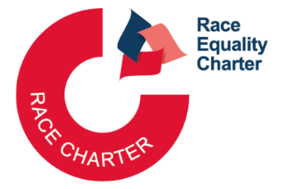
Through our REC work we have:
- Built a robust evidence base, drawing on multiple staff and student datasets, two EDI surveys and extensive consultations.
- Developed a five-year REC Action Plan (2026–31) focusing on the experience of racially minoritised (RM) staff and students.
- Aligned with the APP priorities by addressing inequities in access to the OU, pass rates and ‘good’ pass rates for Black students, while also supporting work to improve their sense of belonging and mattering. REC actions support these APP priorities through activities to improve staff cultural humility, increase the diversity of the staff body, and strengthen understanding of, and support for, students seeking sanctuary, including through the migrant-focused working group.
- Continued to support targeted initiatives such as 100 Black Women Professors NOW, which provide development, sponsorship and networks for Black women academics. This has informed our approach to progression and leadership, with participants achieving promotion, awards, Senate membership and creating a Black Women Academy. The OU now has two Black women professors.
- Committed to publishing our Ethnicity Pay Gap annually.

What we’ve learned
A cross-university team of 31 staff and students led by the EDI Senior Leadership Team conducted a rigorous self-assessment of 21 staff and student datasets and two EDI surveys for staff and students to understand the University’s culture and any differences in experience among racially minoritised staff and students. The surveys were complemented by 9 staff consultation events and 12 student consultation events, providing solid evidence base for our REC action plan.
Our self-assessment highlighted persistent inequities, including:
Staff
- Racially minoritised (RM) staff, particularly Black staff, were more likely to be employed in lower-grade roles and underrepresented in senior positions.
- RM staff were less likely to be shortlisted and appointed, with disparities increasing at higher grades.
- RM staff, particularly Black staff, were more likely to have experienced situations that made them feel uncomfortable due to their ethnicity (24%) were less confident (34%) that leaders would address racially inappropriate behaviour.
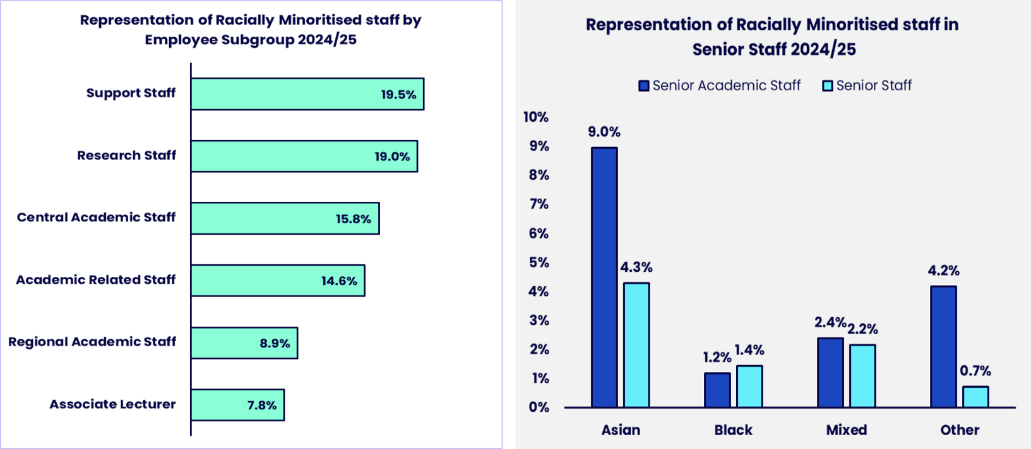
Figure 2: Representation of Racially Minoritised Staff
Students
- RM students, particularly Black students, had lower good module pass rates - 64.6% compared to 67.9% for white students. Black students had the lowest good module pass rate at 58.4%.
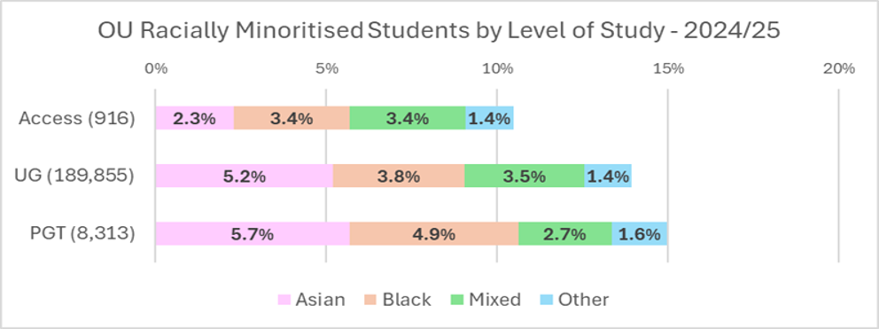
- RM students, particularly Asian students (17%) were more likely to have experienced a situation that made them feel uncomfortable due to their ethnicity. Black students are least confident (54%) that tutors will address racially inappropriate behaviour.
Figure 3: Student data by level of study and ethnicity
These findings confirm the need for systemic change in culture, structures, processes and accountability.

Our objectives for 2026 - 31
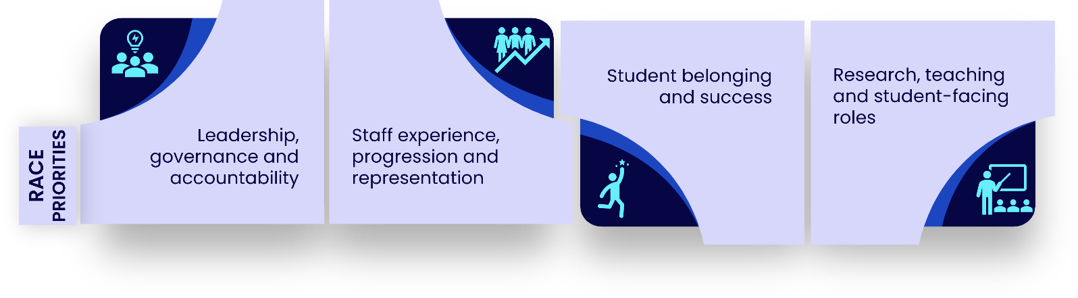
The REC Action Plan identified seven priority areas and for the purposes of this Strategic Plan we group our objectives under four themes:
1. Leadership, governance and accountability
- Increase racial diversity in governance and senior decision-making structures.
- Equip leaders with the skills and confidence to make inclusive decisions and hold themselves accountable for race equality outcomes.
2. Staff experience, progression and representation
- Improve recruitment, retention, progression and cultural climate for racially minoritised staff, particularly Black staff, and address underrepresentation at senior grades.
- Strengthen reporting routes, support and protections so that RM staff can safely speak up about racism and see action taken.
3. Student belonging and success
- Work with Access and Participation Plan (APP) and other initiatives to work towards eliminating ethnicity awarding gaps, especially the Black-white awarding gap.
- Improve sense of belonging, cultural climate and confidence in tutors’ responses to racially inappropriate behaviours for RM students.
4. Research, teaching and student-facing roles
- Enhance support for racially minoritised research-only staff and postgraduate research students, addressing issues such as fixed-term contracts and access to networks.
- Increase the racial diversity and cultural competence of Associate Lecturers/Regional Academics and other student-facing staff.

Across all of this, we will seek to move beyond a solely charter-driven approach, being open to listen and act on what our own community tells us needs to change and how they experience the impact of our actions. This includes a need to disaggregate current data to ensure that analysis and consequent support activities are more nuanced, particularly when considering the needs of our international students. We therefore commit to exploring student experience by including the valuable voices of our international students in our attempts to reduce inequity.

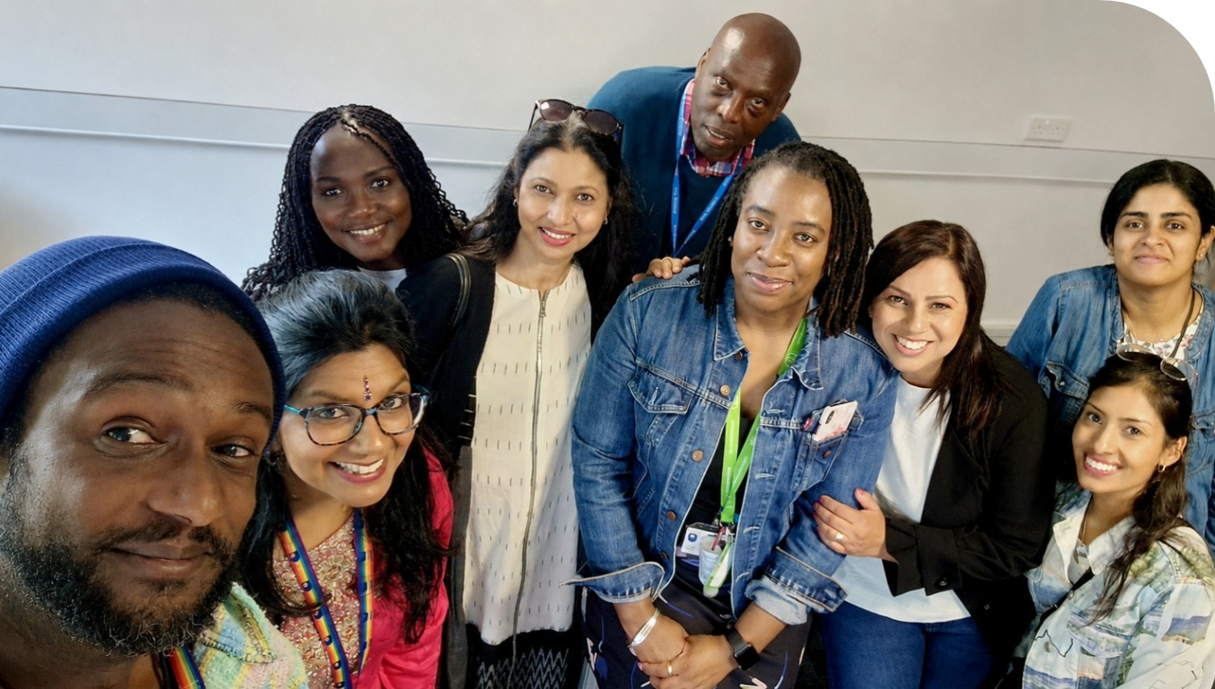
Decolonisation
In support of the OU’s commitment to anti-racism work through the REC and the drive to reduce inequity through the APP, in line with best practice in the HE sector, the University is committed to advancing an institution-wide approach to decolonisation that includes but importantly, extends beyond curriculum reform. Reviewing and diversifying curricula remains an important aspect of this work, as intended through the strategic lens of the Inclusive Curriculum initiative, however, meaningful decolonisation also requires critical examination of how institutional power operates through policies, decision-making structures, cultural norms and everyday practices.
A dedicated Decolonisation Working Group will be formed to support colleagues to engage in decolonisation initiatives that address the consideration of whose knowledge and perspectives are prioritised within teaching, research and leadership; how institutional policies and processes may be disadvantaging particular student groups; whose voices are represented in governance and strategic decision-making; and how historical and contemporary inequalities and inequities can shape experiences of belonging, success and progression.

Detailed actions for race inclusion are set out in the REC Action Plan (2026-31).


3.4) Gender

Context and case for action
Gender inclusion has long been a focus at the OU. We have been members of the Athena Swan Charter since 2012 and hold an institutional Bronze award, with a mix of Bronze and Silver awards across several Schools and units (Table 1). A Bronze award is the foundational level of the Athena Swan Charter which shows a commitment to promoting fairness, inclusion and opportunity for women, men and gender-diverse colleagues and students.
Progress towards an institutional Silver award has been slower than we would like, and colleagues have told us that gender work can feel overly focused on the charter rather than on everyday experience. However, staff are reminded that Athena Swan is fundamentally routed in taking our staff and students’ everyday experiences and working to make tangible changes in this area.
The Athena Swan Charter is a gender equality charter where awards are conferred by AdvanceHE. Though it is called a ‘gender’ charter it encompasses the following protected characteristics: sex, gender re-assignment and pregnancy and maternity.
We use the term “gender equality” where it aligns with the Athena Swan Charter and wider institutional and sector language. However, the way we approach this work is equity-focused, ensuring that actions are designed, implemented and evaluated in response to identified barriers, needs and inequities.

What we’ve achieved so far
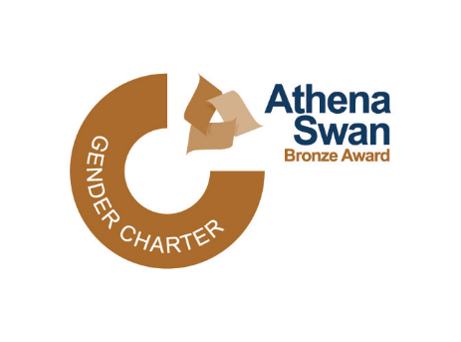
We have:
- Renewed our institutional Bronze Athena Swan award and supported multiple Schools to secure Bronze and Silver awards (Table 1).
- Developed a comprehensive Athena Swan data pack and an active Athena Swan Champions Network to share learning and support applications.
- Introduced practical initiatives such as the Menopause Policy, a dedicated baby-feeding area on the Milton Keynes campus, and expanded provision of gender-neutral toilets across OU sites which benefits gender diverse colleagues and women.
- The Menopause Moments Network has created several spaces for colleagues to access menopause-related information and support, including a Viva Engage group, mailing list, private MS Teams space and regular online meetings. The group also maintains a Menopause Hub with resources and information about voluntary Menopause Champions, who can offer one-to-one support.
- Established the Women’s Development Community, with over 500 members, and continued to support leadership development through the Aurora Programme.
- Published annual Gender Pay Gap reports show the OU performs better than the sector average by regularly reporting a small gender pay gap.
- Committed to piloting the Career Accelerator Women's Development Programme.
The Athena Swan Self-Assessment Team (SAT) has been meeting every three months since January 2024 to provide oversight and strategic direction for our institutional Silver Athena Swan Award submission. The following draft priorities for the Silver submission have been agreed:
- Tackling bullying and harassment
- Create an inclusive working and learning environment for trans, non-binary or gender diverse staff and students
- Progression Pathways for Professional Services Staff
- Promotion of academic staff on specific contract types
- People Services parental leave support
- Improve wellbeing and mental health support for men, researchers and trans, non-binary or gender diverse staff

Table 1: Athena Swan Awards across OU Faculties and Schools
Faculty/School/Unit | Award Level (Year)
Faculty of Science Technology, Engineering and Mathematics (STEM)/ School of Physical Sciences (SPS) | Silver (2021)
STEM / Engineering and Innovation (E&I) | Silver (2021)
STEM / Computing and Communication (C&C) | Silver (2021)
STEM / Mathematics and Statistics (M&S) | Silver (2022)
STEM / Knowledge Media Institute (KMi) | Silver (2022)
STEM / Environment, Earth and Ecosystem Sciences (EEES) | Silver (2026)
STEM / Life, Health and Chemical Sciences (LHCS) | Bronze (2021)
Faculty of Wellbeing, Education and Language Studies (WELS) / Education, Childhood, Youth and Sports (ECYS) | Bronze (2022)
WELS / Health, Wellbeing and Social Care (HWSC) | Bronze (2024)
Faculty of Arts and Social Sciences (FASS) / Psychology and Counselling | Bronze (2024)
Faculty of Business and Law (FBL) / Business School | Bronze (2022)

Schools and Professional Services Staff (PSS) units can apply for unit/school level Athena Swan awards alongside the institutional Athena Swan award. School level awards are important because this is the level that our students benefit from specific and targeted gender equality initiatives in addition to a focus on academic staff within that specific school. PSS units benefit from a unit level Athena Swan submission because initiatives are targeted at specific staff groups within that specific unit. Local initiatives are often easier and quicker to implement than OU-wide actions and the cost-base is reduced.

What we’ve learned
Recent years have seen financial constraints, restructuring and staff turnover, which have slowed progress and made it harder to sustain local Athena Swan work. Colleagues have also highlighted that gender inclusion work must move beyond compliance and awards to address broader issues such as reproductive health, caring responsibilities, workplace culture and the intersections between gender, race, disability and other identities.
Caring responsibilities are also increasing, disproportionately affecting women, including those who take on dual caring roles for both children and older relatives. The Athena Swan team and the Carer Staff Network have been working closely together to ensure that care forms part of the new Athena Swan action plan.

Our objectives for 2026 - 31
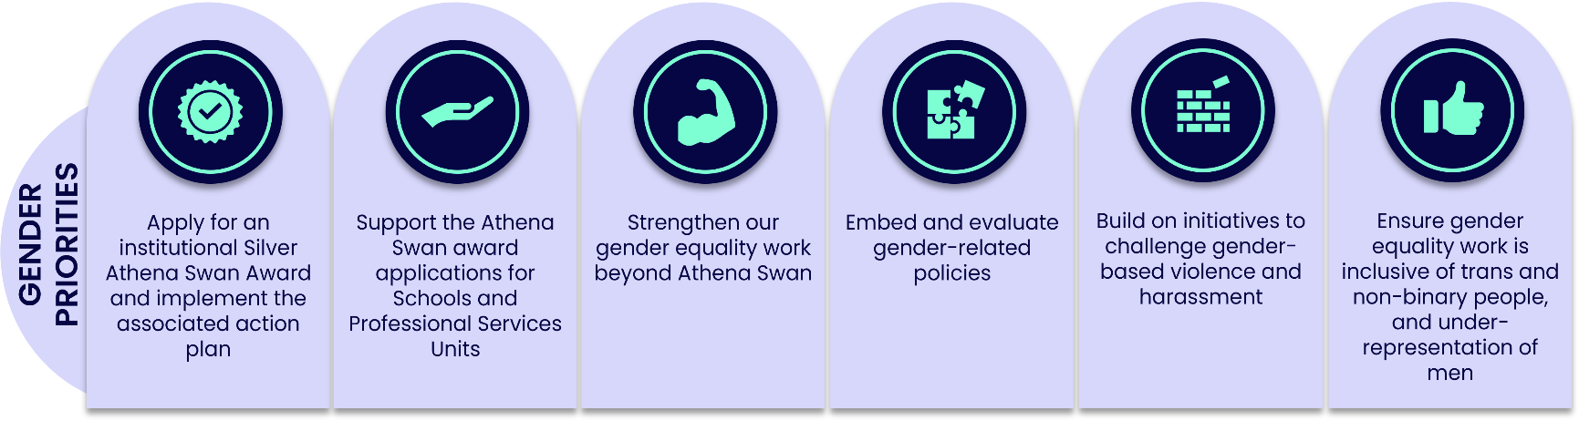
Over the lifetime of this Strategic Plan, we will:
- Apply for an institutional Silver Athena Swan award, and, subject to approval, implement the associated action plan, using it as a framework for sustained change rather than an end in itself.
- Support the Athena Swan award applications for Digital Services and LDS (two of the largest Professional Services units at the OU), and for the Schools of Languages and Linguistics (LAL), Socials Sciences and Global Studies (SSGS), and Law School.
- Strengthen our gender inclusion work beyond Athena Swan, including action on gender pay gaps, progression and representation at senior levels.
- Embed and evaluate our Menopause Policy and other gender-related policies, ensuring line managers and leaders actively support staff through key life stages.
- Build on initiatives such as International Women’s Week, the Women’s Development Community and future White Ribbon accreditation to challenge gender-based violence and harassment and promote safe, inclusive cultures.
- Ensure gender inclusion work is explicitly inclusive of trans, non-binary or gender diverse people, and responsive to under-representation of men in particular disciplines or roles.

Athena Swan and LGBTQIA+
Athena Swan is a gender charter and as such this work also intersects with the work of the LGBTQIA+ working group. The Athena Swan Charter includes:
- gender re-assignment as a protected characteristic
- one of the principles of the Athena Swan charter is supporting gender diverse people
- collecting gender identity data in addition to sex data as recommended by AdvanceHE
- several actions pertaining to supporting gender diverse people in the Bronze Award action plan
- supporting trans, non-binary or gender diverse staff and students is a priority in the Silver Award action plan
Detailed actions for gender inclusion are set out in the draft institutional Silver Athena Swan Action Plan. This is a live document that is reviewed and refined throughout the five-year cycle, informed by staff and student experiences and emerging evidence.

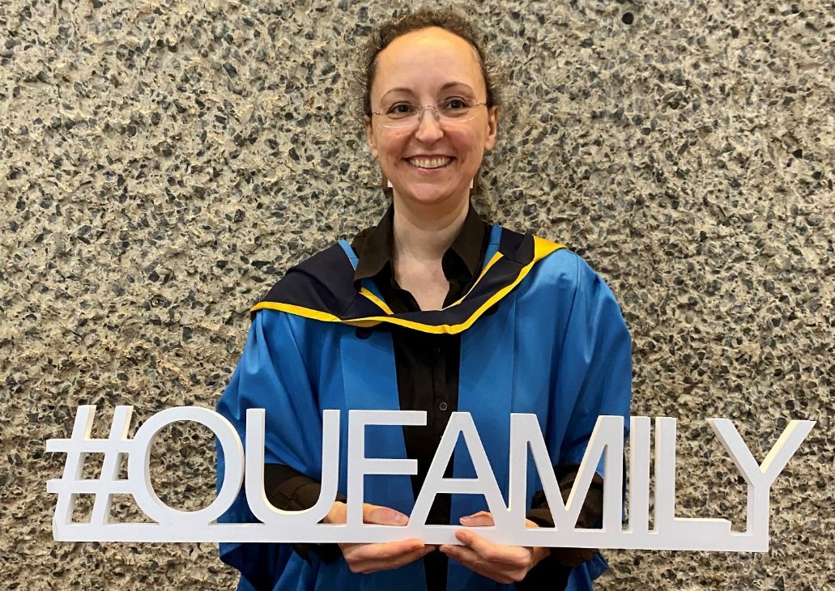

4. Good EDI practice

4.1 Our commitment to sharing good practice and collaboration
The University is committed to sharing good EDI practice and collaborating so that equity, diversity and inclusion are not isolated initiatives but part of a coherent, university-wide approach. This supports a culture of continuous improvement and helps make the OU a university of choice for staff and students.
We already promote equity and belonging, embed EDI in training and KPIs, provide platforms and a central EDI repository to share evidence-based practice, use existing channels to highlight impact, and draw on EDI champions and staff networks to share good practice and spread learning.
To further strengthen this approach, we will use key vehicles for change to embed, evaluate, and scale effective EDI practice across the institution. This will include:
- Enhancing training and professional development to build capability and confidence in delivering inclusive practice across all roles.
- Strengthening the use of data and dashboards to better understand disparities, monitor progress, and inform decision-making.
- Developing evaluation mechanisms to assess the effectiveness and impact of EDI initiatives and ensure accountability.
- Drawing on research and scholarship to inform practice and assess what works in improving outcomes for staff and students.
- Identifying and scaling effective approaches to reduce duplication, share learning, and embed successful practice across faculties and units.
We will further encourage innovation and accountability in delivering the EDI Strategic Plan by increasing the sharing of good practice and reducing duplication of effort; establishing a community of practice aligned to the EDI priority areas; promoting peer learning circles between units and faculties; and creating more opportunities to showcase successful, evidence-based EDI initiatives that improve outcomes for staff and students.

4.2 Good EDI practice in the Nations


The Nations play a key role in delivering the EDI Strategic Plan as part of the devolved operating model of the University. Acting under the authority and strategic direction of central governance, the Nations are responsible for translating institutional priorities into locally relevant action, ensuring effective delivery, engagement, and policy alignment within their contexts. This includes working with local stakeholders, identifying and responding to nation-specific needs, and embedding EDI principles across activities and decision-making. While aligned to the overarching strategic framework, the Nations have the flexibility to prioritise and tailor delivery to reflect local demographics, challenges, and opportunities, enabling a more responsive and impactful approach to advancing equity, diversity, and inclusion across the institution.


The Open University in Ireland
Legal context
EDI activity in Northern Ireland (NI) is underpinned by the Northern Ireland Act 1998, which deems the University to be a Public Authority. This means we are required to:
- give due regard to the promotion of equality of opportunity across the protected characteristics covered by Northern Ireland equality legislation
- give regard to the promotion of good relations between the two community traditions.
Together, these commitments form our statutory equality duty.
Since 2012, a single OU Equality Scheme has met the legislative requirements of the UK as a whole, including our duties in Northern Ireland. Each year, we offer an Annual Progress Report to the Equality Commission for Northern Ireland (ECNI), evidencing progress against our equality duties and the commitments made in the OU Equality Scheme. We also have a statutory duty to provide Fair Employment data to ECNI on the composition of our workforce in Northern Ireland.
Access and Participation
In our Outcome Agreement with the Department for the Economy, we have committed to address regional imbalance, widen access and participation, and raise productivity by tackling barriers to education access.
To meet our access and participation goals, we are further developing strategic partnerships with key stakeholders, including AWARE NI, The Kings Trust and Libraries NI, to introduce more people from widening access demographics to the benefits of lifelong learning.
We are also working to:
- support more young people with a statement of Special Education Needs to access higher education through the OU
- diversify our marketing casebook by developing new student case studies, featuring women studying STEM subjects, students with a shared disability; and young men from IMDQ1 areas, to showcase skills and employability messaging.
Reaching and supporting students across Ireland
We will continue working to reach all areas of Ireland through our core recruitment activity and validation agreements with Further Education colleges in each Northern Irish county.
We also provide tailored advice and guidance to scholarship students in Ireland, including Black Open Futures, Carers, Inclusive Futures and Sanctuary scholars.
Future priorities

Over the coming years, in support of the EDI Strategic Plan, the OU in Ireland will engage with a range of strategic and legislative initiatives which intersect with our legal duties, including the Northern Ireland Disability Strategy 2025-2035 (Department for Communities), race equality legislation reform, a new departmental Widening Participation Strategy, engagement with the Office of Identity and Cultural Expression, and developing relationships with grassroots organisations in the LGBTQIA+ space.


The Open University in Wales
Legal, regulatory and funding context
EDI legislation in Wales is anchored in the UK-wide Equality Act 2010 which protects individuals from discrimination based on nine characteristics.
In Wales, distinct specific Statutory Duties (the 2011 Regulations) require listed public bodies, including educational institutions, to publish equality objectives, impact assessments, and engage with citizens.
The OU in Wales is regulated by the Office for Students (OfS) and funded by Medr, the body responsible for funding and regulating the tertiary education and research sector in Wales. We therefore support Medr in meeting its obligations as a listed public educational body in Wales.
Social responsibility, wellbeing and future generations
In 2015, a landmark Welsh law was enacted which sets out five ways of working to enable public bodies to achieve seven wellbeing goals. The Wellbeing and Future Generations Act 2015 calls for “a society that enables people to fulfil their potential no matter what their background or circumstances” and is inspired by indigenous wisdom and the Seventh Generation Principle. The Act guides and encourages a collective endeavour to improve the economic, social, environmental and cultural wellbeing of Wales.
Aligned to the UN Sustainable Development Goals and reflecting the approach set out within the Inner Development Goals, the OU in Wales has developed an integrated approach to inclusion, bringing together EDI, Sustainability and Wellbeing under the banner of “Social Responsibility”.
The rich intersections that exist between these disciplines underpin our approach to ensuring that the OU in Wales reflects and contributes to the wider OU mission to be inclusive, ethical, and socially responsible.

Race equality and anti-racism
To support Welsh Government ambition to make Wales an anti-racist nation, we have proactively supported and informed The OU’s Race Equality Charter Bronze Award work. We have also designated bespoke resources to embed the identified actions across the University’s work.
Our evolving cohort of champions supporting social responsibility work will enable the OU in Wales to continue taking a proactive and holistic approach that supports, guides and empowers staff and students to embody our inclusive principles.
Access, participation and socio-economic inequity
The OU recognises that socio-economic deprivation is a key driver of inequity. Students residing in IMDQ1 are therefore prioritised within the Access and Participation Plan (APP). This is particularly relevant in Wales, in the context of the Wales Socio-economic Duty and where socio-economic inequity continues to shape access, participation and student outcomes."



The Open University in Scotland
Legal, regulatory and funding context
The Scottish Funding Council (SFC) embeds EDI as a cross-cutting requirement across its entire Outcome Framework and Assurance Model (OFAM). This means we must evidence how EDI is integrated into governance, planning, delivery, and monitoring of all outcomes.
We must also demonstrate compliance with EDI legislation through Public Sector Equality Duty (PSED) reporting, and delivery of National Equality Outcomes (NEOs). These include:
- improving success, retention and satisfaction across protected characteristics
- reducing gender imbalances
- improving disabled students’ experience
- supporting mental health
- tackling harassment
- ensuring representative staff, Boards and Courts.
Other statutory requirements in Scotland include The Children and Young People (Scotland) Act which places ‘corporate parenting’ responsibilities on all post‐16 education bodies, and the British Sign Language (Scotland) Act which requires all public bodies to publish a BSL action plan.
Our approach to EDI in Scotland
The OU in Scotland demonstrates to the SFC that EDI is:
- Strategic: embedded in governance, planning and financial decision-making.
- Evidence-based: underpinned by robust data and Equality Impact Assessments (EQIAs).
- Integrated: visible across teaching, research, estates, student experience, and workforce culture.
- Improving: supported by clear actions to address inequalities and enhance outcomes for students and staff.
Corporate parenting and support for carers
Through delivery of our Corporate Parenting Plan, we have seen an increase in the number of undergraduate entrants declaring care-experience which we are proud of. We continue to support sector initiatives that raise awareness of corporate parenting in higher education and the language of care, utilising OpenLearn Create where suitable and where opportunities arise.
Through our work in Scotland to support carers, the whole OU was awarded Carer Positive (Established) status, an award operated by Carers Scotland on behalf of the Scottish Government.
Future focus areas will include:
- Exploring disparities in completion, continuation and pass rates to identify where further support may be needed.
- Continuing to embed student voice
- Raising staff awareness of Corporate Parenting responsibilities
- Strengthening partnerships with other Corporate Parents (e.g., Hub for Success, CEECEF)
Partnership work
The OU in Scotland works in partnership with a range of organisations to support work on racism, gender balance, gender-based violence, estranged students and forced migration.

We also participated in Scotland’s first survey on the prevalence of Gender Based Violence (GBV) at Scottish HEIs. This survey was led by EmilyTest, the GBV in education charity, and was the first ever Scotland-based survey of its kind across universities and colleges.

4.3 Overarching activities and practice

Equality Impact Assessments (EIAs)
EIAs ensure that every policy, project or service is designed and delivered in a way that is fair, inclusive and does not disadvantage any group. By systematically assessing the potential effects of our decisions on people with protected characteristics, as well as factors such as caring responsibilities, socioeconomic background and intersectionality, EIAs help us identify risks early, plan mitigating actions and embed equity thinking into everyday practice. They also enable us to meet our legal duties under the Public Sector Equality Duty (PSED), Equality Act 2010 and Section 75 of the Northern Ireland Act 1998 by demonstrating how we consider equality in our decision making.

In June 2026, an updated EIA template (2026) and EIA screening tool (EIA-ST) were launched to streamline and simplify the process for authors. The EIA-ST is a webform that gathers background information on new or significantly amended activities to help the EDI team better support and inform authors if a full EIA is needed (as not every activity will need a full EIA). This prevents unnecessary completion of full EIAs if not required and ensures the EDI team is involved earlier and more effectively. In addition to this, guidance has been created on what 'significant amendments' includes, and information has been added to the EIA intranet page on supporting documents / processes that may be required if an author is introducing a new activity. Accessing EIAs has also been made easier for staff, as they can now be accessed directly via the Intranet A–Z. We will continue to update our webpage(s) and publish relevant guidance to support the EIA process for staff where and when applicable.

Staff Networks
Staff networks create safe, supportive spaces where staff can share experiences and strengthen belonging. They also provide lived experience and insights that help the University shape more inclusive policies, practices and decision-making. They increase visibility of diverse groups and play an active role in driving cultural change across the OU. We recognise the value they bring, which is why we are committed to supporting them with dedicated budget, full-time equivalent (FTE) release time for chairs/co-chairs, and ongoing guidance from the EDI team, ensuring networks have the resources they need to thrive and contribute effectively to institutional EDI priorities.
At the OU, we have 9 Staff Networks:
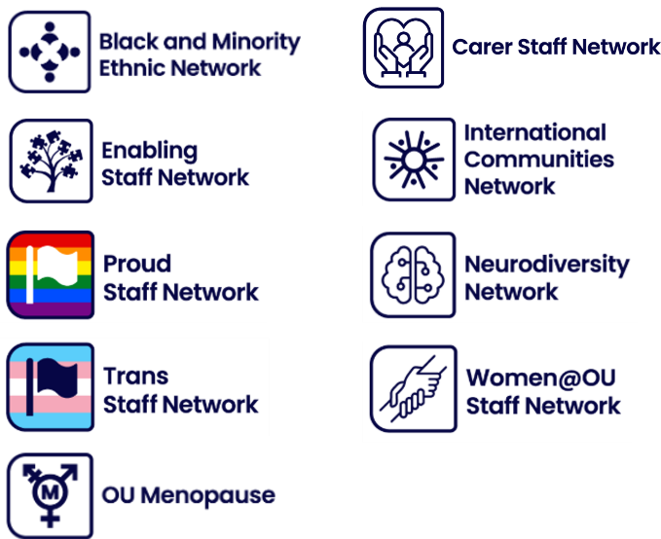
- Black and Minority Ethnic Network
- Carer Staff Network
- Enabling Staff Network
- International Communities Network
- Proud Staff Network
- Neurodiversity Network
- Trans Staff Network
- Women@OU Staff Network
- Menopause Moments
To find out more about Staff Networks and how to join, please visit the Staff Networks intranet page (internal only).

Student support, connection and community
OpenSU (Students Union) provides a number of ways in which students can access support, advocacy and advice as well as opportunities for students to form connections with each other and build student-led communities. Below are some examples of student-centred support activities:
- Welcome Week
- Individual Representation Service
- Community drop-ins
- OU Students Connect
- OU Pride
- Equality, Diversity and Inclusion newsletter
- Black, Asian and Minority Ethnic Students Group
- Disabled Students Group
- OU Wellbeing App
- Allyship Hub
- Menopause Support Hub
- Neurodiversity Support Hub

Carers at the OU
The OU recognises that caring responsibilities are a significant, and often under-acknowledged, part of colleagues’ and students’ lives. Caring intersects with multiple dimensions of inequity, including gender, wellbeing, career progression and engagement. Women are more likely to experience a “double burden” of paid work and unpaid care, while men may face barriers to openly identifying as carers or seeking support due to workplace norms and expectations.
The OU has taken steps to strengthen support for colleagues and students with caring responsibilities, including:
- clarifying entitlements and the process for requesting unpaid Carer Leave through the Dependants and Carers Leave Policy and Procedure
- launching the Carer Passport institution-wide in January 2024, providing a confidential tool to support conversations between carers and line managers about support needs and working arrangements
- linking the Carer Passport to related support, including Agile Working, Career Breaks, Wellness Action Plans and Contingency Leave
- adding Supporting Carers as a Manager to the People Manager Toolkit in 2025, enabling managers to respond more effectively and consistently to carers’ needs
- maintaining membership of Employers for Carers to support our carer-inclusive practice
- supporting the Carer Staff Network, which provides peer support and helps shape institutional practice
- strengthening collaboration between the Carer Staff Network and the Athena Swan team, ensuring care is reflected in the new Athena Swan Action Plan
- achieving Carer Positive Established status in OU Scotland through our work supporting carers at the OU and through sector-wide initiatives
Together, these actions help normalise conversations about caring, support more consistent management practice, and provide a clearer framework for colleagues and students with caring responsibilities.

The Access and Participation Plan (APP)
The APP is committed to removing the barriers identified as perpetuating disadvantage and inequity for Black students, students with mental health difficulties, and those from areas of socioeconomic disadvantage. Together, these groups represent around 30% of OU students. Our goal is to address the challenges within the University’s culture, systems and practices and to strive for structural change, supported by the OU’s annual financial commitment of £2.5m towards activity designed to reduce inequity. By establishing equity as our foundation, we aim to move beyond making adjustments to accommodate unequal opportunities and instead create lasting change.
Inclusive Curriculum
The Inclusive Curriculum Tool (ICT) was developed in 2018 to help authors and editors review OU curriculum content, including assessment, to improve inclusion and accessibility. Its use has been mandated by VCE Academic for all new curricula since March 2022. Version 6, launched in September 2023, includes 56 prompts covering all protected characteristics, supported by guidance and resources to inform revisions and content development. Version 7, now in development, will move the ICT to a digital platform, integrate OU-developed AI tools, and improve coverage, consistency, and impact evaluation.

Learning and Development
- Allyship Programme. In 2024, we launched our Allyship Programme to empower colleagues to become effective allies and actively contribute to our Equity goal and inclusive University culture. Through the programme, colleagues gain a deeper understanding of why action is needed and how to use their power and privilege to help build a more equitable University and society.
So far, across two cohorts, more than 300 colleagues have engaged with allyship learning and over 90 have completed the full programme.

- EDI Learning Hub. Also in 2024, we introduced the EDI Learning Hub as a central platform and starting point for individual learning, where colleagues can deepen their understanding of a wide range of EDI topics.
The Hub offers a wealth of resources, including open-source content such as online articles, YouTube videos, and TED talks, alongside materials created by the OU EDI Team and colleagues across the University. It also acts as a central mechanism for delivering and signposting learning linked to REC and Athena Swan action plans, supporting staff engagement with key EDI priorities.
Recognising that EDI is a collective responsibility, the Hub is a valuable tool in our journey to becoming a more inclusive community. By offering foundational knowledge and diverse viewpoints, it aims to broaden perspectives, amplify the voices and experiences of marginalised communities, and support everyone in their EDI learning.

- New Equity and Inclusion Essentials mandatory training. In August 2026, we replaced Equality Essentials with the new mandatory Equity and Inclusion Essentials course. Updating and improving the course was an action within the Athena Swan Bronze action plan. Developed in-house by the EDI Team, the new course provides a fresh and up-to-date foundation to key EDI concepts, our legal duties and what good equity practice looks like in everyday work at the OU. The training underpins delivery of both REC and Athena Swan actions by establishing a consistent baseline of knowledge and expectation across the University. We have worked with a range of internal stakeholders to ensure the course is relevant to our community, aligned with our equity commitments, and offers clear, practical guidance on what EDI means at the OU.
- Union Black. In 2024, we published the one-hour version of the Union Black course on OpenLearn and MyLearningCentre (MLC). The course explores the history and experience of people racialised as non-white. It is designed to inform, inspire, challenge and enable staff and students to take steps towards anti-racism.


5. Our success measures
The Key Performance Indicators (KPIs) below reflect the priority areas of the EDI Strategic Plan: Disability, Neurodiversity and Accessibility, LGBTQIA+, Race and Gender inclusion. They are evidence-informed and based on areas where data shows persistent inequities in staff and student experience, representation and outcomes.
For staff, the specific KPIs for gender and race have been chosen because they represent areas requiring significant improvement. Other important actions are embedded within relevant action plans, including the Race Equality Charter Bronze Action Plan and the draft institutional Silver Athena Swan Action Plan.
For disability, neurodiversity, accessibility and LGBTQIA+ inclusion, we have chosen to focus on colleague experience. These KPIs will support our ongoing work to develop robust SMART action plans for both priority areas, through the Disability, Neurodiversity and Accessibility Steering Group and the LGBTQIA+ Working Group.
We have also separated sexual orientation and gender identity KPIs to avoid masking differences in experience, particularly where the data shows greater disparities for trans colleagues. We are also improving our data categories so that, in future, we can report more accurately on both disability and neurodiversity.
The student KPIs are taken from the Access and Participation Plan (APP) 2025–2029, which has already been agreed and approved by the Office for Students (OfS). Together, the staff and student KPIs provide a clear framework for monitoring progress annually across the life of the Strategic Plan. They are evidence-informed with assurance of good data quality for accurate reporting.

5.1 Staff KPIs

By the end of the Strategic Plan period:
- The gap between female senior staff representation (defined as staff on PB or SS pay grades) and overall female staff representation will be reduced from 9 percentage points (2024/25) to within 4 percentage points (2030/31).
- The proportion of racially minoritised candidates at appointment stage will be consistent with proportion at application and shortlisting stages. In 2024/25 the gap from applicant to appointment for racially minoritised colleagues was 22 percentage points.
- The gap in positive responses to values-based engagement survey questions between colleagues who shared disability(ies) and those who do not will reduce from 9 percentage points (2024/25) to 3 percentage points or less (2030/31).
- The gap in positive responses to values-based engagement survey questions between transgender colleagues and the overall colleague population will be reduced from 8 percentage points (2024/25) to 3 percentage points or less.
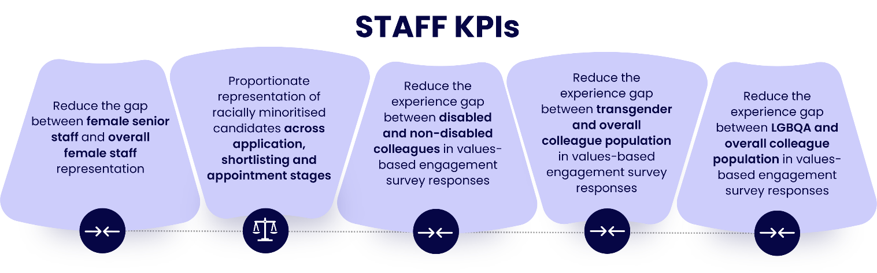
- The gap in positive responses to values-based engagement survey questions between LGBQA colleagues and the overall colleague population will be reduced from 3 percentage points to 2 percentage points or less. It was 3ppt in 2024/25.

5.2 Student KPIs

By the end of 2029, we will:
- Increase in the number of Black students recruited, above that expected from population changes, from 1,131 (2023/24) to 1,256 (2028/29).
- Reduce the gap in module pass rates between students in IMDQ1 and IMDQ5, by increasing the pass rates for students in IMDQ1 from 58.0% (2022/23) to 62.8% (2028/29).
- Reduce the gap in module pass rates between students with and without mental health difficulties, by increasing the pass rates for students with mental health difficulties from 54.9% (2022/23) to 63.7% (2028/29).
- Reduce the gap in module pass rates between Black students and white students, by increasing the pass rates for Black students from 56.8% (2022/23) to 63.7% (2028/29).
- Reduce the gap in FHEQ level 4 and 5 module pass rates at grades 1 and 211 between Black students and white students, by increasing the pass rates for Black students from 36.9% (2022/23) to 50.3% (2028/29).
- Reduce the gap in Positive Progression rates between graduates with and without mental health difficulties by increasing the Positive Progression rates for graduates with mental health difficulties from 67.9% (2022/23) to 71.7% (2028/29).
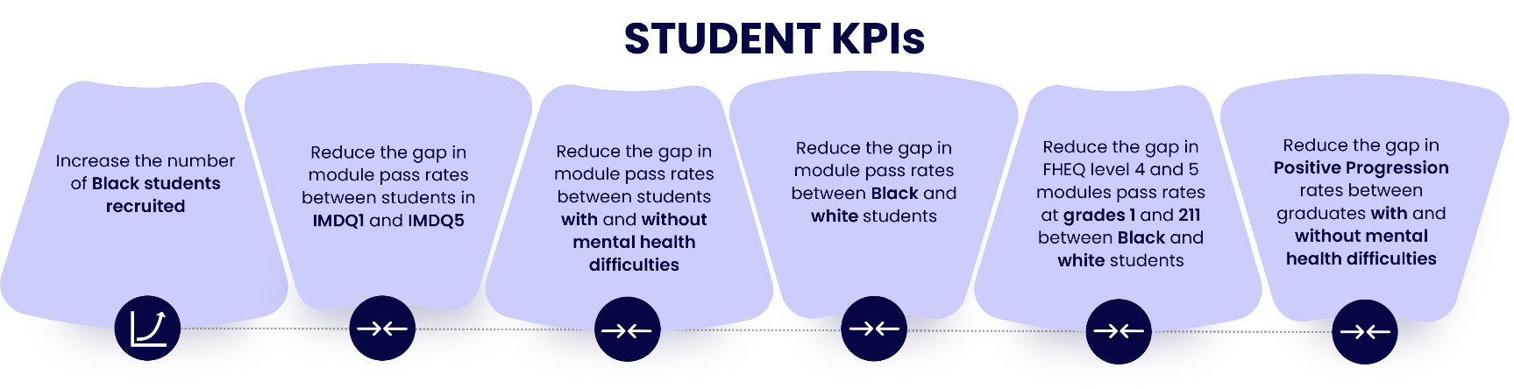



IMDQ1 – Index of Multiple Deprivation – group 1 (the most deprived areas)
Report and Support is the University’s safe space reporting tool, giving staff, students, learners and visitors a confidential way to report bullying, harassment, discrimination, hate crime or sexual misconduct either anonymously or with their details. It helps people get timely support, enables the OU to spot and address harmful behaviours, and strengthens its commitment to safety, dignity and inclusion across the community.
White Ribbon is a leading charity in England, Wales, Scotland and Northern Ireland engaging men and boys to prevent men’s violence against women and girls. Organisations work with White Ribbon to develop and deliver a transformative action plan over a three-year life-cycle. This work also aligns with Athena Swan.
The Athena Swan self-assessment team (SAT) includes five working groups, one of which is the ‘Supporting Trans and Non-binary staff” working group. This group is working closely to align with the LGBTQIA+ working group.

